PSYCHO-SCIENTIFIC FRONTIERS

Selected publications from a variety of subjects of psycho-scientific research. Editor: Rolf Linnemann (Certificated Engineer) * Steinweg 3b * 32108 Bad Salzuflen * Tel. (05222) 6558

Internet: http://www.psychowissenschaften.de E-Mail: RoLi@psygrenz.de
Translator’s email: evak30@optusnet.com.au

Protocol extracts from the Menetekel from the years 1956 to 1975.

Theme : Experiences with the mass-media

Questioner : (ZDF) German TV station
Mediums : Uwe Speer (17) and Monika-Manuela Speer (15)
MESSENGERS of LIGHT : ELIAS, ARGUN, AREDOS

The following text to this theme was psychically received by the Medialen Friedenskreis Berlin (MFK), a Christian/Spiritual community, between 1956 and 1975. The transmissions form a part of the Menetekel, a collection of protocols of around 4,500 A4 sized pages amassed over 20 years and they have recently been restructured. All of these mediumistic messages were left in their original form, even if similar questions were repeated. The work of the two automatic writing mediums, Monika-Manuela Speer and Uwe Speer, began when they were 15 and respectively 17 years old. The total production of the MFK-Berlin (Medialer Friedenskreis Berlin), the Menetekel and the 21 transmissions from the space-brothers are considered the absolute pinnacle of psycho-scientific research. Other spiritual circles have often tried to copy the work of the MFK, but its quality was never achieved. The reproduction and distribution of these rearranged messages and protocols is explicitly encouraged and is not covered by any copyright.

Preface

The educational level of nations (1956/57) is mainly influenced by their daily newspapers. Most people are erroneously of the opinion that the daily papers bring them objective coverage of events. These gigantic newspaper corporations, with their enormous investments, represent power and comprehensive knowledge. Only a small number amongst the readers notice and contemplate that this comprehensive knowledge is unilateral and extremely fragmentary and that this power only serves ungodly politics.

Reporters are not omniscient in regard to the many important fields of research. One often looks for neutral coverage of events in vain. What are generally lacking are personal opinions and specifically a higher responsibility. The chase after sensations and honoraria turns many journalists into liars and fomenters of the basest kinds of instincts and natures that can poison and stir up whole nations. This highly negative assessment is subsequently put to the test.

H. V. Speer, Circle leaders of the MFK, Berlin.

January 1959

Experiences with the press (Author H. V. Speer)

The Mediale Friedenskreis, Berlin (Psychic Peace Circle, Berlin) allowed two reporters to participate in its séances so they could convince themselves of the genuineness of supernatural contacts. They were allowed to ask questions and take photos whilst we had a connection. Based on the gained conviction, the journal “Revue #30”, a special pictorial report was published. This pictorial report was copied from the “Revue” by the East German newspaper “Neue Berliner Zeitung” and the associated texts were distorted. This mud raking reporter, who never participated in a séance or even talked to a participant or one of the mediums, wrote the following nonsense:

“Flying saucer port sighted by Uwe Speer.”

(It was never suggested that the medium saw anything.)

“Polar star villa.”

(The polar star was never ever mentioned.)

“The UFO sect only meets under candlelight to receive their orders!”

(The Psychic Peace Circle is not a sect, but a free, spiritual community. Orders were never received, only DOCTRINES.)

“I hope that these UFO people do not regard the human race as being backward because of this mediaeval form of lighting.”

(The occupants of UFOS regard the whole press on Earth as being backward and mendacious.)

This malicious report twists every word around here also, because it continues:

“The receivers of these ominous messages were the ‘writing medium’ Monika and ‘drawing medium’ – surprise, surprise – her husband Uwe Speer, from Berlin-Wilmersdorf.”

(The fact that these two young people could be psychic siblings never entered the reporter’s ignorant mind.) In his ungodliness, the reporter continues:

“These UFO people are not interested in the atomic missiles here on Earth.”

(Every enlightened human being knows that the exact opposite is true. We published that the occupants of UFOS observe all terrestrial rocket launches with the greatest of interest.)

At the end of this mendacious report, one we regard an exemplar of the general stupefaction of the public by the press, the devil chases his own tail, because the writer make the same mistake EVIL always makes and unmasks himself in the process. The East German journal continues:

“Thousands of members of the ‘Psychic Peace Circle’ believe this nonsense and the West German magazine “Revue’ report is even completely serious about this. This should please the inventors of UFOS: Distraction successful.”

(The “Revue” could be serious about this, because they were dealing with eye witness accounts and factual reports. “Distraction successful” – From what? – From the Soviet’s moon-rocket with nuclear warhead? No surprise then that spiritualism is completely garbled and disowned by the press. We do however know that peace on Earth and across all frontiers is only possible with the help of the UNIVERSAL TRUTH and never through any form of politics.)

One more example

Those that have not read the psychic protocols of inter-planetary beings do not know what actually goes on in the world and where our violence will take us. Even theology and also the press live in almost culpable ignorance, because they always rejected the reality in a most blasphemous way.

The “Nachtdepesche” (German magazine) for instance wrote on the 22nd of October, 1957:

“Ashtar” is the non-terrestrial commander of 10 million occupants of flying saucers. There is a picture of him, a drawing he transmitted via telepathy to a “Messenger of LIGHT” in Berlin and he looks like Winnetou (Karl May character) with a nose like Schiller and a James Dean turtle neck.”

If this journalist had ever dealt with the psycho-sciences a little bit in his life, he would not have written such nonsense. Fully automatic writing and drawing has nothing to do with telepathy. It is the otherworldly influence on the nerves and muscles of a sensitive medium. It is absolute magnetic guidance, an automatic movement without the medium’s influence.

Do not believe the press. It must learn to deal with the truth first!

The medium is also not a “Messenger of Light” that received something.

September 1958

“Monika Speer talks to the universe”

The last two internal pages of the (former) Munich Journal “Revue”, #30 from the 26th of July 1958 contain a special report titled “Monika Speer talks to the universe”, by Werner Roelen.

This special report states:

“Humbug, superstition or truth – this is the question here. What the Revue reports about the “spiritual meetings” conducted be the Berliner family Speer may just produce a pitiful smile with many readers, but might actually also induce contemplation. Just like New York, London and Paris, Berlin also has a “Psychic Peace Circle” whose members are convinced that flying saucers (Unidentified Flying Objects – UFO) have orbited and controlled planet Earth for a number of years. These UFOS, the circle participants ensure us, are manned by human-like, highly evolved beings, UFO occupants, who come from other stars in space, that they are thousands of years ahead of us in their mental and technological development and that they are here to converse with mediums amongst us – like Monika and UWE Speer. Revue reporter Werner Roelen had the opportunity to take photos and ask questions at a number of such meetings.

He writes:

‘These meeting are conducted in a solemn manner, candles on the table illuminate devout countenances, but there is no hocus-pocus here as is the case with other spiritual sessions. The participants of this circle are convinced that they are in contact with messengers from space and they also believe that UFO occupants act under direct instructions of a divine power.’

A very simple explanation is given in regards to the “fact” that UFOS have only recently appeared near planet Earth: Because the technological development on our planet has reached a point where one can expect people to advance into space, these beings from space want to squash all future calamitous plans. They for instance beseechingly warn again exploding a nuclear device on the Moon. Such intentions could provoke an immediate intervention here on Earth by UFO occupants, as they have the power to destroy large factories or rocket launch sites, without harming one single human being. The Psychic Peace Circle, Berlin has around 100 members and there are about 5,000 people in West Germany who believe in UFOS.”

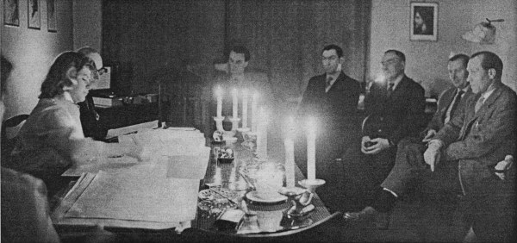

Members of the Psychic Peace Circle meet at Ahrweiler Strasse 36 in Berlin-Wilmersdorf at the home of the family Speer. Pictured left is Monika Speer writing a remotely controlled message that states: “Rocket technology on Earth is nothing more than playing a very expensive game!”

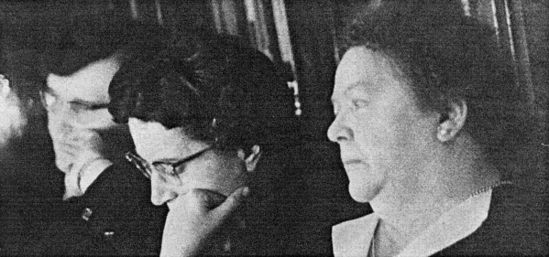
The members of the Psychic Circle attend the meeting full of devotion. The messages are read immediately after and everybody can ask direct questions.
The circle leader explained: “Our meetings have nothing in common with spiritism, the moving of tables and such like nonsense.

Monika Speer, a 22 years old secretary, is the “writing medium” for UFO occupants.

“My hand is guided by invisible FORCES, I write without will”, she said.

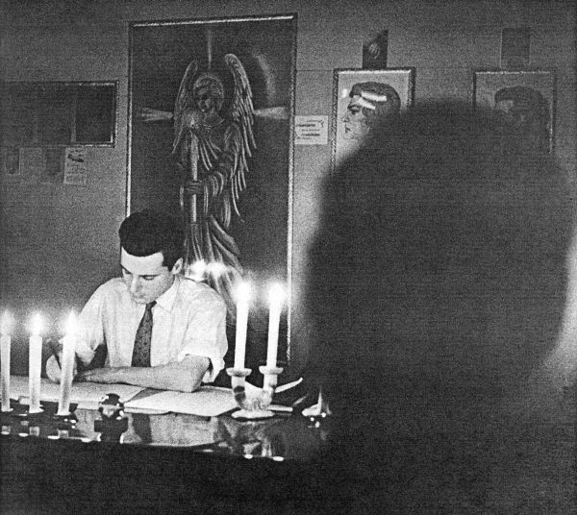

W

Uwe Speer, a 24 year old Gold-cutter, was photographed by a Revue reporter during a meeting as he put a drawing from UFO occupants to paper.

The following has to be said about this:

These very good photos are not posed, but were actually taken during a genuine contact by candlelight. The reporter asked 10 questions that were prepared by the editorial office in Munich and they were spontaneously read. The answers to these scheming questions came instantaneously and with amazing intelligence. The text published in the Revue was not presented to us for possible corrections and this is why it contains a number of discrepancies:
- The Psychic Peace Circle has around 100 active members and they regularly come to observe the séances.

- About 5,000 people in West Germany sympathise with the Peace Circle and correspond with it. To add to this are also numerous spiritual friends from many different countries.

But millions of people believe in the existence of our space brothers and there are around 200,000 pieces of documented evidence in various governments’ hands. Our mediums do not work in a trance state, they are completely awake.

It is quite correct for the Revue to emphasise that:

“Monika Speer, a 22 years old (18-11-1936) secretary, is the writing medium of UFO occupants. (Verifications from other countries are at hand):’My hand is guided by invisible FORCES; I write without will’, she says.”

These kinds of magazines must maintain their neutrality, because they are not competent enough to enter a battle of wits with our opponents. The Revue at least thought it appropriate to break the ice. The reporter Werner Roelen writes the following about the work of the Psychic Peace circle, Berlin:

“These meetings are a solemn affair, the candles on the table illuminate devout faces, but there is no hocus-pocus, as is the case with other people’s spiritual sessions.”

Well now, the Psychic Peace Circle, Berlin did arise from experimental spiritism. (See brochure: “The Great Encounter”.) The phenomena included levitation, telekinesis and complete pieces of music of raps (knocking sounds). Our experience tells us that we cannot call these phenomena nonsense and we never expressed such an opinion. On the contrary – these phenomena were very convincing and genuine. We ended up abandoning this also very interesting line of investigation because it is not qualified to adequately guarantee messages from the spiritual realm.

- Christian spiritualism offers us the certitude of the truth and the wellbeing of all participants and mediums.

* * * * * * *

Spiritualism on Zweiten Deutschen Fernsehen (ZDF) (1964)

Question (ZDF) : The ZDF intends to air an authentic program about experimental spiritism, occultism and spiritualism as well as the work of supernatural mediums. Are the mediums of the Psychic Peace Circle, Berlin prepared to cooperate in such a program?

Circle leader : All persuasive measures have not brought a result so far. The two mediums, Uwe and Monika-Manuela, unfortunately reject the publication of such a program.

Question (ZDF) : Would one not have to assume that when faced with such an endeavour, the medium simply capitulate? – We are dealing with a great opportunity here.

Circle leader : Both mediums already dealt with the public in the past. The reporters did however not keep one of their promises! Their reports did not state the facts. It was mentioned for instance that the text was supposed to be countersigned by the leader of the circle. Nothing has been taken into account! – No fees were paid. We did not even receive a pre-print version of the journal “REVUE”. Not one of the photos was presented to us for approval prior to publishing! The whole experiment took place under false pretences of facts.

The worldwide publication led to a situation where the mediums had to run the gauntlet in their neighbourhood, because their full address was included in the report. They were mobbed and derided in public and it made their situation at work quite impossible. Both mediums had to give up their profession and change jobs as well. In spite of this hostile reception, they continued with their eminent mission for the Psychic Peace Circle.

Question (ZDF) : The ZDF guarantees you discretion. Their faces can be modified if you so desire. There are no risks involved in this case. Would you be prepared to show your ability under these circumstances?

Circle leader : Television represents absolute new ground for spiritualism and it can only be discovered through appropriate experiments. The absence of the required lighting can make everything impossible. The FOUNDATION of VIBRATION plays the greatest role into the bargain. It is a case of FREQUENCY and harmony. To achieve this simultaneously is very difficult.

Question (ZDF) : We are dealing here with a positive program. The manager in charge of recording is supposed to be a Rosicrucian. One endeavours to show the public that there are also genuine mediums and genuine contacts. What do you say to that?

Circle leader : We had reporters here who could not suppress their atheism in spite of observing a genuine contact. They wanted to argue with our SPIRIT GUIDES. Such behaviourism naturally attracts DEMONS. This SPIRITUAL SIDE may not be underestimated! A television crew is nothing short of a signal for such spirits.

One has to remember that television viewers believe in bluff too easily. Even genuine contacts and authentic reports can turn negative. Somebody in England made a very good documentary about such ghost hunters. This film was objectively interpreted for television. Everything was in order and it could also have impressed viewers in Germany, but the score for this very good film was some ridiculous electronic music. Due to the musical effect, everything was distorted to sound ridiculous. You can see how certain means can completely destroy something positive.

Question (ZDF) : We intend to respect all religious feelings. Could such an attempt not be positive?

Circle leader : Such an attempt must be PROTECTED accordingly! The necessary PROTECTION will however be immediately breeched by otherworldly spirit beings of a lower order, if the terrestrial prerequisites are incorrect. Our circle has tested everything for years.

- One single guest within a circle with a negative attitude can render the whole séance impossible.

Question (ZDF) : We are prepared to adapt to your wishes and experiences. Would your mediums be prepared to make the recording in your devotional room instead of our studio in Mainz?

Circle leader : Most television personnel and reporters are generally no spiritualists. Their mental attitude alone, for instance their pronounced objectivity, hinders any sensitive contact and offers the negative WORLD of SPIRIT opportunities to attack. This is the reason why good circles are hard to find.

- Where good spiritual work is achieved, one sternly guards against newcomers, because they can do a lot of damage. It is then very difficult to re-establish contact. The risks are great!

You can see why spiritualism is a confined science, confined by the spiritual behaviourism that is an absolute basic requirement for any success. Some researchers in the USA were so brash that they completely undressed a medium, no matter what gender, and closely inspected the most intimate parts of the medium’s body. Who wants to put up with such shenanigans? – We are conducting a séance tonight. I will give you the opportunity to personally ask the WORLD of SPIRIT questions. We will abide by the decisions of our spiritual GUIDANCE. But please ask the medium beforehand if it is willing to participate.

Question (ZDF) : (Directed at the medium Uwe) Are you prepared to place yourself at the disposal of the television crew? We will completely abide by your wishes.

Medium Uwe : I am aware that I will be once again exposed to public ridicule. I do however stand by the truth, I will participate if the television crew promises not discriminate against me.

Later, during the session with MESSENGERS of LIGHT:

Question (ZDF) : Are the GUIDES from the WORLD of SPIRIT in agreement in regards to the recording by the ZDF of an original contact between the here and now and the hereafter in this devotional room?

ELIAS : We are for any distribution of spiritualism¸ but we are however against all revilement.

Question (ZDF) : We require some additional lighting. The candles alone are not enough. The blue light factor does also not suffice. How high can we increase the light during contact?

ELIAS : Up to a strength of an additional 100 Watt.

Question (ZDF) : The recording personnel consist of eight people. I will send four of them outside whilst we have contact. What would you like the rest of the composition to look like?

ELIAS : It suffices to include around six circle participants. This room is PROTECTED. The recordings can be made tomorrow evening, Sunday the 17th of September (1964).

A production team of the ZDF transformed our devotional room into a machine hall. After the large flood lights were in position, the whole endeavour no longer looked like being successful. The additional lighting wasn’t just another 100 Watt, but more than 1,000 Watt! – The whole technical construction was positioned directly behind Uwe Speer. The paper in front of him radiated a blinding white. The warmth thus produced made the medium perspire profusely. The television camera was positioned directly over his left shoulder (Picture 1).

We began the séance with the usual music.

We then made the appellation.

All of us no longer believed that contact under these physical conditions was actually possible. But to our surprise the contact happened instantaneously. Everything worked like clockwork. The medium had completely drawn within itself and was now just a tool in the hands of HIGHER POWERS. This was an incredible masterpiece of psychic ability and masterful concentration on the spiritual world.
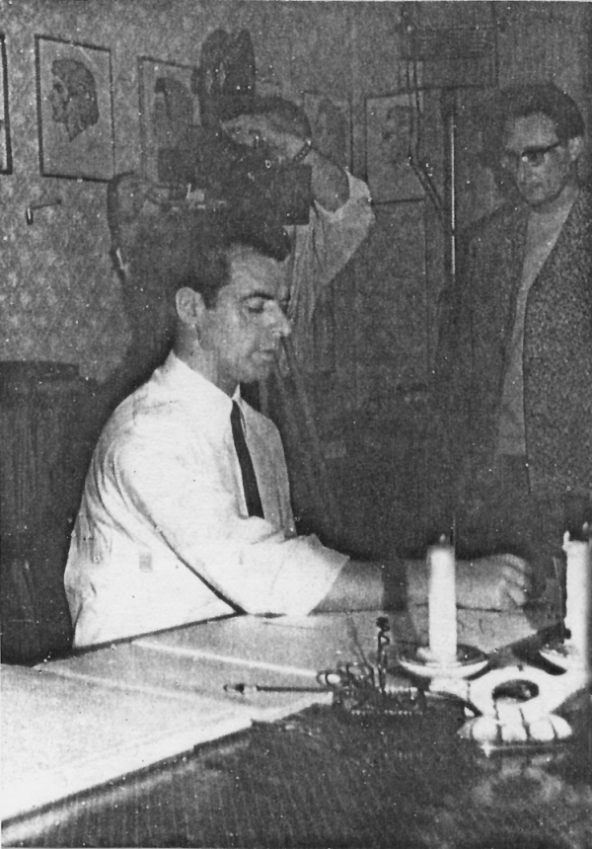
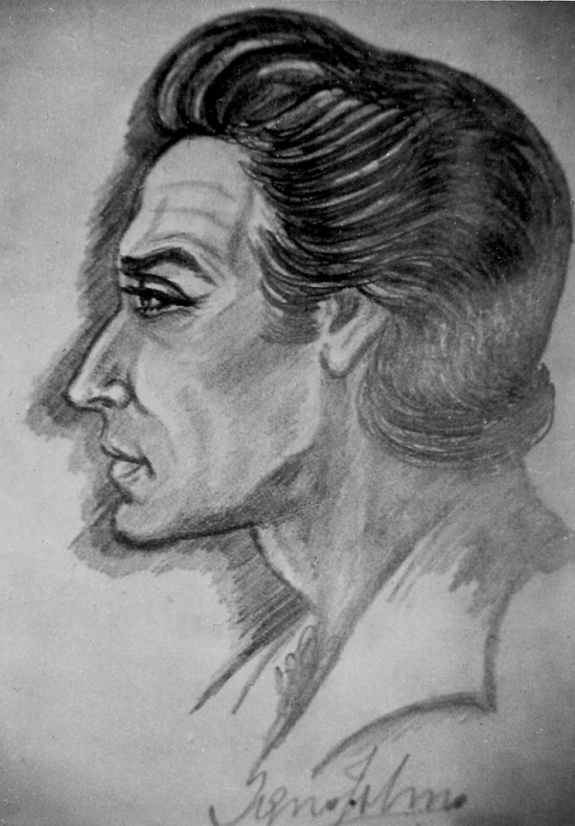

Picture 1: The medium Uwe Speer in action.

Co-workers of the ZDF television crew in the background.

Apart from answering the questions put by the ZDF employees, various portraits of GUARDIAN ANGELS (all the following pictures) and other present SPIRIT BEINGS were also drawn. Every one of these physically drawn pictures was drawn within 12-15 minutes in one line. (The pen never left the paper) The draughtsman was the MESSENGER of LIGHT JOHN SHERIDAN. His medium was Uwe Speer (Without any training as a draughtsman). The recording crew was very impressed. The stage director had this to say:

“The very best of our recordings up to now! I wasn’t wrong, because I sensed that something special was going to take place here.”

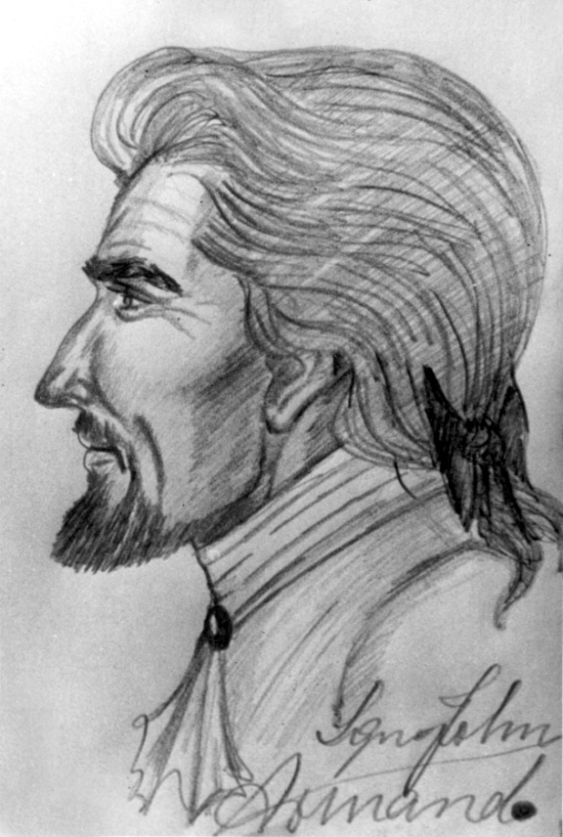
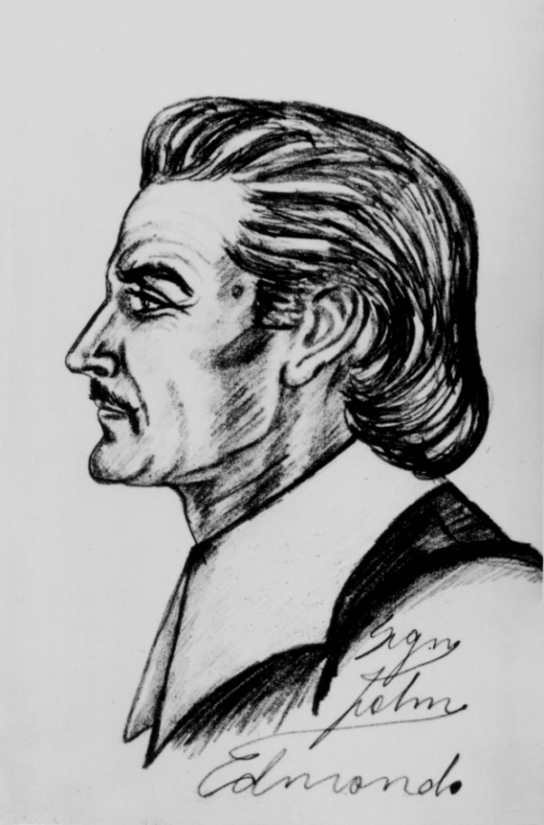

After this was done, the people from the ZDF asked the WORLD of SPIRIT their questions:

Question (ZDF) : What is spook?

ELIAS : Spook is the manifestation of the invisible.

(Comment: One can already recognise by this answer, which followed instantly, that it was formulated very precisely.)

Question (ZDF) : Why are particularly children involved as mediums or also otherworldly children in negative spook?

ELIAS : A great factor exists between otherworldly CHILDREN and children living in the flesh in regards to paranormal phenomena. We are dealing with inner tensions. The psyche is unstable. The physical wants to vent itself and this tension in conjunction with an inner turmoil promotes spook. Certain CORRELATIONS exist between the souls of deceased children and children with psychic abilities going through puberty in the here and now.
- Psychic instability can produce paranormal spook phenomena, because the psychic side endeavours to give vent to its ENERGY.

Question (ZDF) : Do people on Earth possess the absolute freedom of thought, respectively do they possess individual privacy of thought?

AREDOS : All human beings can naturally think as they please, but they do not possess an individual privacy of thought, because every otherworldly soul can telepathically connect with everyone’s thoughts.

- Telepathy between otherworldly souls is the way they have always communicated.

- Telepathy between the otherworldly and the physical is far better than between two people within the Earth’s environment.

That everybody has many thoughts they think are their own happens on an hourly basis, but they actually telepathically stem from the spirit beings around them. These inspiring thought naturally influence one’s own freedom of thought.

Question (ZDF) : Does one also encounter one’s enemies in the hereafter?

ELIAS : Yes, this is possible. But one recognises one’s shortcomings much easier in our WORLD of SPIRIT. Whether one is prepared to discard these shortcomings is another question. But the terrestrial reasons for animosities are no longer valid in the WORLD of SPIRIT. The animosities that exist in the WORLD of SPIRIT usually have completely different causes than is the case on Earth.

Question (ZDF) : Did you encounter great difficulties implementing this meeting?

ELIAS : No, we had no major difficulties, because using this meeting place for so many years makes it taboo.

Question (ZDF) : Why can Lucifer’s devotees commit evil acts without being punished as they are also subject to the LAW of KARMA? Would Lucifer not have to suffer to such a degree where he would perish under the LAW of KARMA?

AREDOS : Every soul has the freedom to do good or evil deeds. Lucifer also has a soul and also the freedom to do as he pleases. The situation with Lucifer’s devotes here and in the hereafter is that they take pleasure in evil. Why do the people on Earth stick with their vices? Surely only because they find pleasure in them!

KARMA (Atonement) is naturally a LAW. But karmic suffering does not improve every soul. It is therefore a question of time. The fact that Lucifer did not succumb to his KARMA lies in the fact that a whole planetary humanity (Earth) helps him over again to orchestrate evil. The actual KARMA therefore always affects the committers in this case. Lucifer is crafty enough to cleverly avoid KARMA. Apart from that, the time when GOD’S LAW catches up with him is not ripe.

- Whatever people do, they have to give account for themselves. It is impossible to make somebody else responsible for one’s actions, not even Lucifer as instigator.

People are generally not forced to do evil in most cases. Those that smoke for instant derive pleasure from it. Those that like to drink feel well. People also do evil because it amuses them. They watch boxers, even if they bloody their noses – and they think it’s funny! And then there is what’s called a shiver down one’s spine experience something committers of sexual crimes feel. – People subconsciously commit sins on a daily basis, because they think they are harmless pleasures. They do not have the correct power of discernment, because they do not know the truth.

Question (ZDF) : Can people recognise by their KARMA that they have sinned?

AREDOS : No, KARMA is a LAW that, in most cases, comes into effect immediately after a sin has been committed. LAWFUL KARMA is at work, when smokers become ill for instance. But when one explains to them that smoking is to blame, they balk at this explanation. They will all assert: “Smoking is not o blame.” – This is how people delude themselves. They are not worried about any threatened punishment but when this punishment arrives, they assert that is has nothing to do with their antinomian lifestyle. Almost all humanity suffers in one way or another, but nobody wants to hear that almost all suffering is self-indebted.

Question (ZDF) : How can suffering be self-indebted if it is inherited?

AREDOS : In a lot of cases people have been their own ancestors.

- People suffering from a hereditary illness could have been their own great-grandfather in a past life. They thereby often atone for their own past.

A European of Caucasian blood could have been an Indian or a Negro in a past terrestrial life.

- The kinship to a race is determined by the level of one’s development. But souls can also become recidivistic so that they reborn as members of an undeveloped race.

This important fact should be made known all around the world, because it does not attract any attention at all.

Comment: The completion of the psychically drawn portrait of the MESSENGER of LIGHT was recorded by the ZDF. The whole meeting shall by televised by the ZDF at the end of January 1965.

Question (ZDF) : How does the spiritual realm assess the Holy Communion administered by the church? Does the Holy Communion have any significance for spiritualists?

Answer : If people receive a lift for their body or their soul from certain rites or ceremonies, let them have it! We show great tolerance in every respect. But I have no desire to witness such a ceremony. Something like this also does not help CHRIST. I would not help me either and I know that many thousands that have thrown off the shackles of religion, neither gain help or benefit from it either.

The greatest service one can render CHRIST is to adopt him as one’s archetype and to follow his example and his doctrines, to strive for living a life that accomplishes the greatest service and to genuinely endeavour to improve one’s inherent POWERS to a degree where one can console mourners, heal the sick, bring relief to those afflicted by doubts and confusion and bring help to those in need of help.

- Life is more important than any ceremony. True religion is not a ritual, but a sacred service to one’s fellow man.

Question (ZDF) : Is the Holy Bible relevant as a textbook for us?

Answer : Please do not confuse the facts. You could strike every printed word from every so-called “spiritual” book; you could remove every hymn from books of praise and veneration. You could refrain from all ceremonies, all rituals and all traditions and still be deeply religious; because as a spiritualist you lead a life of nobleness and service, wherein the spirit within you finds its true expression.

We do not say to you that your attention should be directed at ceremonies. It is not the form that counts, but the life lived. What you do and how you behave, this is what counts, quite apart from the fact that these ceremonies originate from times long before the days of CHRIST.

- Service to one’s fellow man is superior to venerating GOD; because it shows one’s preparedness to serve GOD under any circumstances.

- Service to one’s fellow man, even if we’re dealing with elucidation, is of the greatest necessity and it stands way above any religious ritual and way above any ceremony.

My opinion is crystal clear: I see that religions accumulated too much from the past and that a great deal of it has no logical relationship with true religion at all. The enlightened spiritualist regards religion completely different to the way the churches look at it. Church ceremonies, adoration and all formalities were conceived by priests at oecumenical councils who had no idea of what spiritualism was all about, except that it corresponds with the devil.

I personally have no interest in ceremonies, because they are completely irrelevant for me and for my spiritual development. But I would like to say in spite of this that those that honestly believe that ceremonies or rituals can help should not stop participating in them.

- We are of the opinion that it is best to disassociate oneself from childish, theatrical things once one has left one’s childhood years behind.

There is actually a real communion, namely the unification of the spirit with the HIGHER SPIRIT. Spiritualism is the highest form of a true religion in as much as it is absolutely bona fide and strives for the accordance between souls. With its help one can leap over the barriers between the here and now and the hereafter. It is the best kind of alliance that is actually possible. Everything else only promotes superstitions.

- Any effusive cult has nothing to do at all with CHRIST’S MISSION.

Question (ZDF) : Has the name of the declaring spirit any pertinence when we receive DOCTRINES from the spiritual realm?

Answer : I am not bound to any name, only to the truth. You might as well place the truth instead of a name. As far as I’m concerned you could use an “X”. All that is of pertinence is the truth.

- The most famous names on this Earth often enough produced the greatest mistakes.

My doctrines come from a SPHERE that can only be reached by a few and this is why it is devoid of any mistakes. I am however aware that the most eminent truth will always be attacked, because it hinders the progress of the negative forces. Negativity will hard headedly defend itself with all available means – even the most unfair – because the truth is the opposite polarity to aberrations.

Do not allow yourselves to be dissuaded from your mission by this. We will inspire progressive human beings to stand at your side and to render you support, because the GREAT BATTLE between GOOD and EVIL has begun and because this dispute will be fought in an unimaginable way and with severity. The deployment of SPIRIT FORCES increases more and more. Not all of those on the side of the truth will be churchgoers.

- It will not be religions that will bring peace. It will solely be the comprehensible truth that will save this planet.

My name does not play a role – even if I was GOD’S highest ANGEL – I would never divulge it to you. I am just a nameless communicator of the ETERNAL TRUTH throughout the whole universe.

Church religions and their dogmas put pressure on their believers by threatening them with eternal damnation. They finance their religion by making false promises that are a thorn in CHRIST’S eye.

World politics is a structure that is rotten through and through, because its foundation is based on spiritual aberrations. The foundation of world politics must bear the inscription “ETERNAL LIFE” and not “eternal death”. Because the foundation of world politics does not coincide with the LAWS of world harmony, all of terrestrial mankind lives between barned wire, machineguns, explosives and canons. – The carnival is the precursor of all bellicose disputes. It is the rabid war dance of those of ill will and those that prefer all vices over the highest of values.

- There will be no peace without an absolute clarification in regards to the cognisance of GOD!

It doesn’t mean that human beings are born somebody’s enemy when they are born on this EARTH, no matter what race or nation they belong to. All that happens in all cases is that when a human being is born, it should develop him or herself and this means that we are dealing with a member of a great family of nations and a child of the humanity. These points of view have no pertinence within your politics at all. On the contrary – they are discriminated against!

- The governing bodies have neglected their duty to teach logical thinking to the nations entrusted in their care.

One allows industries to promote negative lusts and passions, because the governing bodies derive a part of their salary and expenses from industries’ incomes. This is a cowardly, selfish betrayal of the highest morals, the ethical code of conduct every human being on Earth is highly beholden to.

(Comment: The experiment has been successful. This made television accessible to spiritualism. An enormous new frontier of insights is opening up. The powerful, physical lighting does apparently not play a decisive role. This makes it plainly obvious: Spiritualism is not a science that shies the garish light of public criticism! Spiritualism is no longer occult.)

April 1965

The exploration of the spiritual realm (By Herbert Viktor Speer)

The ZDF dealt with current problems, it dared to deal with the hot potato called psycho-science. The ZDF broadcast a series of three reports:

- Occultism
- Poltergeist
- Spiritism.

The first part dealt with soothsaying and clairvoyance. We are of the opinion that soothsaying, respectively, fortune telling and the reading of cards do not belong to the occult psycho-sciences. Clairvoyance is indeed a spiritual phenomenon. For instance, defects on three cars belonging to the television crew were pointed out by a clairvoyant. The house the television crew would enter was also prophesied. This was a remarkable piece of clairvoyance, because clairvoyance on command is particularly difficult. The comment to his accomplishment was too subdued. This hot potato is unfortunately always dealt with by people that have no idea about what they are dealing with.

The second part dealing with spook phenomena did not have anything on film at all; one could only talk to eyewitnesses. This is however not evidence at all for the layman in or eyes. But there is one characteristic the experienced spiritualist will recognise that was not mentioned by the television narrator whatsoever and completely overlooked: HOT ROCKS were flung. All materialisations are hot the moment they make an appearance. This has to do with the sudden displacement of atoms whose energy leaves these traces behind. No deceiver would come up with the idea of heating stones in a fire prior to using them. There would probably not have been an opportunity to do so in the case we’re dealing with. The scientific comments were guarded and careful. We are convinced that, based on these circumstantial evidences, the case with the flung HOT STONES was a genuine phenomenon, even if only eyewitnesses reported about it.

The third part was titled “Spiritism”. We are not involved with spiritism, because we already occupy a higher level. They also showed a pendulum in action. The instability of the pendulum was revealed on television. One cannot depend on it. Attempts to lift things, akin to levitations, were however remarkable. This experiment can also be carried out by non-psychic people. With the help of our SPIRIT GUIDES, we will try to explain whether these trials have anything to do with spiritism.

The highlight of this occult broadcast naturally remains the direct contact, that is to say, the communication with the hereafter. As our readers already know, the photos of our circle were not staged. It was an example of a genuine contact. It is clear to all of us that such a small example will never suffice to convince. The stage director who interpreted the broadcast correspondingly explained that the actual séance last for about two hours. Due to the abridgment forced upon us by the television station, the text from the spirit guide ELIAS could not be played back in full. We cannot quite comprehend why this abridgment was enforced, as the use of a pendulum and attempts to lift things did not really belong in this section.

Television at least decided to deal with this theme. Most of the comments made were however from the previous century. We spiritualists and psycho-scientists know the kind of objections raised better than any theologian and academic. It is certainly appropriate for them to talk about it, but they only deal with one side of the coin, whilst we endeavour to show the obverse side of extra sensory perception (ESP) as well. The narrator stressed that there was a desire within people to “make contact with the dead”. He said that this was the reason why spiritism endures. - We do not quote the dead unless they announce their presence. But we do ask spirit TEACHERS to help us and to elucidate us. These TEACHERS are in a sense our ANGELS who help us.

Spiritualism is closely related to the question of professional capacity. Just who is qualified to make a “professional judgment”? – After the ZDF had taken photos in our circle, they professed to be “capacities”, ergo experts. One of the production managers referred to his affiliation to the Rosicrucians. It became however clear during the replay of the broadcast that the stage director had no idea what spiritism was all about. The whole occultism was actually an unknown, ergo new-land to him.

- The recordings were cut at completely wrong places so that no layman could make sense of any of it.

The queried critic, who was supposed to examine the phenomenon, had neither knowledge nor experience on the subject. He could give no other explanations than the ones others had given for hundreds of years. Like the fairytale of an “ingenious subconsciousness” that suddenly becomes independent – all of this has been warmed up before – and has nothing to do with spiritualism.

Spiritualists have the same experiences over again all over the world, namely that their valuable work and endeavours are discredited by wiseacres, even though they allegedly behave in a “neutral” manner. One can well do without this type of “neutrality”. An open challenge is far better, because the contrasting interpretations can then be openly negotiated. We spiritualists are not fanatics and also not superstitious exorcists, necromancers or even disguised witches or warlocks. Due to our very intensive studies and experiments we regards ourselves part of the elite of the sciences.

When scientists at universities are asked about supernatural phenomena and when their opinions are served up to the world at large, the opposite side must also be allowed to speak. It is unfair that the experienced spiritualist may not give his commentary.

- It does not suffice to present mutilated fragments of a séance or of other phenomena that are then interpreted by incapable and completely falsely orientated, senile wiseacres. The dangerous dilemma spiritualism has been confronted with since time immemorial is clearly revealed here.

A recorded séance must be explained by the circle’s leader, because he knows the signs that promote the evidence. He knows the mystery of the contact. The circle’s leader is capable of telling the public something about it. These explanations may not be mutilated by spiritually inexperienced editors of the television station. Only after the interpretation of the séance by an expert may the other side have their say. It is then hardly likely that their elusions and attempts of twisting things around will seem credible.

At least we know now who and what arrests spiritual progress. A doctor’s mortarboard may have its justification, but this hat does not fit all heads, particularly not the head of spiritualism. Spiritualism is not concerned with the terrestrial laws of nature and not with physical matter either, it pursues other LAWS that might astonish us, but that are not necessarily illogical or impossible.

The opinions of wiseacres can only operate within the framework of the academically accepted natural sciences. They shy away from emerging from this solidly defined circle. To operate within such lopsidedness and such limitation would be an absurdity in the eyes of spiritualists. The spiritualist gets used to the INCOMPREHENSIBLE, because it becomes more and more comprehensible as his studying progresses.

Those that are for the truth and for progress aught to be wary of so-called “experts”, because they draw their knowledge from assumptions and from theories, but certainly not from practice!

* * * * * * *

June 1965

The exploration of the spiritual realm (By Herbert Viktor Speer)

The screening of the television film, it only included a small section of our séance, was interpreted by a scientist as follows:

“It is probably better to leave the dead to rest in peace.”

One could not make it any easier for oneself when dumbly confronted with a supernatural phenomenon. These are the words of a naturalist capitulating when faced with an overwhelming truth, but enormously reluctant to deal with it.

Only our researcher’s spirit induced us to overcome all shyness in regards to the hereafter. This is the only way other eminent researchers also managed to make progress. If these scientists had said that one should rather desist from nuclear armament and nuclear tests, we might have comprehended this. But the whole pitiful ignorance and cowardice in regards to the mystery of death and ETERNAL LIFE is clearly apparent here.

We further ascertained that particularly interested doctors and psychologist show a major interest in experimental spiritism. They are not interested in doctrines or revelations originating from spiritualism, all they are interested in are spook or physical phenomena like telekinesis or levitation, that is to say, the abrogation of gravity. A spiritistic matinee performance is more popular than a spiritual, religious hour of solemnising.

We were often asked if we could not conduct our séances better without candles and without creating a religious atmosphere. Serious scientific researchers were apparently against any solemnity. We are therefore of the opinion that academic science rather deals with the lower world of spirit than with a more EMINENT LEVEL. No surprise than that they are made fools of and lied to.

The layman’s imaginations in regards to the hereafter are in no way correct. They do not comply with the facts. The layman presupposes that the spiritual realm is a realm of peace and harmony. This however only applies to the higher SPHERES, but there is no idling about there either, only sedulous activity for progress.

Spiritists and spiritualists make the experience that most otherworldly souls are eminently fiendish and dangerous. All beastliness is on a superlative level. This alone provides clear cut evidence for the existence of an otherworldly place. Let’s take a medium as an example, one that is really devout and disconcertedly tries to not commit a blasphemy. It can happen that the medium can be utilised by base spirits if it operates within an unprotected circle and amongst characterless participants. An unequal blasphemy is then committed and expressions are used that one finds impossible to come to terms with because they surpass our vocabulary. Is this supposed to be the true subconsciousness of this devout medium? This would be too absurd. Apart from this, an alien individuality can always be detected.

Base spirits are the truly dead and they are best left alone. But if one chides them or even offends them, they behave in a far worse manner and if at all possible, they will deploy spook. We managed to observe that they can have quite a considerable influence on physical matter. Under favourable circumstances they can easily move or lift 100kg. This fact raises the question of whether constructions like the pyramids were built with spiritual help, that is to say, with the help of base otherworldly entities. There are also HARD WORKERS in the hereafter, but they are incapable of performing other spiritual work.

November 1967

Psycho-science on television

The Süddeutsche Fernsehen, (South German Television) in Stuttgart endeavoured to obtain our help. Our wish for a prolonged demonstration of a meeting was unfortunately not fulfilled. No psycho-science can be explained in around 20 minutes. We did at least not shy away from this mission.

One can openly say that our research circle is amongst the pioneers in this field of knowledge. A genuine séance underneath glaring spotlights under the most difficult conditions must be almost unique on this Earth. Only an experienced, completely confidently working medium is capable of such an enormous feat.

The reader may bear in mind just why these television people had a good reason to specifically turn to us when dealing with revelation-spiritualism. The good reputation we gained over many years gradually bears the fruits of worldwide respect and acknowledgment. We did neither ask nor endeavoured to be filmed for a television report. Our good name helped when it came to eagerly ask for our cooperation. The ice has not yet been broken, but the dawn of new insights slowly begins to rise.

The churches in particular have to be convinced that one is dealing with an eminently important science here and not with the devil’s spook or even with heresy.

What the television team from Stuttgart was able to experience did not just amaze them, but extricated some reverence from them. As specialists in the field of fully-automatic writing we gave the following explanation right at the beginning:

John 8. 6 - 8:
“They said this to trap Jesus so that they could accuse him. But he bent over and wrote on the ground with his finger.”

This is biblical evidence that CHRIST also knew about automatic writing and that he also deployed it.

The exploration of the spiritual realm (By Herbert Viktor Speer)

One asks the question of why the survival after one’s death (Disembodiment) is not part of mankind’s general knowledge. There are lots of reasons that prevent the dissemination of this knowledge. Those that possess this knowledge are however not being taken serious, they are thought to be pious visionaries. To be regarded a crazy nutcase is not a comfortable feeling. The following case should explain the tight spot the psycho-sciences are in this respect:

The Süddeutsche Rundfunk, (South German Broadcasting Company) turned to us with the following letter:

“We want to discuss the doctrines and actions of the representatives of various psycho-scientific, religious and philosophical fields of knowledge and also give a well-known medium a chance to talk. We thought of you and we would like to ask you whether we may visit you at a still to be determined date, October/November, with one of our recording teams?”

A serious decision, because millions of people participate in these programs purely by watching them. A modern publication of enormous proportions!

We had to write the following answer and it clearly shows the dilemma we were in:

In regards to your letter:

The ZDF (see above) recorded one of our séances. This film was then reduced to around 3 minutes and broadcast completely garbled. The most excellent dialogue of the WORLD of SPIRIT was cut here and there and its meaning disfigured. The whole thing was negatively interpreted by a stage director who was completely ignorant of these things. A university professor from Heidelberg was asked to give his opinion at the end of the program and his comments were absurd and contradictory.

This was not what the WORLD of SPIRIT expected, a WORLD we entertained well over a thousand contacts with. The recording director and the stage director duped us terribly by promising us a completely different approach. The medium, voluntarily active in our circle and working as a public servant in his private life, was discriminated against and ridiculed after the program went to air.

The medium experienced a similar situation due to the behaviourism of the press, because they too did not stick to their promises, but abused the trust of the medium instead.

These are the reasons why I could not convince the medium Uwe Speer to place his services at your disposal.”

This exchange of letters says everything. The editor of the magazine “ANDEREN WELT” (Other World) had a similar experience when he put his trust in a female reporter of “Der Spiegel”. “Der Spiegel” published complete misinterpretations and untruths in its magazine that helped influencing the public to reject all psycho-scientific facts and take an interest in atheism. The same things occur with politics. Lies are also disseminated all over the world with brazen audaciousness.

The fact that mankind is still deeply affected by atheistic thoughts, lie to one another and wage wars is due to the dissemination of these infamous lies propagated via the largest publication media on Earth. Radio, television, films and the press are the main culprits in regards to the confused world situation that guides mankind towards an abyss. If one has to talk about a revolution, a decisive revolution against all false information by all of mankind is in order. We find the same lies are spread in regards to UFOS and contrary to all evidence, they are still discriminated against. (Comment: The recordings took place just the same.)

April 1968

The exploration of the spiritual realm
The following conversation between a television stage director (S. D.) and the circle’s leader (C. L.) was filmed and recorded on tape.

S. D. : I heard that you conducted more than 1,000 séances. Were all of them spiritistic meetings?

C. L. : We did indeed entertain contact with the WORLD of SPIRIT, we are however not spiritists, but spiritualists.

S. D. : Please explain the difference to me.

C. L. : According to our findings, spiritism deals with a lower region of the spiritual world. It might be interesting and informative from a scientific point of view, but it doesn’t serve the purpose of raising mankind’s spiritual development to a higher level. Spiritualism is a higher form of CONTACT. We do not satisfy our curiosity through experimenting with sensational phenomena. We are trying to improve man’s knowledge in regards to the human existence and the meaning of life. We have otherworldly TEACHERS at our disposal for this mission, TEACHERS we can absolutely depend upon. We tried and tested them for many years.

S. D. : You must be aware that our television station cannot tout your mission. All we can do is report. In spite of this I am of the opinion that the general public must gradually be enlightened about this. What do you make of ARCHANGEL MICHAEL who allegedly appears at a number of circles?

C. L. : As we have been able to glean from our contacts, ARCHANGELS are supposed to have assignments that have nothing whatsoever to do with our terrestrial existence. ARCHANGEL MICHAEL is therefore inaccessible to us. It is true that he plays an important role in the battle against EVIL, but he never approaches a medium.

S. D. : Many mediums however report the opposite. How do you assess their assertions?

C. L. : Our contacts are highly qualified and have been tried and tested over many years so that they would surely have encountered an ARCHANGEL if this was at all possible. Our mission is known the world over by spiritualists and a large section of those that undertake spiritual research. We regard such assertions as hoaxes and they indicate spiritual immaturity.

S. D. : How does the work you do sit with the evangelical church you belong to?

C. L. : I don’t see any problems there. The church is not atheistic – and neither are we. On the contrary – with the help of MESSENGERS of LIGHT we bring new revelations for existing religions and we correct the mistakes that developed through dogmas and human fallacies.

S. D. : This is an issue I would like to confront the churches with. Why are your messages not printed and disseminated in larger editions?

C. L. : This has been suggested a number of times, but our spiritual GUIDANCE has always rejected it. The fact that we print our own brochures, respectively through duplication, makes us completely autonomous. Nobody interferes with these messages. They are completely genuine. It has happened that our messages were falsified moments before going to press. The bible suffered the same fate; it was interpreted in a hundred different ways and modified over again. This doesn’t mean that there is nothing of pertinence in the bible. On the contrary –it contains a lot of truths and we verify this in a more comprehensible way and not as scientifically inexplicable miracles.

July 1968

The exploration of the spiritual realm

We know that mankind is informed through the press, radio and via television. Mankind assumes that this information I based on the truth. One unconditionally accepts the things presented in such a way. We repeatedly found that this is not the case.

- The press as well as television do not shy away from malevolently and methodically falsifying the truth.

This is particularly true with the occult sciences, but the various religions are also no exception. No surprise then that the people on all terrestrial continents are kept in complete ignorance in regards to their survival after death. This is an evil that is very hard to find the right words to describe. It is more than an evil, it is a capital crime that surpasses all wars ever fought, because the consequences for each human being are more terrible then anyone can imagine.

The Stuttgart Television Station asked us over the phone and in writing for our co-operation in a paranormal scientific program. We later found out that were demonstrably dealing with the dissemination of completely false facts under false pretences. But willing to promote something positive, we confidently placed ourselves at their disposal. Our spirit guide ELIAS had warned us! Stage director Knaut however managed to allay all our concerns with lies. A genuine séance was recorded, but in a shortened version. What did one do with the recording? What was actually presented to the public as alleged, truthful information?

- All floral decorations in the devotional room were ignored.

- Every word by the spirit guide ELIAS that mentioned a divine MISSION was cut out.

- Our statement that we were not atheistically minded was removed.

- The following words by the stage managers were inserted instead:

“We would like to know why heavenly voices can send some very devilish messages down to Earth, for instance threats to kill politicians – and whether those up there have no moral considerations when a medium sells a stricken mother messages from the hereafter about her son killed in an accident, for a lot of money and this month after month.”

The truth is altogether the enemy of the churches. One allowed the Church President of the Evangelical Church to say a few words to this deliberate falsification the television station lowered itself to. He stated that spiritism was pure “idolatrousness” whilst the church “only dealt with GOD” and “not with departed spirits”. He naturally meant the spirits of the deceased. This church president is however so ignorant that he didn’t even know that spiritualism is acknowledged as a Christian religion in England. This also applies to a number of other countries. Even Queen Elisabeth II does not object to spiritualism, because she sent a welcoming telegram to a major spiritualistic ceremony.

One tries with all available technological means, with lies, false orientations and technical corruptions to suppress the truth and keep it from the rest of mankind. This also applies in regards to so-called “flying saucers”.

This forces every human being to individually search for the truth and to draw their own conclusions. Individuals will never find the objective truth through the major information media of the state. Their reporter and stage directors are instruments that are paid for their campaign of untruths. No surprise then that mankind wages wars!

September 1969

The exploration of the spiritual realm

On Wednesday, the 9th of July 1969 at 8:30pm, the Sender Freies Berlin broadcast a program of considerable value. The program was transmitted under the title: “Permit me – a ghost”. It was a documentary with original recordings of Peter Leonard Braun. English spiritualism was explained and some of the most famous hauntings re-enacted.

This was a remarkable introduction of the doctrine of spirits to the German public. It was interesting to find out that there is a map of England that shows the location of thousands of cases of hauntings with pins.

The things the English accept as a matter of course is still new-land for the Germans. Whatever one managed to find out in this field up to now, has always been ridiculed by reporters. This report was by all means neutral and informative in this case. Let’s hope that this positive beginning does not simply stop. The public could also be gradually informed in this way. This issue is much too serious to be ridiculed by ignorant people. The reporter asked the president of the English Spiritualist Society:

“What is your opinion of spirits? Do you believe in the existence of ghosts?”

The answer was:

“We do not believe in ghosts, but in apparitions.”

The denotation “ghosts” has been ridiculed to such a degree over time that one prefers another name for it. We find that this is absolutely appropriate.

This program was presented with the help of tape recordings; it showed that for instance rapping sounds are not restricted to a specified location, but that they follow the medium. Based on our own experience we can say that almost all spiritual phenomena are tied to a medium, because they provide the ENERGY for its execution.

It is a shame that the really useful mediums in Germany are not known. There are a great number of mediums in England that are unified in a kind of union.

When a special case of haunting hits the news in Germany, the Parapsychological Institute in Freiburg/Breisgau takes an interest. One tests the case and analyses whether one is dealing with a deception or a confidence trick. If the phenomenon is genuine, one looks for a physical, respectively a terrestrial explanation. This naturally completely excludes the truth. One will not admit under any circumstances that a spirit being might have had a hand in it.

The situation would be different if the explanations for the phenomenon were left to a suitable, tested communication medium. Contact with the WORLD of SPIRIT on the spot would shed light on this phenomenon. We assume that the spirits that went to a lot of trouble to instigate a genuine case of haunting, would also be prepared to provide exact information about the reason for it. If this should not be the case, a spiritual battle would ensue that would also be informative.

Many years ago, in the early days of our research, we experienced something similar: We were able to observe quite distinctly how base spirit beings tried to hinder other spirit beings from giving us positive answers. GOOD and EVIL are particularly powerful factors in the spiritual realm. The battle between them is already clearly visible on Earth. These contentions are of a superlative nature in the hereafter. Base spirits always regard the negatively interpreted cases of their well prepared hauntings a roaring success. The gentlemen from the Parapsychological Institute will be enormously surprised one day, because they too will have to enter the spiritual realm one day.

October 1969

Lie against truth

The public is lied to in a most encompassing fashion. This isn’t just the case in the field of spiritualism, but in all other areas also, namely in politics and cultural life.

Here is another example on offer: The insincere stage manager of the Süddeutschen Fernsehens, Horst Knaut, knows no boundaries in regards to not sticking to a contract or with his reporting. As of late, he calls himself a “researcher of the occult” even though we ascertained that he knows about as much as the average atheist about the occult. In issue number 18 of the brochure “JASMIN”, which calls itself an “informative pamphlet”, Knaut published a report about our séances. The following is a correction to what he wrote:

- The leader of the circle is not a retired public servant, but a para-psychologist.

- The medium Uwe Speer has been voluntarily active as a medium since the foundation of the community and this for over 17 years, he is not 21 years old, but 35 years old.

- The number of participants is not 20, but 10 experienced co-workers at the most.

- The writing desk of the leader of the circle is not overloaded with books he wrote himself, but shows a selection of international, spiritual literature.

The “elucidating” report of the “researcher of the occult” Knaut further states:

“The opening music is a recording of the Don Cossacks Choir.”

This record was however requested by the stage director. The spirit guide ELIAS would also not answer political question, religious questions or questions on health, on the contrary – he would become quite narky. Well, those that read the Menetekel can answer this question themselves. We can therefore say that we can do without such untruthful nonsense. There are bound to be more of these “researcher of the occult” that arrest progress and nothing is sacred to them, not even a contract, because this report is a total breach of a written arrangement.

Dear reader, these examples show how lies are used against the truth. The question now arises: How can scientists gain better insights if they are kept up-to-date with this kind of nonsense?

One should not forget that in England, spiritualism is a religion that is recognised by the state. This acknowledgment is entered into soldiers pay books. To our astonishment, the Christian Church has supported the evil machinations of the above mentioned mister Knaut with more lies.

We are of the opinion that such contemporaries, those that intended to defame us, are everything but researchers of the occult. The word “occult culprit” is more appropriate here in the true sense of the word. Every reader knows the weakness of backward people: I am not the culprit, others are! We have to put up with a lot of other things during the course of the worldwide BATTLE of ARMAGEDDON. There are just as many lies told in regards to the phenomenon UFO represent. Whom can we actually give credence to?

We naturally admit that there is also a giant heap of nonsense to be found in regards to spiritualism. But the truth is represented in spite of this. We must endeavour with all our might to extricate this truth from all this rubbish. The occult culprit Knaut certainly deserves to face an action of defamation, but this is not the function of our Peace Circle. He at least certified that our ELIAS possesses a high level of ethics.

January 1971

Double standards

When a scientist brought a church dogma to waver in the past, he was burned at the stake or tortured. When scientists and researchers do the same these days, one tries to muzzle them or stick them into an asylum.

The reason why we prefer to duplicate our doctrines and revelations ourselves and not shy away from hardship is that we don’t like to be muzzled.

The writer Erich von Däniken, substantially influenced by our brochures and booklets, made the mistake of procuring money for his expeditions by means of falsified documents. Due to his success, he was however lucky enough to be able to repay all money so procured. His works however shake the very foundations of church dogma. If he is correct, the churches disseminate a false religion. This correctness must consequently be broken, that is to say, Erich von Däniken was not allowed to be right. A Swiss court convicted Erich von Däniken to 31/2 years in jail for forging.

Switzerland’s largest arms manufacturer, Dr. Dieter Bührle (48), whose estate is estimated at around SFr600 million, supplied roughly DM75 million worth of war paraphernalia to international crisis regions with the help of falsified documents and the circumvention of certain laws. He recently received a fine of DM19,000 and also a term of imprisonment for his crimes against humanity from the National Criminal Court of eight month with a three year good behavioural bond. A proverb says: “The little ones are hanged whilst the big ones are let go.”

We do not want to whitewash Erich von Däniken’s misconducts, but it is quite obvious that two standards are applied here. Those that want to show their support for a plea for mercy for the writer Erich von Däniken from a pure sense of humanity or justice should send their signature to the following address:

Alexander Ziegler
Tödistrasse 12
CH 8712 Stäfa am Zürichsee
Schweiz

The television station that counterfeited our séance through false interpretation goes unpunished. Who is prepared to take a television corporation to court?

The well known quizmaster Lou van Burg was fired by a television station because he entertained a relationship with a woman. The bosses of television station however do not shy away from presenting the greatest obscenities one can think of as entertainment for millions of people. Double standards are applied here as well.

What happens amongst those responsible for whole nations when such injustices are tolerated on a smaller scale? Double standards can cause genocides.

Double standards are a very dangerous thing. Double standards have existed for thousands of years. Even CHRIST became a victim of double standards. His murderer went free! CHRIST on the other hand was crucified!

It is a fortunate thing that ABSOLUTE JUSTICE does exist, but it seems to be mainly anchored in the hereafter.

Ignoring all hostilities and aspersions, we will continue to explore and to publish our results.

June 1971

An interview

Journalist Volker Kipke published an interview in a Berliner daily newspaper about the séances that take place at the Psychic Peace Circle, Berlin. He cited words the leader of the circle, Herbert Viktor Speer, is alleged to have said. Amongst other things one could read:

“It is exceedingly difficult to ask disembodied, drifting souls sensible questions…”

It further states:

“The acceptors of the Menetekel are mainly other circles, UFO control towers and intellectuals.”

Furthermore, the whole report of how a séance progresses is described in an ironic style. Mister Volker Kipke never ever participated in a séance, but he wrote a whole series of articles for a newspaper about the “supernatural” just the same. Because of this mendacious interview, a lady known to us called Kipke to ask him a few questions.

“Can you please explain to me what ’drifting souls’ are all about?”

“No, I don’t know. This is a Berliner expression.”

“Where are these ‘UFO control towers?”

“I have never heard of them. Mister Speer told me about them.”

“Can you give me some information about something you are really informed about?”

“You have no idea what journalism is all about. I only report and I do not require any specialised knowledge at all to do this.

“But you do express your miserable opinion and discriminate against a great and important mission.”

“I consider the whole thing a lot of garbage.”

“Do you specialise in garbage?”

The receiver was placed back in its cradle.

This is an example of how one deals with people that fight against the truth.
May 1972

The exploration of the spiritual realm

Interest in the psycho-sciences is on the rise. Even though the daily newspapers are still guarded, various weeklies publish more and more articles on extraordinary phenomena. As our work, respectively our research into the hereafter has been acknowledged the world over by experts, television corporations endeavour to gain our assistance. Stage manages are unfortunately so ignorant that is it presently impossible to expect an objective contribution from them. We therefore publish a conversation that depicts this situation:

André Libik : I am a television stage director producing my own shows. As I am filming a movie with another producer titled “The other way”, I would like to ask for your cooperation. We are mainly dealing with ESP, that is to say, with extra sensory perception. We are aware that you are a world-renowned authority in this field. Can you demonstrate and explain a contact with the hereafter through your medium?

Circle leader : So as not to beat about the bush, I would like to say right from the start that we are no longer prepared to do this. All our past endeavours have been falsified.

André Libik : I hereby declare that my intensions are absolutely bona fide; ergo that nothing will be adulterated. I give you a written guarantee.

Circle leader : All other producers also made that promise. But nothing was adhered to. One talked to us with angel’s tongues and duped us with false facts. The medium was made an object of ridicule in a most despicable way. You can imagine what happened, as the medium is professionally active in a relatively exalted position in charge of a fair number of personnel. The medium does not make a living from his psychic abilities, but is engaged in a voluntary and honorary capacity in the service of mankind. To abuse this LOVE in such a way in order to find the truth is a dirty trick.

André Libik : Why did you not take this television corporation to court?

Circle leader : You try to take such a powerful opponent with its own legal team to court. Apart from this, it is certainly not our mission to squabble with anyone. We never instigate litigation, under no circumstances, even if we’re dealing with money. Can you imagine the losses we sustained in the past because of such situations?

André Libik : I was full of hope in your case. One must have the courage to make a start and not give up that easily. I am acquainted with Professor Bender, this should tell you something.

Circle leader : Knowing mister Professor H. Bender is not a recommendation for me. He’s a man with many opportunities at his disposal and he is at least informed. The reasons why he doesn’t publicly avow to what he knows are something that I cannot accept. Our research is genuine and I have the absolute certainty that the medium, namely my son, has not duped us during the last 20 years of cooperating with us. The suspicion of deception or deceit is absolutely lacking in our case. How can you explain to a television audience how one can verify automatic writing?
André Libik : You are supposed to do that. You are the expert we give an opportunity to have a say.

Circle leader : This is impossible to achieve in just 20 minutes. One would have to produce a film that is at least two hours long. The evidence is somewhere completely different from where the sciences assume it to be. We are dealing with millions of odds and ends that cannot be depicted in a short film. There is for instance the guidance of the hand, the arrangement of the writing on paper, overcoming difficulties with ENERGIES and a lot more. These observations take years to monitor. We carried out over 1,000 séances and were able to test and observe everything. It is impossible to maintain that a normal person can carry out 1,000 séances without achieving a result. The result is: genuine! Ergo, genuine contacts with otherworldly entities! It is not the members of our circle that come to this conclusion, but many, many extraneous participants, guests, scientists and intellectuals that observed the work we do. Senior medical officer Dr. Hermann Gerbis for instance observed our séances for years. He tried to convince his colleagues, but his was impossible, because an interest in this was simply lacking. And besides, all his colleagues were pre-programmed with unilateral prejudices.

André Libik : There must surely be an opportunity to awaken people’s interests? This is why we shoot the film “The other way”.

Circle leader : Why did you specifically pick this difficult theme that can hardly be explained in this fashion, because it absolutely requires detailed knowledge?

André Libik : I am convinced that psycho-science, respectively research into the hereafter has a great chance. This field of knowledge is approaching us with great force. We therefore have to be vigilant if we want to awaken public interest.

Circle leader : During the last 20 years of arduous work in this field that brought with it a lot of renunciations and disappointments, we were able to study people in every respect and with the help of our contacts, we were able to get to know them even better. People’s interest these days is absolutely directed at their personal material advantages. There are only a few that make a very serious effort to orientate themselves. But only a few amongst these orientated people are prepared to change.

André Libik : This doesn’t sound encouraging, but we will shoot our movie just the same. Some of our television viewers might begin to contemplate this subject after all. It is too bad that you don’t want to work with us; we would do exactly as you ask.

Circle leader : Mister Libik, we placed ourselves at the disposal of an international magazine. This periodical did not even send us a specimen copy prior to publishing and they also did not pay us, we actually had to go and buy this periodical that featured a sizeable illustrated article ourselves! In spite of the evidence we provided, the article was interpreted the way Professor Bender would have done.

We placed ourselves at the disposal of a number of daily newspapers: They reported their findings in a cynical style that pursued a specific purpose.

Aside from this, we also placed ourselves at the disposal of the ZDF (Zweites Deutschen Fernsehen). The recordings were genuine but incredibly difficult to make under such powerful floodlights. This did not leave a favourable impression with the viewer, because the recorded material was cut at the completely wrong places. Nobody could make real sense of it.

We were then also prepared to work with the Süddeutsche Fernsehen (German television station). Once again an infinitely difficult assignment! These recording were interpreted by the stage manager with text that had nothing to do with it. The president of some church had a few words to say after; he spoke of “ungodliness” and “heresy”. This happened in spite of the fact that spiritualism is a religion that is recognised by the state in England. We don’t even want to mention Brazil. Do you understand what I mean?

- The End -

I n d e x:

Preface 1
Experiences with the press (Author H. V. Speer) 2
One more example 3
“Monika Speer talks to the universe” 3
Spiritualism on Zweiten Deutschen Fernsehen (ZDF) (1964) 6
The exploration of the spiritual realm (By Herbert Viktor Speer) 15
The exploration of the spiritual realm (By Herbert Viktor Speer) 17
Psycho-science on television 18
The exploration of the spiritual realm (By Herbert Viktor Speer) 19
The exploration of the spiritual realm 20
The exploration of the spiritual realm 21
The exploration of the spiritual realm 22
Lie against truth 24
Double standards 25
An interview 26
The exploration of the spiritual realm 27

ZDF stands for Zweites Deutsches Fernsehen, Second Germany TV station.
Interlude from Notre Dame by Franz Schmidt.

