PSYCHO-SCIENTIFIC FRONTIERS

Selected publications from a variety of subjects of psycho-scientific research. Editor: Rolf Linnemann (Certificated Engineer) * Steinweg 3b * 32108 Bad Salzuflen * Tel. (05222) 6558

Internet: http://www.psychowissenschaften.de E-Mail: RoLi@psygrenz.de
Translator’s email: evak30@optusnet.com.au

Extracted from: Wegbegleiter, December 2003 Volume VII. Independent journal for a renewed focus on what is essential. Publisher Martin Weber, Fabrikstrasse 1, D-77746 Schutterwald

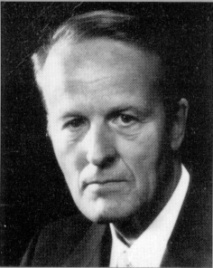

Prof. Dr. Ph.D Werner Schiebeler

Bruno Gröning –

His sensational healings

And his tragic end

Werner Schiebeler, diploma physicist, Prof. Dr. Ph. D, born in Bremen in 1923. Studied physics in Göttingen and in 1955 graduated from the Max Planck Institute, Göttingen with his thesis on fluid dynamics. From 1955-1965 worked in the electrical industry at Standard-Elektrik-Lorenz AG in Pforzheim, seven years as head of a development department for electronic teletext technology. From 1965 lectured physics and electronics at the then State School of Engineering, now University of Applied Sciences, Ravensburg-Weingarten. Appointed professor in 1971and retired in 1983. In addition to the subjects of natural-science and technology, he also taught para-psychology and para-psycho-physics from 1969 onwards at regular special lectures at the University of Applied Sciences, Ravensburg-Weingarten and continued to do so the ensuing years.

The author published numerous articles in journals as well as brochure and four books on various para-psychological topics. In addition he also released a film about the “Paranormal healing methods in the Philippines” at the Institute of Scientific Films in Göttingen. He received the “Ernesto Bozzano Price” from the Associazione Italiana Scientifica Metaphysica in 1974 and the “1st Swiss Price” from the Swiss Foundation for Parapsychology in 1988.

BRUNO GRÖNING

30. 5. 1906 – 27. 1. 1959

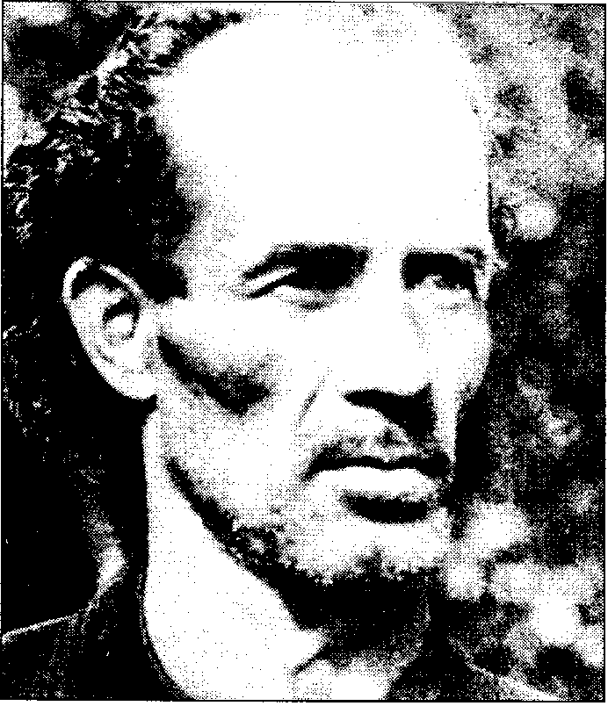

Youth and commencement of healing activity

Bruno Gröning was born on the 30th of May 1906 in Danzig (Gdansk), he was the fourth of seven children of bricklayer foreman Günkowski and his wife Olivia. He already attracted attention as a child and one thought that he was an oddball. He caught dysentery in 1915 and was at death’s door for weeks, but eventually convalesced against expectations. He left school prematurely to begin a commercial apprenticeship, changed over to carpentry and many career changes saw him work as waiter, projectionist, watchmaker, pastry cook and telegram messenger at the Post Office. He got married to Gertrude in 1927 aged 21. He soon discovered his effect on ill people. His wife thought it was all a bit whimsical, she was afraid that it would draw people’s attention and that he would be ridiculed. Their first child was born in 1931 and the second child followed in 1939. The first child had a cardiac defect and suffered from the consequences of that. Bruno Gröning did indeed heal the ill in his neighbourhood, but his wife hated him doing so and therefore kept the child away from him out of jealousy. She took it to a hospital in Danzig where the child died.

- Gröning already found out at that time that he was unable to help where patients did not desire his help.

His healing ability was paired with a certain degree of clairvoyance. He predicted the start of WWII to the day amongst other things and provided some rough information about its course.

He had to join the Wehrmacht in 1943, went to the eastern front and ended up being captured by the Russians in 1945. During his confinement he was able to ease his fellow prisoners’ discomforts and hunger edemas. Gröning was released from captivity on the 29th of October 1945. With the help of a comrade he reached Haigerloch in Dillkreis (Hessen) on the 14th December 1945. By working part-time for farmers he managed to financially keep his head above water. In 1946 he found his family (Father and siblings) and his wife and moved into a two bedroom makeshift flat. Odd jobs and joblessness followed one another.

The wife of his landlord, a Mrs. Richter, asked Gröning to treat her niece Ilse Sch. in Duisburg. She suffered from severe neurasthenia (powerful psychic irritability and a state of exhaustion). Gröning initially tried distant healing, but eventually drove to her place and cured her. The niece Ilse Sch. recommended Gröning to her acquaintances and went with him from apartment to apartment in order to help the infirm.

In January 1949, Gröning’s wife separated from him.

In March 1949, he was visited by an engineer by the name of Helmut Hülsmann from Herford who had a boy with him that suffered from muscular dystrophy. Hülsmann took Gröning with him to his house where he didn’t just heal the son, but where his “star” began to rise, that is to say, his healing abilities became known to the general public. Patients and pleas for help abounded and the press took an interest in him. People asking to be healed arrived at the house of Helmut Hülsmann day after day. Gröning had the following to say to physicians and representatives of the press on the 13th of May 1949:

“I help those that believe in God and I chase those that are possessed by the devil or are evil away from me.”

When Gröning was asked why he didn’t come forward before and why he didn’t prevent the war, he answered:

“God only gave an order now. I am only an instrument in God’s hands. There is nothing to me and I don’t want any money for the help I give. I only carry out the orders I receive from God, I cannot act differently from what God tells me. I do not heal, people are healed through me!”

Gröning had this to say (1, P. 35):

“It is within my power to only heal people that are willing to readopt the faith they have lost. This is not a hypothesis, these are God’s words. I have an inner pride, because I am one of God’s little servants. I am capable of healing people that only present me with a piece of paper, without a name or address, on which they ask me to heal them. What I say is converted into action!”

It further states (1, P. 27):

“I differ from other healers in that I do not contemplate healing illnesses or diseases. I leave that up to those that are legally authorised to do so. I also do not prescribe medicines. I refuse to hear a patient’s medical history. I also give those that are looking for treatment of their illness the good advice to see a doctor first. In a few words, I only do what everybody else must do: Help and help again. My help is however based on something else.”

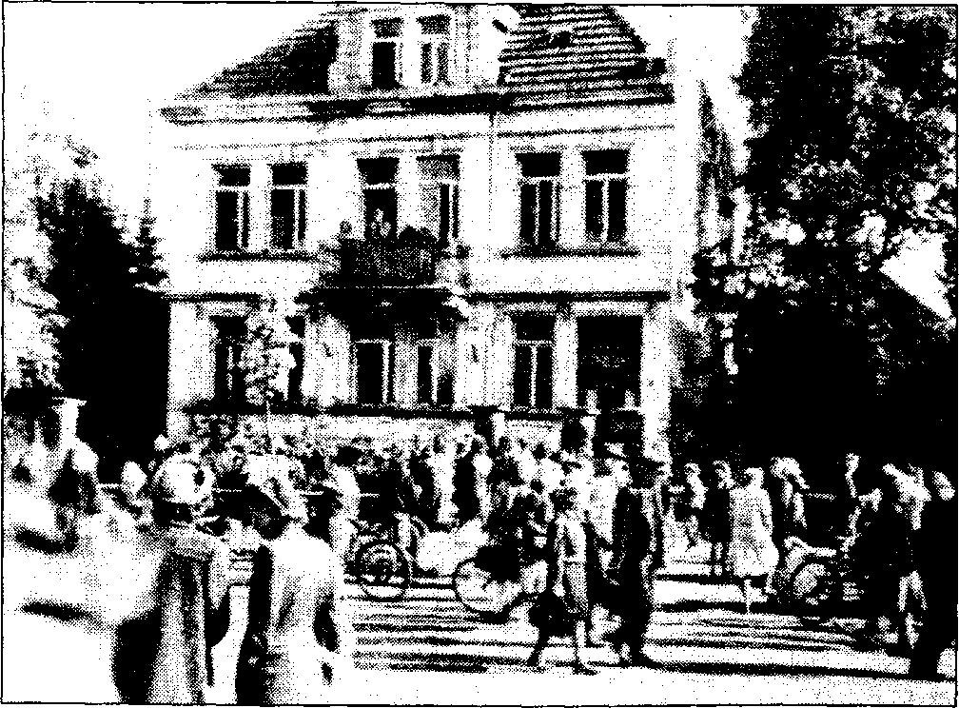

People waiting in front of the Hülsmann’s house in Herford, Wilhelmsplatz 7, in September 1949.

Ban on treatments and the last healings for the time being

The first ban in regards to Gröning’s activities was announced by the authorities at the beginning of May 1949. But it soon became clear that it could not be enforced by the police against the great number of people that camped day after day on the Wilhelmsplatz. The ill and those wasting away came in the thousands to the little Westphalian town. They came in buses, trucks, coaches, by train and on foot, by horse carriages and bicycles, hand-drawn carts, wheelchairs and ambulances. The human misery exposed here was devastating and abysmal. Patients sat in deckchairs and stretchers in the surrounding gardens and parks. New arrivals waited for days and nights to be healed. The lame, the blind, a community of misery and distress. Poor people the lot of them, it mattered not whether they sat in luxurious cars or arduously moved on crutches. Their only wish, a hundred and thousand times over, was to be healed!

A lot of them were indeed healed. The large number of cases described by E. A. Schmidt and Dr. Kaul attest to this without doubt. And then there were all the thank-you letters from healed patients, even some doctors amongst them, who wrote to Bruno Gröning after they returned home. Some of these witnesses are still alive today and can confirm what they experienced at that time.

A final and comprehensive healing ban came into effect in the 2nd of June 1949.

As this led to affrays in Herford, the local council tolerated the presence of those looking for help only for a while longer.

Then came the last evening.

Three to four thousand people has gathered at the Wilhelmsplatz in front of Hülsmann’s house on the evening of the 17th of July 1949. Bruno Gröning stepped onto the balcony of Hülsmann’s house just before 10pm and addressed those waiting one more time. His address ended with the words:

“This cannot be stopped. Healing should take place all over the world. All human beings, it matters not what nation, race or religion they belong to, are worth their while to receive help. We are all God’s children and we only have one Father and that is God. Something I do not want is gratitude. Thank your Lord. He deserves the praise if it succeeds. The good within people must oust the evil within. All will be weighted according to their deeds and if found not too light, the hope for salvation will remain. Throw your suffering from you!”

He then asked those present to go home quietly and to no longer protest. This large mass of people dispersed only slowly.

What happened in the early morning hours on the 18th of June 1949 has been written about a number of times. Here is a report by the Münchner Merkur:

“In the light of the early day, Bruno Gröning once again turned to the waiting cars full of severely ill patients. This was a procession of miracles for us there and those that could witness this, not a bellicose procession, but a triumphal procession of a placatory and helping power. Nobody was immune to the power of the situation. Lamed limbs of children suffering from constant cold pressures became warm again. Bruno Gröning climbed up to one Truck to another, went from person to person either laying on straw or mattresses. They sat up and felt full of new energies.

In one of the truck, visible to all there, was a 70 years old woman who was completely paralysed, the driver told me that she had been carried to the truck in an armchair. After a few words from Gröning, she moved her arms, stood up and when the truck moved off, she turned to the throng of people standing around with a smiling face and waved her arms and hands that had been so utterly motionless up to then. This continued in this way with wagon after wagon until the square gradually emptied: This was the last and probably also the most successful public act by Bruno Gröning from Herford. The ban on his activities came into full effect from that moment on.”

- Gröning talked to the patients during the healing procedures, but he didn’t touch them, ergo didn’t lay his hands on either. He didn’t make any diagnoses and didn’t prescribe any medicines. He never ever tried to encourage the patients to forgo medical treatments.

The superintendent of the Church diocese of Herford, Preses Kunst, expressed himself as follows about Gröning’s effectiveness at that time:

“The fact is that people known to me have gotten rid of old complains and display a new sense of vitality since their visit with Gröning. Miracle workers have often been active in the Ravensburger region. I have asked a lot of people the cardinal question: “Do you believe that Jesus Christ is God’s son?” All of those that I asked became self-conscious and couldn’t give me a definite answer. One has to conclude from this that they are somehow connected with the powers of evil.

I also asked Gröning the same question. He gave me a clear answer: ‘Yes, I do believe that Christ is God’s son.’ This impressed me very much. According to the New Testament there is an important point of view in regards to God’s special gifts, namely that they are placed at the disposal of the community. I have no reason to doubt that this is the case with Gröning.

The apostle Paul writes in the New Testament in his first letter to the Corinthians 12, 7 – 10: ‘The Spirit’s presence is shown in some way in each person for the good of all. The Spirit gives one person a message full of wisdom, while to another person the same Spirit gives a message full of knowledge. One and the same Spirit gives faith to one person, while to another person he gives the power to heal.’ The pastors here in Herford have told all the members of our community who asked us for advice that we haven’t come to a final decision yet. We did not dissuade anyone from going to Gröning. But before they do, they should ask the Lord to protect them from being healed by the powers from below. Gröning is aware of this advice and he assured me that he understood our concerns very well.”

Medical-scientific examination of healing processes

The press and also individually interested doctors have in the meantime concerned themselves with the “Gröning” case. After Gröning’s healing activities had come to an end due to pressure from the authorities, the Illustrated REVUE in conjunction with psychotherapist Professor Dr. von Weizäcker organised a medical examination of Gröning’s healing procedures. The REVUE’S editorial office rented a house in Heidelberg, this is where the examination should take place and this is where Gröning went to live for a number of days as of the 27th of July 1949. The monitoring of the tests was placed into the hands of the internist Dr. Wüst from the Heidelberger Ludolf-Krehl-Klinik, the Marburg psychologist Dr.H.G. Fischer and the Marburg psychotherapist and physicist Rolf Germer. Some of the patients to be treated came from the Ludolf-Krehl-Klinik and some were selected from the 80,000 who had personally written to Bruno Gröning asking for help. These letters were transported from Herford by truck.

The selected patients were pre-examined by Dr. Wüst at the Heidelberg University Clinic. After their treatment by Gröning, a follow-up examination determined changes within the subjective and objective state of health of the patients.

The examiners ascertained the removal of long term afflictions of the patients by Gröning, as it had happened on numerous occasions in the past. One case was however unsuccessful.

It wasn’t normally a case where Gröning would only look at and talk to the patient about trusting in God, he often engaged them in detailed, healing promoting conversations. Here is a short excerpt from one of the sound recordings:

Bruno Gröning treated Mrs. Else Joest who had suffered from severe and painful intestinal complaints for over 13 years.

Gröning : (linguistically awkward) I ask you to not think about your affliction. Concentrate! Switch thoughts about external things off… - observe – a lot of things will catch your attention, fully and completely concentrate on your body. Shall we start? Backwards has also its merits! (Often used, but strange formulation)
What can you feel within your body? – Is a wave coursing through your body? – I am not trying to put words into your mouth, not that you have to assume that you “have to say yes” here. You don’t have to do so. Concentrate on how I say it and whether it conforms to the truth. It matters not if you say no once in a while – some feel it easier whilst some don’t. You don’t have to paraphrase what I say, just tell me the truth – and we will make progress. Don’t think too much about your affliction, this interferes with what I do, I can’t quite get there. It doesn’t have to be like this.

(Gröning turned to Mrs. Joest):

Gröning : What is wrong with you?

Joest : I feel very heavy.

Gröning : Is something happening in your abdomen now?

Joest : Yes – a pulling and lifting.

(Gröning turns to other patients for a few minutes.)

Gröning : I just noticed a twitch in your body.

Joest : Yes!

Gröning : Does the right side pull?

Joest : Yes – as if everything was pulled together.

(Gröning busy with other people.)

(Mrs. Joest’s arms are starting to shake.)

Gröning : Everything seems to be pulling together inside – what about your lower back?

Joest : Very painful – but a different pain than normally. I feel a pulling on my left side.

(Gröning busy with other people.)

(Mrs. Joest feels a pull in her lower back and warmth in her kidney region.)

Gröning : What are your kidneys doing?

Joest : They are getting warmer.

Gröning : Could one say – hot?

Joest : Yes!

Gröning : You now have that pulling feeling again like the first time. You feel as if everything is organising itself within your bowel, as if order is established.

Joest : Yes – there is a lot of work going on.

(Gröning busy with other people.)

(Joest feels pressure in her lower back.)

Gröning : Still happening?

Joest : Yes! –

(A longer pause.)

Gröning : What’s happening to your lower back?

Joest : It feels lighter.

Gröning : It moved downwards.

Joest : Yes! – I suddenly have a strong impulse!

Gröning : Very severe?

Joest : Yes – I have to go to the toilet immediately.

Gröning : Please go.

(Joest leaves the treatment room and is away for 8 minutes. She then returns.)

Gröning : You were successful, weren’t you?

Joest : (Happy and bewildered) Yes!

Gröning : A lot of stool? A complete evacuation?

Joest : Yes – the first time in 13 years without a laxative.

Gröning : Sit yourself down again. – The process in your body is still going on.

Joest : Yes –I am still very hot. But so light, I am not used to this.

Gröning : It will be this light for you from now on.

Follow-up examination

This success made a particularly strong impression on Dr. Wüst, because he intimately knew this woman’s history of suffering. The end of her extraordinary sever chronic constipation happened after a short treatment by Gröning and it was of lasting duration. The evacuation of her bowels took place at exactly 8am every morning from then on. One can surely assume that this case is healed, particularly if the existing tension in her marriage about having children can be resolved. One would then have to clinically establish whether the myomas of her uterus is reduced or completely disappears after conception.

Of particular interest is the following case that was treated in Heidelberg.

It concerned a semi-skilled worker be the name of Strobel. He had been suffering from a painful rheumatic illness (Morbus Bechterew) since 1945, this led to a considerable restriction of movement of his spine and it caused him great pain when walking. He could only enter the treatment room with great difficulties.

The treatment through Gröning happened in the same way as with Mrs. Joest with the result that his difficulties with walking and his pain was largely removed. A certain restriction of movement and sensitivity in regards to pain of the cervical spine however remained.

And now comes the significant bit:

Psychotherapist Rolf Germer subsequently treated patient Strobel in the same way with words and suggestions as Gröning had done before. Surprise, surprise, the rest of the discomfort felt in the cervical spine also disappeared after Germer’s treatment. Whether one was dealing with a genuine healing could only have been determined after years, because Morbus Bechterew is a chronic, spine-stiffening decease that creeps up incrementally and can also show spontaneous, temporary remissions.

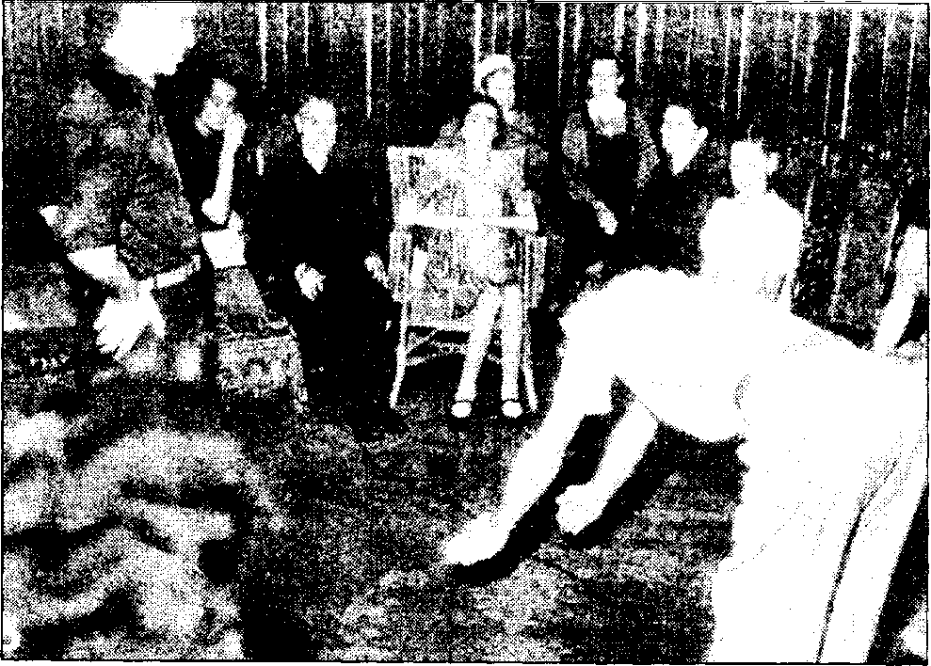

Gröning allows the patient with Morbus Bechterew (Strobel) to do movement exercises.

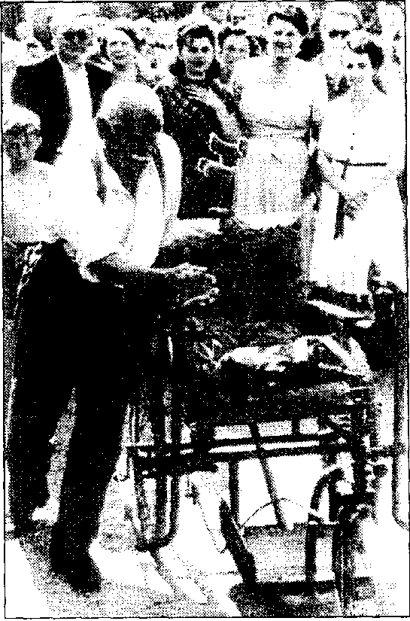

Healings sometimes took place with Gröning when he didn’t hold long conversations with his patients.

When Gröning was in Munich on the 25th of August 1949 in order to treat a few patients in front of a number of physicians, hundreds of people had congregated in front of the house also hoping for help. When Gröning left the house through the gate, a 71 year old man by the name of Johann Haas, he had been a paraplegic for four years, tried to find his way through the throng of people in his wheelchair. When Gröning became aware of this, he asked the people there to make room for this person. When he sat in front of Gröning in his chair and beseechingly looked up, Gröning said to him:

“Stand up and walk!”

This person got up from his wheelchair without hesitation and said to those around him with tears in his eyes:

“This is the first time in four years that I have managed to stand.”

He walked towards Gröning in order to embrace him. He then went home pushing his wheelchair in front of him.

Assessment by the doctors in Heidelberg

The examiners’ summarised their assessment about the Bruno Gröning’s actions on the 7th of August 1949 as follows (an abridged version):

“Bruno Gröning is not a charlatan, not a hypnotist, not a witchdoctor, but a talented, non-medical psychotherapist. With his childish-natural but also religion based empathy, he endeavours to help people with their mentally induced suffering (psychogenic suffering) and to heal the associated, mainly “organically” appearing illnesses (psychosomatic illnesses). He does not pretend to be a prophet or a messiah. He is however a credulous thought-consciousness, something that was indiscriminately propagated and his successes are overemphasised by the press and more powerfully supported through blind veneration or the calculated adoration within his environment than is usually the case with trained, medical or non-medical psychotherapists.

His decisive basic talent for this is his above-average mental capacity for empathy for other people. It is in connection with a natural talent to deal with people. Both of these idiosyncrasies stem from his optimistic and immediately attractive character that is additionally supplemented by his clear cut self-assurance. All of these characteristics are important to a psychotherapist and they are present in him to an extraordinary extent.

Is a ban on healing justified?

This ban was obviously the result of a certain feeling of helplessness in regards to the stampede caused by those looking to be healed. It is partially based on the lack of understanding of conventional medicine for all mental healing, ergo psychiatry. This arose from the fact that after Gröning offered to have his healing powers verified, one demanded the healing of purely organic and even hopeless illnesses. This ban was on the other hand supported by the justified concerns about the insufficient reliability of a medically untrained healer who is unable to see the boundaries of his healing abilities.

Are there also concerns about Gröning from a psychotherapeutic point of view?

At this point in time – yes. We ascertained that with patients where the mental conflicts still exist because of a lacking or incomplete assessment of the causes for this conflict (analysis), his rapid grasping method of diagnosis can sometimes even create life-threatening complications.

Secondly, there is also the danger that Gröning, due to the lack or insufficient diagnostic capabilities, only removes the illness’ physical appearance. This is for instance the case with alarming pains that are the symptoms of a life-threatening, rapidly advancing illness. A psychotherapist can also quite easily remove this pain. He will however reject the idea of removing the pain caused by an inflammation of the appendix, because it doesn’t remove the infection, but might however keep the patient from being operated on in time.

Thirdly, Gröning dos not control the “contact problem”, that is to say, the mental connection and release of the personal relationship between the psychotherapist and the patient, to a degree where the patient will become sufficiently independent at the end of the treatment. The treated person quite often ends up in an unfortunate state of suspense or even of bondage to Gröning.

Last but not least, he probably overestimates certain clairvoyant influences coming from him that play a part in his work and that give his healing activity an unclear picture (for instance with remote-diagnosis and remote-healing). These problems must be subjected to scrutiny at a later date. But they basically do not touch upon the way we described his work methods.

What is our attitude towards accepting Gröning?

The above mentioned concerns – in spite of basically approving Gröning’s aim in life to heal – do not allow an unconditional acceptance of Gröning for now. There has however been sufficient evidence from earlier co-operation with him to make us hope that Gröning can be trained into a reliable psychotherapist with the co-operation of physicians. It is therefore necessary to discontinue with districting him through a ban. For those that seek to be healed to visit a doctor that is prepared to allow Gröning to work in his practise is expedient. Further opportunities might arise from the co-operation between Gröning and sensible physicians modelled on the Heidelberg examinations, but to protect the interest of science and naturally also the patients, they must stretch across a period of time of at least four months. This gist of this is that one cannot dismiss Gröning’s by banning his activity. In the interest of science and patients one must explore Gröning’s methods in detail and make it accessible to other psychotherapists. One must provide Gröning with the opportunity to continue his work accordingly.”

As benevolent as this advisory opinion was for Gröning in one respect, it was a hindrance in another respect, because it didn’t advocate the immediate resumption of his healing activities. The authorities and the courts based any further decisions on this.

Gröning’s work at the Traberhof by Rosenheim

When Gröning still worked in Herford, Leo Harward, the owner of the Traberhof (stud farm) in Happing by Rosenheim, wrote asking for help for his sister-in-law who had been paralysed for ten years. If Gröning was willing to come, the Traberhof would be at his disposal to establish a homestead for all those looking to be healed. Gröning accepted this invitation. After a short stop in Munich on the 19th of August 1949, he continued his journey to the Traberhof. Not only the sick should be healed there, but documentary films should also be on the agenda.

The same situation as in Herford came about in a very short time, that is to say, great masses of people looking to be healed arrived in order to experience Gröning personally. On the evening of the 28th of September 1949, hundreds of people had assembled in front of the residence of the Traberhof and waited for Gröning to appear and to experience his power to heal.

The Rosenheimer Zeitungsblitz (6) reported:

“Dusk has now completely established itself. Sunlamps are aflame all around and movie cameras begin to silently record. All other sounds completely abate and all eyes are on the balcony where Gröning appears at 20:15 accompanied by his host, his co-workers and the healed. This is followed by minutes of complete silence wherein mankind’s great helper folds his hands and looks up to the sky. He then established complete contact with his faithful seekers of a cure by looking at each individual’s exited face.
With his warm and sympathetic voice Gröning now begins to say a few simple and deeply pious words, words that are capable of captivating the imagination of so many:

‘My dear seekers of a cure! As on any other day, people are assembled here, poor and tortured people, that are seeking and finding a cure for their ailments. But also those that have been driven here out of pure curiosity and a few that are well aware that they are sceptic. I sense this acutely and I ask them to veil their thoughts and to allow themselves, first and foremost, to be convinced by the facts. We are not dealing with slights of hand and cheap demonstrations of miracles, the hour for this is too serious and the suffering of the people around me too great.

I didn’t ask anybody to come here, on the contrary, I asked you yesterday to wait for the day when I can give you help under ordered circumstances. Those that do not believe in me no longer have to turn up!

I know that lots amongst you are heading towards being healed at this very moment! I intent to remain here in Upper Bavaria and I ask you to be patient until I am given permission to heal in public and the healing centres have been chosen. Only those that carry the divine faith within them have a right to be healed. There are unfortunately those that have either lost this faith years ago or have dragged it through the mud. I have them know that: The only doctor, the doctor for all people is and remains our Lord! He alone can help! He does however only help believers, those that are willing to discard their old afflictions. They do not have to believe in little Gröning, but they must have faith in me. I don’t expect their gratitude, God alone deserve it; I only do my duty.

As they are not enlightened I have them know that they can leave their financial worry at home, but they have to bring their ailment and a lot of time with them so I can rob them of them. All of you should show your human side and not be spiteful, not false, not do anybody any harm and never be envious. The best and greatest gift in this terrestrial life is not riches, not money, but your health and it is worth more than everything that is good here on Earth. They have heard from my co-workers about how they should behave so that they can feel the best possible effect. I will not conduct a public healing here! I have to reliably know that I am allowed to heal in public. It has however always been the case that people that were near me have been healed. You don’t have to tell me what you’re suffering from, I can see through you and I know all there is to know about you!’

Gröning exhibited the power of his influence with a few simple examples that were confirmed by people shouting from the ranks and he then continued:

‘Every one of you received what you wanted; but only those that feel connected to their Lord. I will establish, if everything goes well, a number of sanatoriums from here to help all of you and this in close co-operation with physicians. To all of those that came here on behalf of their sick relatives I can say: I am already with them!

When they get home they will find that the patient at home is no longer exactly the way they left him!’

A long, sustained applause thanked this selfless man for his words.”

Approval by the Chief of Police

The Munich Chief of Police Pitzer unexpectedly and spontaneously emerged from the background:

“My dear Rosenheimers! I speak to you here from my personal experience. I have come here first and foremost as an ill person, but also as a Bavarian civil servant and observer. Never in all my life have I received such an excellent diagnosis, not even from the most famous professors, as I received here from mister Gröning and this within a few seconds without him even touching my body. I personally believe in my cure and I will carry the responsibility of what is happening here to the highest governmental authorities whether certain gentlemen like it or not, you know which ones I am talking about. What is of importance is that sick people are helped. I have been engaged in my work for four years and ended up with a severe affliction and I sacrificed half a fortune looking for a cure. I am speaking on behalf of myself and on behalf of all of you and this must be heard everywhere, because I have to remain healthy for all decent human beings. I thank you mister Gröning for your help. May the Lord give you the strength to help all the people that come to you with a strong faith and an open mind.

Continue to show complete trust in Gröning’s healing powers and help to overcome the last difficulties. My friends in parliament will make sure that one day, maybe soon, Gröning will receive his license to heal.”

Thereupon Hagn, the CSU Member of Parliament had this to say:

“I wasn’t actually going to say anything, because I had a very sceptical attitude in regards to the Gröning affair and I wanted to personally convince myself about what is going on here. I have experienced such a lot of shocking things today that words fail me to describe them. More I cannot say. I ask all of you, please believe in Gröning’s calling!”

The thunderous applause of the exited masses once again roared.

Below is the above translated newspaper article.
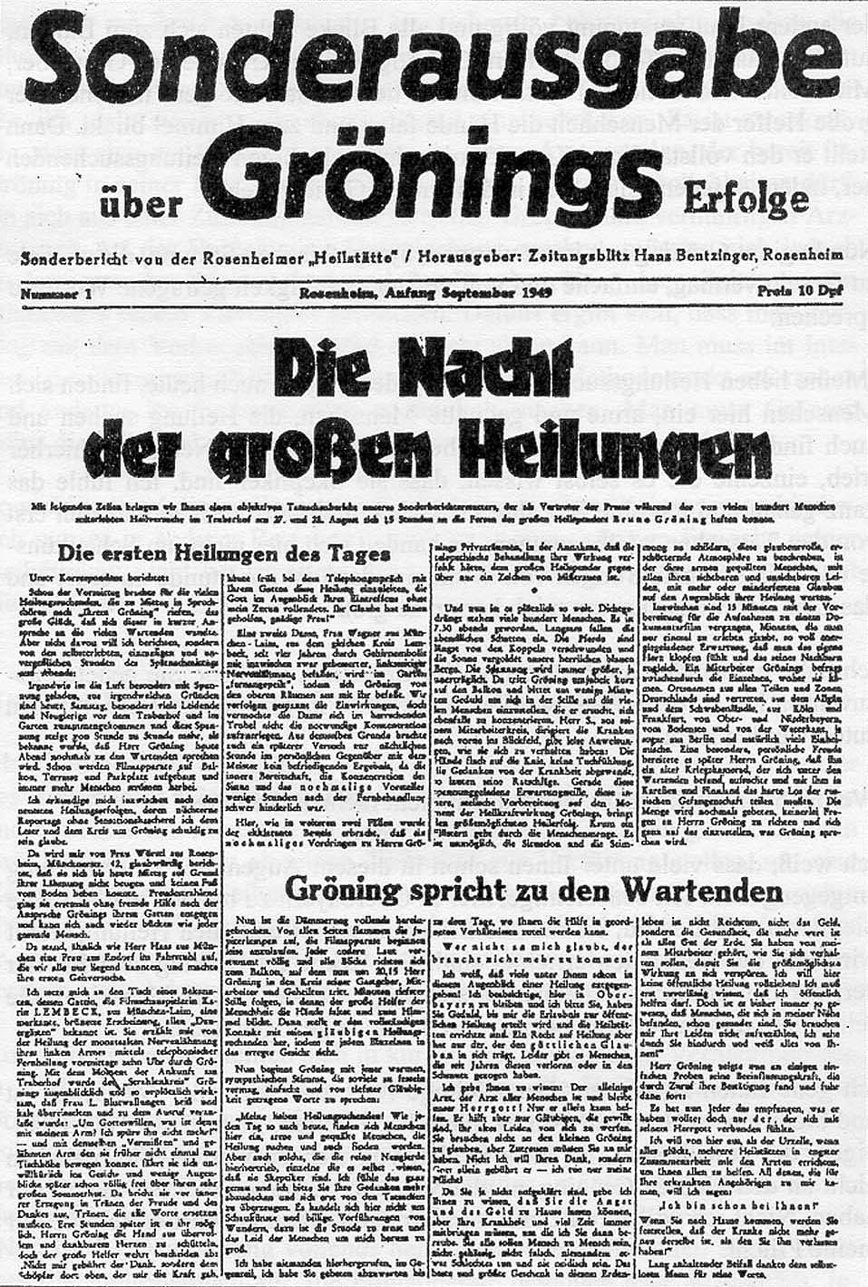

Press conference

After a temporary absence of Gröning, an initial conference of the entire Bavarian Press was held at the games room of the Traberhof a few days later and its course was recorded as the closing scenes in a film produced by the Engler Film AG.

A doctor from Munich, Dr. Zetti, who had unreservedly found his way to Gröning and who was against teaching the great master of the art of healing the basic principles of anatomy, in a clinic for instance, spoke first. He literally said:

“We physicians can and must learn a lot from Gröning, because it has been irreproachably verified in hundreds of cases that the little Gröning has helped and healed where science and medical knowhow have already failed. Not how, but that people are healed is the thesis and demand of the day!’

Gröning’s legal advisor, Mr. R. A. Roedel told the press:

“There is no law against Gröning’s healing method, because he predominantly helps where all medical artistry was unsuccessful. The concerns of the population is justified. Mankind’s great helper will leave Germany if Bavaria will also officially ban his healing activities. One cannot demand from a man like Gröning to have to work as an orderly for months at a clinic in order to placate some bureaucratic law, whilst hundreds of thousands could be cured from their illness through his methods during that time. The legal profession will find a legal avenue to guarantee Gröning a free hand as soon as possible.”

Gröning then spoke himself and he asked the representatives of the press to help these poor people by making true and objective reports, free from all sensationalism and profiteering and not cause severe mental anguish through garbled reports to those already healed.

“I say to physicians, Gröning continued, ‘leave these poor people in my care, people you have already written off, people you can no longer help, because the best and greatest healing successes have been achieved with these hopeless cases up to now!’

My power is not a human, but a divine power and I live with it and die with it. I help all those that believe in our Lord. I will however not consider subjecting myself to further medical or scientific scrutiny, because I have provided the evidence of my healing power a thousand times over.

Wherever I go I find thousands of people I am asked to and will help, but wherever I go I also find the word ban appear! I co-operated with a couple of eminent physicians to begin with, they undertook the preliminary examinations of patients to then irreproachably verify the healing after. This is how it is going to be responsibly handled at the healing centres yet to be constructed. The things I have been able to do for my patients up to now has only been about 5% of my healing power.

But I am not a physician or a miracle worker, I am and will remain the little Gröning, a poor individual in financial regards, but I do not need and do not take money. My riches are my divine power to heal and nobody can take that away from me.

My diagnoses have been 100% correct up to now even though I haven’t actually seen patients in many cases. Wherever they may be, I am still able to analyse the patient’s past, present and future, because I am able to tell them what is going to happen today, tomorrow and the day after tomorrow. In spite of my charitableness I am a captured individual, because wherever I go I am surrounded and persecuted by people looking for help, by people that trust in me, but also by people that want to destroy me. All of you must be aware that it is easier for me to heal a thousand people all at once than a single individual, because I have to work through the whole body in specific cases.”

In spite of the intersession by a number of physicians, lawyers and officials (Chief of Police), Gröning did not receive a ministerial license to continue. Something that was particularly inauspicious for him was the fact that “co-workers” attached themselves to him in order to get financial gains from their activities. Gröning himself did not ask for money from the infirm, but these “co-workers” in charge of organising this and who decided who would see Gröning directly, accepted money for what they did. He allowed this to happen for a while.

One of these “managers” was an Otto Meckelgurg, he even founded an association to investigate and promote Gröning’s healing methods, who declared himself the association’s chairman. He granted himself a monthly salary of more than DM 1,000.00 plus expenses. He unscrupulously selected those amongst those looking for help according to their financial capabilities. According to Meckleburg’s own admission, Gröning revealed that Meckleburg had procured over DM 100,000.00 from his activities. (1, P. 177). After having a bitter time learning and experiencing, he cut his ties with Meckleburg on the 10th of July 1950.

Balls of silver paper for patients

At that time he started to distribute small balls of silver paper (made from cigarette paper). They were supposed to assist the flow of healing energy. When asked about their pertinence Gröning said (1, P. 104):

“Just the way the Church gives its believers pictures of Saints, charms and lots more to constantly remind them of its doctrine, I give my listeners balls of silver paper or silver platelets to remind them of my words. The balls that I distribute to my listeners during my lectures or at the end of my lectures are the symbols of my followers. What my friends do with them is up to them. Some of them have these balls with them all the time. The way members of federations and associations have a needle, a badge or something similar on their lapel, my friends display, respectively possess these balls.

- A symbol always has a meaning. A ball is the symbol of maximum unity, maximum energy. The cross impressed onto the surface of the ball is firstly a reminder and secondly a symbol. It is a reminder in regards to the death on the Cross of the greatest healer, our Saviour and as such an admonition to all human beings that oppose the sacred salvation.

People ought to be reacquainted with spiritual energies, even the so-called enlightened ones. They should re-learn to use them for their own advantage, for regaining and maintaining the divine order. As civilisations progress, people lose the ability to behave naturally and to utilise and mobilise their inner powers. All I want to achieve with my lectures is for my fellow human beings to realise that it is first and foremost up to them to bring about an inner order to their life. Almost everybody has to realise that they have become blind in regards to divine energies. This is why I draw the attention of all of my listeners to the natural forces residing within us.”

Lecturing

After his time at the Traberhof by Rosenheim, Gröning spend some time at various places where he held numerous lectures about his belief doctrine. This is when sensational healings took place sporadically and they unfortunately played a major role during later court proceedings. I will list a few of Gröning’s statements below in regards to his doctrine and activities:

“My selfless sacrifice to help people isn’t always made easy for me. One like to put me in front of a tribunal quite often. This is due, as far as I can tell, to the fact that:

1. People no longer know anything about the natural, divine forces or are able to believe in them and

2. no longer want to believe in them, because they are slaves of their own methods and experiments and do not condone the fact that an untrained person surpasses their endeavours.

These ignoramuses, incompetents and envious people have justified all available means to degrade me by accusing me of trespassing against their healing practices. On could therefore never talk about a doctrine of the person ‘Gröning’, because according to the basic law, the dissemination of any doctrine should be free and untouchable. This is why this is easy to explain: Gröning must be combated with all available means, because even the authorities explain that I earn my livelihood through healing people. They look upon this as a commercial enterprise. Here is a short answer to all the evil and misinterpreted information:

I can assure my friends that I will continue to help as often as I am called and as often as one needs me. In spite of great resistance and hindrances I will never fail you, even if my work takes me to the United States.

This task of helping people is not about the person that is Bruno Gröning, but about those that are needy. We, that is to say, you and I are beholden to God, because He has arranged it for us in such a way that we can help our fellow men. I am nothing but a person that has remained natural.

My body is also subject to illnesses if I allow disorder to rise within myself.

Thousands of my fellow human beings confirm that their condition has improved or has been healed and they are also prepared to swear an oath on my behalf. Let me tell all of them that they experienced a cure themselves, that is to say, their own body has.

I do not heal, but IT leads people through my belief-doctrine to their cure and besides, I do not make a living from it, but for it. We find a passage in Goethe’s ‘Faust’ that states: ‘I am part of that power, always wanting evil and always creating good’. This is the reason why I find it necessary to thank all those people who helped me become what all my enemies did not want me to become, by attacking me with mostly imagined and dirty means. I am accurately aware these days that I can really help the helpless and that I will do so. I see it as my duty and my obligation to help my fellow man out of pure brotherly love. Even Bismarck said: ‘If God gave the power to help (heal) people, the police has no right to take it away.’

Who has the right to forbid another human being the knowledge he puts into action, particularly if it is rooted within the divine? Today’s sciences would have to show an interest in me, mainly because my activities provide an impetus for research and this should be their task for tomorrow. Hasn’t it always been the case that people’s minds criticise and even deride anything ‘New’ until the true core of the matter shines through and the truth become reality?

Faith provides the power to heal

My words, or better say my faith in goodness gave me the strength to help people. The up to now non-believer adopts the belief in his health through this, because the reality is that it is divine order anyway. As he continues to live within divine order, he will feel free of all discomforts and turn into an affirmative buoyant human being, that is to say, he affirms goodness, ergo God. It will be easy for him to fend off all discomforts the body can be susceptible to in the future.

Christ said: ‘Not I, but your faith has helped you.’ But he only said this so that we should believe in all the things we need in a positive sense and that we no longer sin from then on. This is the reason why I like to say often: ‘I do not heal, ‘It’ does. To trust and to believe helps; the divine power heals. – In a nutshell, I only do what everybody else must do, help and help again. To continuously give people good advice, because they expect the good and they need it. We as human beings should basically act according to Christ’s doctrine, that is to say, simply do as he taught us. When people can once again believe in the truly divine, they will experience wellbeing themselves, particularly if they know how to convert faith into action.”

On the 21st of June 1956, Gröning said the following in court:

“Is it culpable for me to show people the way of how they can regain their health and find the correct path in the process? Thousands of allegedly incurable people could be healthy again if they knew about it. I actually do nothing else but draw people’s attention to the fact that it depends on their will whether they regain their health and I show them what they have to do to establish inner order. It has been verified a thousand times over that people who followed my advice began to enjoy their life again. This has been faultlessly verified though interrogations by the police. I have plenty of evidence that my religious lectures managed to give a lot of people a completely different outlook on life. I do not inflict any damage through my activity, on the contrary, I help wherever help has been denied!

When an ill person feels well again after accepting and implementing my doctrine, I ask him to have his state of health verified through a thorough examination by a doctor. I never stop anyone from consulting a doctor, on the contrary, I always advise them to see a doctor and to trust in them. It helps the patient as well as the doctor if an ill person shows trust in their doctor. Or is this also against the rules?

Gröning said the following at a lecture in Krailling, near Munich on the 5th of October 1950:

“My dear friends!

Today I have once again the honour to speak to patients. Another ban has been placed upon me, because individual people do not allow me to heal ill people. For anyone to forbid me to do this is not appropriate. God only knows who has done this and why. I emphasise here that I never ever thought of barring people from the work I do and that I don’t accept the fact that such a ban has been placed on me. When I received the written ban in Herford last year, I said that there is no human law that forbids such things. Only one law is of pertinence for me, namely the divine law and it does not forbid this. I also said: One may stick me into a barrel and bury me in the ground. Whatever happens, happens!

Ever since I received the written ban last year I have not talked about healing. I have however proven to people that I don’t have to personally stand in front of them. I verified this in Hamburg, Herford and other places and at the Traberhof, even though I wasn’t there, masses of remote healings have taken place at these locations. None of the people that were healed knew where I was. And this is why I stand first and foremost as a guiding post for the less fortunate people that guides people back towards the truly divine path. I rebuilt the bridge they cross to get to this divine path.”

The start of criminal proceedings

If Gröning thought that one couldn’t touch him because of his religious healing-lectures, he was mistaken.

Criminal proceedings against him started in March 1952 at the Schöffengericht¹ München-Land because of illegally practicing medicine. According to the adjudication from the 19th of March 1952, he was acquitted due to insufficient solid evidence.

But as the prosecutor appealed at the Landgericht München against this judgment, a second judgement was forthcoming that confirmed the judgement of the Schöffengericht on the 8th of July 1952, because Gröning had made an unpunishable error in regards to practising his medicine and that he therefore didn’t act premeditated.

This however did not enunciate in any way a license or tolerance of his previous healing and lecturing activities. But as he continued with his activities, the prospect of having to face a new process in the near or far future was on the cards. His endeavours to gain a special dispensation for his activity in Bavaria and Baden-Württemberg had actually remained unsuccessful.

He therefore receive a new bill of indictment from the Schöffengericht München-Land on the 4th of March 1955 that stated: Bruno Gröning is under sufficient suspicion to have:

1. Wilfully and repeatedly conducted his healing activities in one case, thereby continuing his activities without proper authority.

2. Carelessly caused the death of a person in another case.

1 Schöffen(gericht) (from Old High German sceffino, the arranger) are in Germany and Austria honorary judges who participate in the main proceedings of criminal cases.

Accusation of involuntary manslaughter

The serious accusation of involuntary manslaughter had now been added for the first time. This came about as follows:

Saving bank teller E. Kuhfuss from Säckingen drove with his 17 years old daughter Ruth, who suffered from severe lung tuberculosis, to Gröning in Bad Wiessee in order to ask him to heal his daughter. The daughter had been treated by a specialist for some time and was in the process of being admitted to a sanatorium a few days later.

Gröning treated this patient on the 5th of November 1949 and asked the father to have some x-rays taken on his return to Säckingen in order to satisfy himself of the progress of the cure.

The prosecutor now asserts that Gröning had on this occasion forbidden them to engage in any further outside medical treatment. Gröning energetically contradicted this assertion during the court case. He asserted that after having been urgently asked by the father Kuhfuss in writing, he personally visited his daughter in June 1950 in Säckingen and to have asked her whether the recommended x-ray examination had taken place on the 5th of November 1949. The answer had been:

“Yes, the examination had taken place, but a thorough inspection had not shown an improvement. But I feel well just the same and I am very pleased with everything.”

Gröning said that he further inquired whether the daughter was once again under a specialist’s care. The answer was: Yes, this was the case and that the female doctor was indeed astonished that the patient was actually still alive.

The public hearing didn’t take place until July 1957.

The court process was conducted very adversely on behalf of Gröning. – Complaisant witnesses were not even allowed admission at court and favourable medical opinions were not taken into consideration. – His lawyers’ minds weren’t really on the case. Gröning later complained:

“Nobody during the whole process, neither the judge nor my two lawyers, showed an interest in how a healing takes place. If one of them had asked and shown an interest in it, they would have known the truth, namely that I am innocent of both charges.”

After hearing the evidence had been completed on the third day of the trial on the 1st of August 1957, the public prosecutor held his closing speech and explained amongst other things that any activity involving the healing of people was covered by the laws of naturopathy. Patients had attended Gröning’s lectures because they believed in the nimbus, ergo aura of the man, namely that he could heal people. They didn’t attend because of the actual lecture, because as a poor copy of biblical accounts it had no real value, they were there to be healed. This is why Gröning’s activity had to fall under the laws of naturopathy, especially as they had been conducted on a commercial basis, ergo in connection with an income. It mattered not whether the amounts paid were as a voluntary donation or charged entrance fees, set contributions the accused lived of had been guaranteed in any case. As he had been warned three times already, he couldn’t use the excuse that he wasn’t aware of the culpability of his actions.

Because the accused had acted reckless and repeatedly contrary to duty, the prosecutor asked for ten month in jail, plus an extra three months for breaching of the law of naturopathy. Bruno Gröning also had to bear the cost of the process. The balls of silver paper and gold platelets in large packets on the judge’s table were to be confiscated.

Gröning’s defence lawyer solicitor Dr. Schwander from Heidelberg dealt with the accusation by the prosecutor to begin with, namely that Bruno Gröning had consciously trespassed against the laws of naturopathy because he had already been warned against doing so. It would not have been clear cut in 1950 whether Gröning’s lectures came under the laws of naturopathy and that they were therefore punishable by law. Solicitor Reuss thought it unlikely that Gröning’s lectures were of a criminal nature and advised him accordingly. Psychotherapy was also not covered by the laws of naturopathy, because it also dealt with mental processes as with spiritual healing, something Dr. Gemassmer had also demonstrated. Bruno Gröning had verified a hundred times over that this is the way he heals. He as a solicitor was also not covered by the laws of naturopathy when he tries to mentally support his female clients that want to get divorced.

First verdict

After the court had withdrawn for an hour and a half to consider the facts it pronounced its judgment:

“Bruno Gröning is fined DM 2,000.00 for illicit healing practices.

In regards to culpable homicide he is acquitted, because the disease Ruth Kuhfuss suffered from had already deteriorated her health whilst she was in proper medical care and because Gröning had never banned her from making contact with her family doctor. The patient had indeed felt better for a while after her visit to Gröning.

Legal costs were to be covered by the public purse.”

Gröning changed his lawyer when the public prosecutor once again made an appeal. New court proceedings lasted from the 14th to the 16th of January 1958. The public prosecutor demanded 8 months in jail for negligent homicide and a further 3 months for repeated breaches of the laws of naturopathy for financial gains, 9 months altogether. An additional fine of DM 1,000.00 and the costs of the court proceedings. A jail term of 5 years was supposed to be converted to 5 years on probation.

Gröning had sent his new defence lawyer Dr. Grasmüller a long letter on the 9th of January 1958 wherein he asked him to emphasise certain points of his defence. He however didn’t do so and instead started his summation with the words:

“I wasn’t even sure whether the accused would be sentenced. Any further defence is actually unnecessary. I will however examine a number of points in regards to causality.”

This summation wasn’t all that encouraging for Gröning and certainly not an effective defence plea. The verdict was therefore accordingly:

“Bruno Gröning is sentenced to eight months in jail because of negligent homicide in conjunction with a 5 year probation period. Because of the misdemeanours against healing practises he conducted in order to gain a profit, the previous fine is raised to DM 5,000.00 plus court costs.”

His defence lawyer appealed against this sentence at the Bavarian High Court on Gröning’s behalf.

Gröning had in the meantime written two letters to the then German Chancellor Dr. Adenauer to ask him for the authorisation of a special approbation for his healing activities. Adenauer answered that as chancellor he did not have the right to make decision that contravened the justice system. He couldn’t and also wouldn’t do so.

The appeal trial

And so it came to an appeal trial on the 22nd of January 1959 in front of the Bavarian Supreme District Court in Munich.

Gröning was not required to be there and he couldn’t either, because he was in a cancer clinic in Paris for a second operation. He had already been operated on for an advanced stomach carcinoma on the 8th of December 1958.

He suffered a closure of the colon and this necessitated the second operation on the 22nd of January 1959.

As a general metastasis had set in, Gröning died on the 26th of January 1959 at 1pm. His urn was taken to Dillenburg.

Bruno Gröning’s former defence lawyer Dr. Andreas Grasmüller had this to say to Gröning’s second wife Josette four years later on the 30th of July 1963:

“In regards to your enquiry about the criminal procedures against your husband Bruno Gröning at the District Court in Munich I allow myself to tell you the following:

After the acquittal had been nullified through a revision by the District Attorney’s Office during the second appeal at the District Court in Munich between the 14th and the 16th of January 1958, your husband had once again been charged with committing negligent homicide and with continuing to practise his medicine and sentenced to 8 months in jail and a fine of DM 5,000.00 with parole suspension on probation.

This decision, your late husband and myself included thought to be incorrect, was challenged by me at the Bavarian Highest District Court by asking for a revision. The appeal trial took place on the 22nd of January 1959 at the Bavarian Highest District Court.

Based on the negotiations that took place, I was convinced that the judgment would be rescinded by the Bavarian Highest District Court. The Bavarian Highest District Court allowed 10 days before it announced its new verdict.

We however received the tragic news of the sudden demise of your husband in the meantime.

Bavarian Highest District Court explained on the 18th of February 1959 that an announcement in regards to the appeal had not been made and that it therefore, due to the demise of the defendant, saw the court proceedings concluded and cancelled the sentencing date.

This denied your husband and myself as his defence lawyer to opportunity to push for an acquittal which both of us could have expected as the matter stood. I have now, after the demise of your husband, no opportunity to attack the court proceedings in any shape or form or to force the subsequent announcement of the revised sentence.

As the matter stand, nobody is entitled to say that your husband has been legally convicted and punished for a crime. I hope that the information I have given you will help you.

Yours sincerely

On behalf of attorneys

Dr. Grasmüller and Dr. Peter

The tragic of Bruno Gröning’s life

The tragic of Bruno Gröning’s life consisted in that his extraordinary effectiveness did not fit the prevailing judicial system.

No standards applied to him.

He could and would not accept the fact that his activities would or could be registered by existing laws. He did indeed make an attempt to acquire enough knowledge to pass a naturopath’s examination, but he never made an effort to perfect this knowledge to be able to pass such an examination. He probably didn’t see an urgent necessity in it. What had also been fateful for him was the fact that he sometimes had greedy co-workers with whose unsavoury business activities he was credited with.

If Gröning had made an effort to gain his naturopath’s license and had he been able to judge people better, ergo surround himself with disreputable co-workers, there would not have been any obstacles in the way of his benedictory healing activities. A legal opportunity to gain a special license for his activities could certainly have existed. But I know of no case where a healer “practised” under such a special license; none of them caused such a public sensation like Bruno Gröning. This was much too considerable with Gröning and this is why the resistance put up by the medical fraternity was too great for allowing him to receive a special dispensation.

What is also tragic is that physicians as well as healers often take little care of their own health. Gröning would have to have been aware of his constantly growing goitre and he should have done something about it. He should at least have changed his iodine deficient diet. He was also a heavy smoker. This is something that does not fit in at all with a spiritual healer who wants to rechannel spiritual healing energies to his patients. Nicotine addiction and healing fit together like cheese and chalk.

I cannot assess whether his addiction to nicotine contributed to the development of his cancer. But his anger in regards to the court proceedings and the prospect of receiving a renewed condemnation could certainly have done so. Death therefore proclaimed the final judgment, a judgment one cannot appeal against.

Bruno Gröning’s death cause a great stir in the papers.

Envy and glee gained the upper hand in comments made about his demise. Radio and television slandered him and talked about the “gullible” that had fallen prey to a “swindler”.

One pastor went as far as talking about “witches mania” and “mass-hysteria” during prayers on the radio. Friends-of-Bruno-Gröning did however start a process against him and forced him to publicly apologise. Churches refrained from making any comments about Bruno Gröning from then on.

One could however still find disparaging articles about Bruno Gröning in the press. One triumphed about the fact that the unease this extraordinary Bruno Gröning had caused in the firmly established world of a lot of people had now been removed through his demise.

The doctrine of Bruno Gröning

The doctrine Bruno Gröning left for posterity has been recapitulated by Mrs. Grete Häusler, who had been healed by Gröning and who distributes literature about him, as follows (2, P. 1 f):

“Bruno Gröning was able to absorb and redirect a lot of energy from the cosmos. They flowed wave-like around the whole Earth. When somebody somewhere mentally aligned with this wave, he could receive them. This energy flowed through the body in a wave-like manner and this also explains remote-healing.

When Bruno Gröning was asked: ‘What is this energy that you receive and redirect?’ he said:

‘It is the divine energy’ –

God is the Sender and Bruno Gröning called himself the receiver. He was able to absorb a lot of the healing energy within himself and therefore also redirect a lot of it, but only in as much as the people concerned had faith in God. Bruno Gröning said analogously:

“We do not only have a positive, divine source of energy here on Earth, we also have an evil, satanic source of energy. Every human being can absorb these energies on a conscious level, but it happens on a subconscious level most of the time… All illnesses spring from evil, are evil and only goodness can remove them.’

He further stated:

‘Thoughts are spiritual energies. The healings taking place here happen on a spiritual level. There are no examinations, no treatments. But a positive, pious thought can effect things the mind cannot explain. People say: ‘A miracle has happened.’ – I never act the way people expect me to act, I act according to what I receive, I can, may and have to emphasise or point out, not from people, but from God. I cannot change this and I do not change it.’

If you entertain the thought today: ‘I want to get better’, Bruno Gröning literally says:

Ask God to help you. Man alone is too weak. When you do this you believe that Satan is powerful, but that God is almighty. Adopt the idea that God is the greatest physician, believe and trust that the divine energy helps and heals!

Separate yourself mentally from evil (the illness) that has crept into your body, but it aside and don’t pay any attention to it! Concentrate all your attention on the healing process! Ask now for the healing energy and observe your body! Well, some people will feel warm whilst others feel cold, there is a tickling sensation in the hands or the feet, or pain makes an appearance. This is the healing energy at work. What you feel now no longer has anything to do with your illness, all that you feel is part of becoming healthy again. This is when the rearrangement within the body begins.

Illnesses are not from God. They are not part of the human make-up, they are something alien. And when people now believe that they are healed through divine energy, this positive energy will evict what’s evil from the body and people will be free and healthy again. This can happen spontaneously with some and gradually with others.’”

These are Gröning’s personal contemplations and assumptions in regards to illnesses. But do they actually come from Satan? In his case also?

Illnesses are a constant component of life here on this Earth and closely enmeshed with God’s creation. They effect that life does not last eternally. Death is nature’s artifice to create new life, to make room for something new. Illnesses also serve the purpose of helping creation to develop further so that unfavourable changes within the genetic materials can be weeded out. They therefore also help to change or eliminate erroneous lifestyles for instance. Those that nourish themselves inadequately, wear the wrong clothes, fall prey to an addiction (for instance alcohol, nicotine or drugs) become ill and die from the consequences. One can surely not blame Satan for all of this!

In contrast to animals, human beings have the ability and the opportunity to alleviate or even conquer an illness. Naturopathy and school medicine for instance serve their purpose here, but also spiritual healing, the plea and the prayer to God for recuperation. And this is where Gröning’s activities enter the picture, namely that he draws people’s attention and admonishes them to absorb God’s healing energies within themselves. He calls it the “Healing energy”. A lot of human beings have practised something homogenous to this before him and after him, but they have not become as famous as Gröning.

An Anglican priest by the name of John Cameron Peddie remembered healing as a religious assignment within the Church, he practised it and wrote a book about it titled “The forgotten Talent, God’s Ministry of Healing” (3). In this book he says, amongst other things (P. 49):

“It is my opinion that God’s healing energy does three things: Firstly, it places the patient into a position where he or she benefits more from the treatment by a doctor as would otherwise be the case; secondly, it helps to motivate the natural healing energy of the body; thirdly, the divine energy provides the patient with everything he or she requires. As Jesus said: ‘…but for God everything is possible’ (Matthew 19, 26).”

What is of specific importance is that after the healing has taken place, be that with the help of a physician, a healer or God, that the people concerned change their way of life, that they eat healthy food, wear healthy clothing, discard their addictions and begin to lead a health-conscious lifestyle. If they do not do this, they will soon enough fall ill again and Satan can then not be blamed either, however the people themselves can.

The effectiveness of the healing process

At the end of this narration I would like to add a few deliberations in regards to Gröning’s healing processes. All the numerous reports show that a lot of people experienced a cure, an improvement or at least an alleviation of their physical complaints under Gröning’s influence. As no systematic collection of patient information took place at that time, I know of no long term examinations that show whether the cure was short term, longer lasting or permanent. It is actually the same with regular physicians, a treatment might only alleviate the problem or the cure might last only for a certain time to then flare up anew.

Even if this would have been the case with Gröning, it doesn’t necessarily speak against his healing method. Nobody has a sure fire remedy against death. But how did his procedures actually work? Gröning talks about a “healing energy” one has to assume that it comes from God. But must God take care of all of this immediately and personally? Might he not have helpers to effect this, like his angels? The Bible for instance talks about the seven righteous angels that carry the prayers of pious people to God and have access to his glory (Tobias 12, 15). Might they not also carry these healing energies down to Earth to people?

The well-known and most eminent British spirit healer Harry Edwards (1893 - 1976) assumes for instance that every healer has otherworldly helpers, that is to say, medically trained spirit beings that effect the healing and only use the terrestrial healer as a mediator. – Or is it in Gröning’s case rather more human imagination, animated through Gröning’s presence and the healing expectations of all the people standing around that trigger their own healing processes? Something like that does exist. Here is an example a doctor told me many years ago: As a young assistant doctor he once x-rayed an ordinary woman suffering from cancer. As the cancer was already at an advanced state, one did not operate and chemo-therapy did not exist in those days. After some time had passed, this woman came to see him full of joy to thank him for healing her (by simply taking an x-ray image). A specialist’s examination indeed verified that the tumours had reduced in size. The suggestion imparted by the technical, for the patient mysterious process, triggered a healing process here.

One’s own, beseeching prayer can also set a healing process in motion, be it that God’s healing energy flows into the patient or that self-suggestion activates the patient’s own healing energies, or that both things happen simultaneously.

A lot of healers feel that something flows directly through their hands to the patient they lay their hands on. The patient also feels that something flows into him or her. The same kind of thing is told about Jesus. A woman who had suffered from haemorrhaging for 12 years touch the tassel of his garment from behind and was instantly healed. Christ felt this and said: “Who touched me? Somebody touched me…for I knew it when power went out of me (Luke 8, 43 – 48).

But otherworldly healing entities have the same kind of sensations. I once asked such a healing bringing entity, one we have worked with for twenty years, how the healing process took place from his point of view and he said (5, P. 41):

“When I transmit energies I feel a lot of delicate rays coming from all directions. They enter me. I can feel them myself and I can transfer them through the hands of the medium. From what direction I receive them is impossible for me to say. All I know is that they come from positive spirits that I cannot see. I cannot perceive a spirit being or a person at the other end of a ray. These rays come from afar, from higher regions, and I feel that they come from even further away. We are told that they are sent by spirit beings, but we have never set eyes on them.”

A lot of patients that were healed by Gröning reported that they felt pins and needles inside of them during the healing process, as if something flowed into them, ergo what Gröning called the healing energy. We can only come up with conjectures about what really happened when Gröning healed. All the possibilities listed here might have colluded together here.

The development after Gröning’s death

Gröning’s name has however not been totally forgotten after his death. We have a Mrs. Grete Häusler to thank for this. She was a teacher in Kärnten (Austria) and 28 years old when she visited Bruno Gröning in 1950 in Munich with, as she said, three incurable diseases. She was spontaneously healed and once she was back at home, ardently told everybody about it. She reported that a number of listeners were freed from their affliction by simply listening to these conversations. In 1952 she invited Gröning to give a lecture in Kärnten. He did turn up, but was hindered by the police from speaking, because the local senior medical officer had effected a ban of his lecture.
Mrs. Häusler however continued to stand up for Gröning and to spread his doctrine. This led to a situation in Austria where she was also being investigated. One tried to forcefully divert her from her faith in Bruno Gröning’s message. She did however remain steadfast and, in the final analysis, did not suffer any permanent disadvantages.

After Gröning’s death she founded the “Bruno-Gröning-Freundeskreis”. It developed into the greatest association for spiritual healing in Europe over the years. It is a lose amalgamation of people looking for help and consists (status 1998) of 550 local communities throughout the world, amongst other places Switzerland, Germany and also Austria. This is where those looking for help or those that are interested learn to consciously absorb the divine healing energy in order to experience healing, respectively help from within themselves. Mrs. Häusler reports that she once asked Bruno Gröning in 1952 about what would happen when he no longer resided amongst the living. His answer had been:

“All people must die. One will place the body in the ground, but I will not be dead. I will come to those that call me and I will continue to help. Everyone will then achieve help and healing from within themselves.”

This is exactly what is being practised in the Bruno-Gröning-Freundeskreis. Bruno Gröning is being called upon and revered like a canonised Saint in the process. One even dedicated a hymn in his honour. The regular meetings of these communities, kind of self-help sessions without a terrestrial healer and free of charge, serve the communal energy absorption and exchange of experiences. Everyone is free to come and go at will. The membership of the Bruno-Gröning-Freundeskreis is free and independent of nationality, creed, ideology or other religious communities. Financial or judicial ties do not exist. All activities are free of charge and any costs that arise are covered by unsolicited donations. Medical measures or therapies are not discouraged. The absorption of spiritual healing energy is also possible as a supplement to medical aid.

Furthermore, Mrs. Häusler also founded her own publishing company that she uses to disseminate comprehensive materials about Bruno Gröning. In order to medically, ergo scientifically shore up the healing processes within the sphere of the Freundeskreis, the "Medizinisch-Wissenschaftliche Fachgruppe (MWF)" was founded within the perimeters of the Bruno-Gröning-Freundeskreis. It consists of over 2,200 physicians and representatives of other profession within the medical sciences from over 15 nations. In the forefront of their work is the systematic collection and verification of performed spiritual healings according to Bruno Gröning’s doctrine. Next to healings, verifiable help in the personal and professional life of people and inexplicable changes through the impact of healing energies on animals and plants are also dealt with.

- One was able to establish an archive over the last years that demonstrates in a most impressive way that organic, well even degenerative illnesses, are open to be healed through spiritual means. To dispute or to explain spiritual healing as simply the result of suggestion is no longer tenable faced with this plethora of examined material.

A great number of spiritual help and healings could thereby be medically tested and documented through the efforts of the "Medizinisch-Wissenschaftliche Fachgruppe (MWF). Successful healings incorporated the most different afflictions, whether psychosomatic or physical. (According to the MWF)

Appropriated literature

The translator is not aware of whether some of the listed literature below is available in English.

1) Häusler, Grete: "Hier ist die Wahrheit an und um Bruno Gröning", 2. Auflage 1986, Grete Häusler Verlag, D 41189 Mönchengladbach
2) Häusler, Grete: "Einführungsschrift in die Lehre Bruno Grönings", Grete Häusler Verlag, D 41189 Mönchengladbach
3) Peddie, John Cameron: "Die vergessene Gabe. Heilen als biblischer Auftrag heute"; Verlag E. Franz, Metzingen, 2. Aufl. 1980
4) Poellath, Eberhard: "Gott ist der größte Arzt, Bruno Grönings Vermächtnis der geistigen Heilung", Zeitschrift Wassermann 1996, S. 48 - 52
5) Schiebeler, Werner: "Die Geistige Heilung durch Verbindung mit der jenseitigen Welt", WerSch Verlag, Ravensburg, 2. Aufl. 1992
6) "Sonderausgabe über Grönings Erfolge", Zeitungsblitz, Rosenheim, Sept. 1949
7) Mehrere Aufsätze über Gröning: Illustrierte REVUE 1949
8) Kamp, Matthias: "Bruno Gröning, Revolution in der Medizin. Rehabilitation eines Verkannten. Eine ärztliche Dokumentation der Heilung auf Geistigem Wege", Grete-Häusler Verlag, Mönchengladbach, 2. Auflage 1994
9) Eich, Thomas (Herausgeber): "Der Bruno-Gröning-Freundeskreis - Was ist das?", Verlag für geistiges Heilen, Schönbrunn 1997

Index

Youth and commencement of healing activity 2
Ban on treatments and the last healings for the time being 4
Medical-scientific examination of healing processes 6
Follow-up examination 8
Assessment by the doctors in Heidelberg 10
Is a ban on healing justified? 10
Are there also concerns about Gröning from a psychotherapeutic point of view? 10
What is our attitude towards accepting Gröning? 11
Gröning’s work at the Traberhof by Rosenheim 11
Approval by the Chief of Police 12
Press conference 15
Balls of silver paper for patients 16
Lecturing 16
Faith provides the power to heal 17
The start of criminal proceedings 18
Accusation of involuntary manslaughter 19
First verdict 20
The appeal trial 21
The tragic of Bruno Gröning’s life 22
The doctrine of Bruno Gröning 23
The effectiveness of the healing process 24
The development after Gröning’s death 25
Appropriated literature 27

