PSYCHO-SCIENTIFIC FRONTIERS

Selected publications from a variety of subjects of psycho-scientific research. Editor: Rolf Linnemann (Certificated Engineer) * Steinweg 3b * 32108 Bad Salzuflen * Tel. (05222) 6558

Internet: https://www.psygrenz.de/ E-mail: RoLi@psygrenz.de
Translator’s e-mail: evak30@optusnet.com.au

From the journal “DIE ANDERE REALITÄT”, a scientific newspaper for parapsychology.

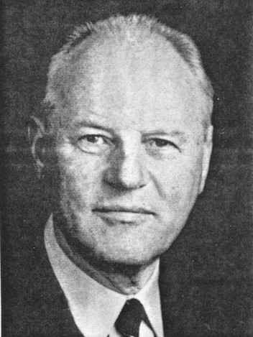

Prof. Dr. Ing. Franz Moser

Precognition -

The scientific view

Professor Dr. Engineer Franz Moser, studied technical chemistry at the Technischen Hochschule Graz and at Princeton University, USA. Since 1966, Professor and on the board of directors of the Institute for the basic processes of technology at the Technischen Universität, Graz in Austria.

Part 1: The theoretical foundation

- Definition of problem

If one wants to scientifically deal with the problem of precognition one has to take notice of the results gained by physics, particularly quantum physics. The reason why this isn’t so simple is that the results have been worked out only a relatively short time ago and are therefore hardly known amongst the scientists themselves on the one hand and because its consequences can turn our whole, up to now valid mechanical view of the world upside down.

One calls such a radical change of view by scientists’ a paradigm shift. This is identifiable through the tough arguments between the proponents of the old and the new paradigm. As Thomas S. Kuhn, a science theorist recognised, the new paradigm will only prevail once the proponents of the old have died out.

The phenomenon of precognition can only be understood when one accepts the new paradigm of physics in its entirety. This is going to be explained on hand of the example of the Einstein-Podolsky-Rosen-Paradox (ERP).

- The Einstein-Podolsky-Rosen-Paradox (ERP)

Albert Einstein and his co-workers Boris Podolsky and Nathan Rosen published a work in 1935 that was supposed to show that the quantum theory was still incomplete. Niels Bohr, the great opponents of Einstein in this discussion, countered this attack in the same year by asserting that Einstein’s assumptions were inapplicable. The question was: How could this conflict between Einstein and Bohr be resolved? The decision was very difficult because one did not have one appropriate experiment at one disposal in this case. One wasn’t even sure whether such an experiment could ever be made.

The fact that the Irish physicist John Bell came up with a theorem in 1962, the so-called Bell’s inequalities, ergo circa 30 years later whilst working at CERN in Geneva, would make it possible to resolve the ERP Problem and it constituted a considerable progress.

It took another 20 years before French physicist Alain Aspect from the University of Paris carried out a positive proof experiment that verified the correctness of the quantum theory. Niels Bohr had been correct, but neither he nor Einstein lived long enough to find this out.

What was this ERP Paradox concretely all about? To put it in simple terms:

- If the quantum theory is a complete theory, one has to discern from it that the whole world represents one giant quantum system, ergo a unit and an inseparable whole wherein everything is connected with everything else.

Furthermore:

- That this world is not four-dimensional, that is must have more than four dimensions, ergo arranged multi-dimensionally.

This insight emerged from the experiment.

The ERP-Experiment can be described as follows:

We have a system of two particles, two electrons in condition 1 in front of us. These particles influence one another in this condition so that any change in one electron instantaneously produces a change in the second electron.

What happens when we distance the particles a long distance from one another? – How do they influence one another then? – Do they remain within a system of instantaneous effect or not?

According to Einstein’s theory of relativity, the maximum velocity of information is the speed of light. If we were to shoot the two particles far apart in opposite directions, for instance one electron to Sirius, about nine lightyears away from Earth, and if we were to make changes to it, for instance to its spin, it would have to take years before the information from Sirius would reach the other electron according to the theory of relativity.

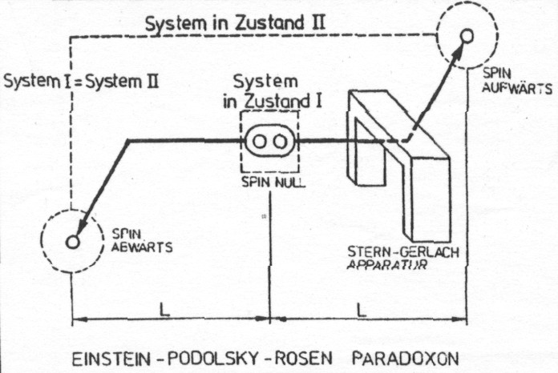

What did the tests show?

Alain Aspect carried out his experiments in a laboratory and instead of vast distances, he had to apply very short time differences in order to ascertain an effect. He measured within the nanosecond range.

Result: An instantaneous transference of information!

This is the decisive result; the consequences are surprising.

3.0 Consequences of the ERP-Experiment

The following consequences of this experiment can be stated in a simplified manner.

1. The quantum theory is complete and correct. It is up to now the best confirmed theory within science’s history.

2. The separability of space represented by Einstein, respectively the locality of reality, one of the basic assumptions of the way we understand nature, cannot be maintained. Under the separability, respectively the locality of space one adopts the fact that two parts of a system that are at a considerable distance from one another no longer have an influence on each other. This assumption is therefore incorrect with the following result:

- The non-locality or the non-separability of the world does not prevail.

Furthermore:

- There is no subject-object separation.

- Synchronicity, that is to say, timelessness reigns.

If everything stands in relationship with everything in a non-local coherence, how can space actually exist? Our concept of space includes displacement and distance, distance of time and space. But if instant connectivity across any ever so great distance exists, time and space no longer exist! There is no past and no future if time doesn’t exist – only the present. There is also no relationship between cause and effect without time, ergo no causality. But to contemplate this is beyond a healthy common sense. The solution of this paradox is possible in spite of this, namely by accepting the following hypothesis .

4.0 The two-worlds theory

We make the following assumptions in this theory:

- We live and we know one biological reality of four dimensions in time and space and causality.

- The ERP experiment reveals to us the presence of further dimensions:

- The non-locality (spacelessness)

- The synchronisation (timelessness)

- The non-causality (no relationship between cause and effect). This world is defined as an energy-consciousness-reality relationship (EC).

- Instead of the up to now four-dimensional world, we looked at it as three-dimensional until Einstein’s theory of relativity came along, we postulate a multi-dimensional world with 9 or 12 dimensions, something that individual scientists have already assumed.

Important in regards to explaining the phenomenon of precognition is the acknowledgment of the dimension of timelessness or synchronisation, something C, G, Jung already talked about.

The concepts of the two-world theory, they can now be scientifically explained, are certainly nothing new. We find the assumption of a timeless, that is to say, eternal world of the hereafter in all religions. The concept of “eternality” that we find in these beliefs completely coincide with the concept of timelessness.

The fact that these concepts overtax our minds should not hinder us from accepting them. Because science’s history shows us that the human mind has always been overtaxed by new scientific insights. One only has to remember Copernicus or Galilei. The world is absurd, but it is not nonsensical. To assume that the world would have to be the way we presently can understand it is an unreasonable reductionism that is refuted by history.

Part 2: Experimental results

Professor Robert G. Jahn and his colleagues at the University of Princeton, USA, furnished the hitherto most definite evidence of the presence of precognition during scientific experiments (compare [1]).

The principle utilised in these experiments was as follows:

Two students form a test team. One acts as sender (agent), the other as receiver (percipient). The sender sends a specific image at a specified or unspecified time. The receiver tried to receive this image. These experiments are carried out at the same moment precognitive or retrocognitive. Precognitive denotes that the reception takes place before the dispatch. Retrocognitive demotes that the reception takes place after the dispatch. These experiments were statistically evaluated by having both participants answer 30 questions in a questionnaire. The results showed:

- That precognition seems to be independent of time and also space.

This would indicate that this takes place within the above described energy-conscious reality of time and space.

Part 3: Attempt to explain and practical consequences

- Everything that exists is consciousness

Every theory about paranormal phenomena must be based on the reality of consciousness. We introduce the concept of consciousness in place of matter and energy and assert that everything that exists only consist of consciousness, an assumption amongst assumptions that Hegel had already made.

How can we justify this these days?

The first assumption is that everything that exists is traced back to ENERGY. This assumption is, after Einstein’s formula E = mc² had been formulated, acceptable and it has been actually verified through the atom bomb so that we can formulate it:

Everything that exists is ENERGY

But this ENERGY is unstructured. We therefore require the second assumption of an additional magnitude, a structural magnitude. What does give ENERGY structure, a pattern and form? We define this second magnitude as INFORMATION and we can write:

ENERGY and INFORMATION equal CONSCIOUSNESS

In a formula (but only symbolically): E + I = C E = Energy
I = Information
C = Consciousness

- The structure of the psyche according to C. G. Jung

In order to understand the processes of precognition we must adopt a model of the structure of the psyche first. The psyche of human beings – ergo their consciousness – consists, according to the imaginations of C. G. Jung, of the EGO, the self-consciousness, the personal unconscious and the collective unconscious.

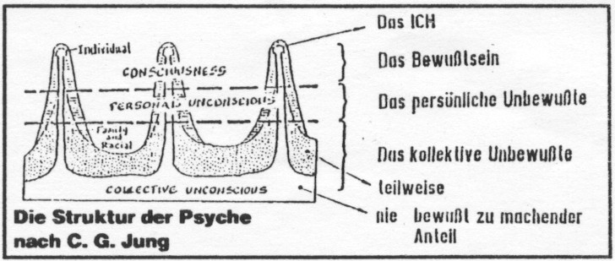

We can assume that all the consciousness’ of all people are included in the collective consciousness. The oneness of all human beings – something that we find difficult to understand – is somehow collected there. But this can be understood via the quantum theory because it stipulates the unity of all systems.

We must somehow introduce the separation into two worlds into this model. We can assume that the EGO and the self-consciousness connote the awake-consciousness within the biological reality, whilst the other parts of the psyche always remain within the timeless energy-consciousness-reality.

- We human beings are therefore always present on both worlds.

This assumption is very important for the following explanation.

- Model to explain the phenomenon of precognition

The basis for the model, as has already been specified, is the assumption that:

Everything that exists is consciousness.

We are also familiar with:

Physical consciousness and human consciousness.

We are furthermore familiar with states of consciousness within the biological reality (denominated I) and the timeless energy-conscious-reality (EC) (denominated II).

Telepathy is therefore the simultaneous exchange of information between subject A and B within the fields of consciousness of the biological reality (or also within the field of consciousness of the EC-reality).

In order to explain the phenomenon called precognition we have to proceed as follows:

Step 1: Subject A and B move from the biological reality to the timeless EC-reality (whether at the same time or at different times matters not).

Step 2: An exchange of information takes place in the timeless EC-reality.

How can one enter this timeless EC-reality one may ask oneself? The answer comes from numerous meditation systems like Yoga, Zen etc. It does however seem that it is possible for some people, or all people, to also enter this reality through simple, powerful concentration on an object or, as was the case in an attempt in Princeton, on a landscape as it were.

4.0 Practical consequences (comp. [2])

The philosophical consequences of this theory of precognition are extensive. We mostly live under the assumption that coincidences do exist. We believe that the world and human beings came into existence through a coincidence (Jaques Monod, “Zufall und Notwendigkeit”). (Coincidence and necessity)

But if only one dimension of our existence exists, given within timelessness, and if we also remain – in a way that is hardly comprehensible to us – at all “times” within this timelessness, coincidences cannot exist, because the future is predetermined through this. This would create a situation where everything that we do has been determined, ergo that we could therefore not have our free will. But this assumption is unacceptable for ethical reasons. Human beings would not be responsible for anything they do.

In order to escape this logical dilemma, it is necessary to postulate additional quality-dimensions of our existence. Well, moral dimensions as it were like for instance: harmonious, disharmonious and neutral dimensions.

If we adopt this assumption we find the following logic:

- We live in a world that also has a spaceless and timeless dimension next to the time and space dimension of the biological reality, but also an additional quality dimension.

- Every one of our decisions of will (thoughts, feelings, actions etc,) predestines our biological reality. There are no coincidences in this case. Everything that happens to us has been caused by us through our thoughts and actions. This is why Buddhism states: “You are what you think”. This is the concept of karma.

- But we possess our freedom of will in spite of this. We are therefore free to decide for or against something.

The seemingly absurd thing of this situation is that we are indeed fatefully tied (determined) on the one hand, and that there are no coincidences, but that our decisions of will are free on the other hand.

To comprehend and to live this paradoxical situation is surely one of our tasks within our future development. It is probably one of the most important tasks that we have to master within our whole evolution.

- Literature

[1] F. Moser: Consciousness in space and time – The foundations of a holistic philosophy based on science; Leykam-Verlag Graz, 1989.
[2] F. Moser: Consciousness in relationships – The foundations of a holistic ethic; Leykam-Verlag Graz,1991.

* * * * * * *

- Latest research

Light particles are more closely connected than one originally thought

Entangled light particles or photons belong amongst the strangest phenomena within quantum physics. They develop conjointly, but separated from one another at the speed of light, still remain connected to one another so that everything that takes place has an immediate, but reversed effect on the other.

One has held the opinion up to now, that this invisible band is destroyed when one of the of the photons encounters matter.

A team of physicists assembled around Erwin Altewischer from the University of Leiden has now verified the opposite [1]. These researchers directed a laser beam at a crystal whereby twin photons were created. These photons then flew towards a metal foil with tiny holes in it. The holes were actually too small for the photons, because their diameter were smaller than the length of the light waves. The particles still managed to squeeze through by converting into so-called plasmons (Surface vibrations), passing through the hole to then adopt their original form again.

- The pairs of photons were surprisingly still entangled after they had traversed through the sieve of light.

- Literature

[1] NATURE, volume 418, P. 304, (2002).

Precognition: Extrasensory perception; advance knowledge of future events.
Instantaneously: immediately happening, have an instant effect.
The experiments of A. Aspect were not carried out with electrons, but with photons. (compare with [1]
A nanosecond is 10⁻⁹ second.

