**PSYCHO-SCIENTIFIC FRONTIERS**

**Selected publications from a variety of subjects of psycho-scientific research. Editor: Rolf Linnemann (Certificated Engineer) * Steinweg 3b * 32108 Bad Salzuflen * Tel. (05222) 6558**

Internet: <http://www.psychowissenschaften.de> E-Mail: [RoLi@psygrenz.de](mailto:RoLi@psygrenz.de)

Translator’s email: evak30@optusnet.com.au

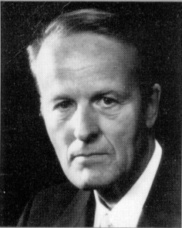

**Professor Dr. Ph. D Werner Schiebeler**

**Methods for gaining contact**

**with the world of**

**the hereafter**

**Werner Schiebeler,** Physicist, Professor, Dr. Ph. D, born in Bremen in 1923. Studied physics in Göttingen and in 1955 graduated from the Max Planck Institute, Göttingen with his thesis on fluid dynamics. From 1955-1965 worked in the electrical industry at Standard-Elektrik-Lorenz AG in Pforzheim, seven years as head of a development department for electronic teletext technology. From 1965 lectured physics and electronics at the then State School of Engineering, now University of Applied Sciences, Ravensburg-Weingarten. Appointed professor in 1971and retired in 1983. In addition to the subjects of natural-science and technology, he also taught para-psychology and para-psycho-physics from 1969 onwards at regular special lectures at the University of Applied Sciences, Ravensburg-Weingarten and continued to do so the ensuing years.

The author published numerous articles in journals as well as brochure and four books on various para-psychological topics. In addition, he also released a film about the “Paranormal healing methods in the Philippines” at the Institute of Scientific Films in Göttingen. He received the “Ernesto Bozzano Price” from the Associazione Italiana Scientifica Metaphysica in 1974 and the “1st Swiss Price” from the Swiss Foundation for Parapsychology in 1988.

Nothing can allow us to predict the radical

changes parapsychology will evoke in

our ideas about the last aims of human beings.

Charles Richet

French psychologist

1913 Nobel Price for Psychology

Bad Salzuflen, June 2003

**Introduction**

Ever since sentient human beings existed on this Earth, a large portion of them were convinced that an otherworldly world existed wherein one continues to live after one’s terrestrial demise and wherein the respective gods or a universal God have their place as creators of the world. This world of the hereafter was given names like *Eternal Hunting Ground, Hades, Scheol* or *Haven and Hell*.

People were also convinced that an exchange of information between the two spheres was possible and that one could receive advice and even help from departed ancestors or higher spirits from the other world. Native tribes in particular amply utilised this when hunting, waging wars or solving crimes. This made it possible for them to better master their daily fight for survival.

The knowledge about these things largely lapsed into oblivion *with c*ultured European peoples. The modern Spiritism that gained popularity in 19th Century, as a practical pursuit of a connection with the world of the hereafter, showed interested and inquisitive people that one could not only receive good advice from another sphere of existence, but that one could also receive comprehensive depictions of living conditions there.

The connecting link or the mediator of the transmissions of news from the world of the hereafter were in most cases a person that lives on this Earth. Through a physical and physiological, yet unresearched sequence of effects, otherworldly entities paranormally interfere with the nervous system of the mediator, cells are animated and this causes the movements of muscles or a visionary, quasi-optical or quasi-acoustical perception of the senses. A particular predisposition, we call it *mediumistic*, is the prerequisite for such a process to eventuate. The “medium” is then forced to do something, for instance to write, or it “sees” or “hears” something. Medicine men, shamans or priests were in the past the people most of the times (or are still partially the ones) that were in charge of making contact with the other world. One distinguishes between the following methods of making contact with the world of the hereafter:

1. The use of the *Ouija Board.*
2. The use of the *pendulum*.
3. The use of the *rapping table*.
4. The use of the psychograph (also called *Planchette*).
5. *Automatic writing*.
6. *Speaking in tongues*.
7. *Clairvoyance*.
8. *Clairaudience*.
9. *Direct writing*.
10. The actions of so-called “*materialisations*”, that is to say, materialised limbs or materialised bodies of spirit entities, ergo inhabitants of an otherworldly world.
11. The *use of technological apparatuses* like radios, tape-recorders, television sets and similar things.

Points 1 to 10 will be dealt with in this brochure.

**1. The Ouija Board**

We are dealing here with a simple mechanical device (Image 1) designed to receive communications from otherworldly entities, a kind of pointing telegraph. The letters of the alphabet and numbers are recorded on a piece of cardboard or wooden board. An easily moved item, a wooden or cardboard pointer or a liqueur glass (therefore the name “moving glass”) is placed, respectively put on it. One or a number of test person lightly touch this indicator with one or a number of fingers. If one or a number of psychically gifted person happens to be amongst them, the item on the board might move under the influence of the fingers on it after a certain time by steering towards letters or numbers. They will have to be recorded and read after.

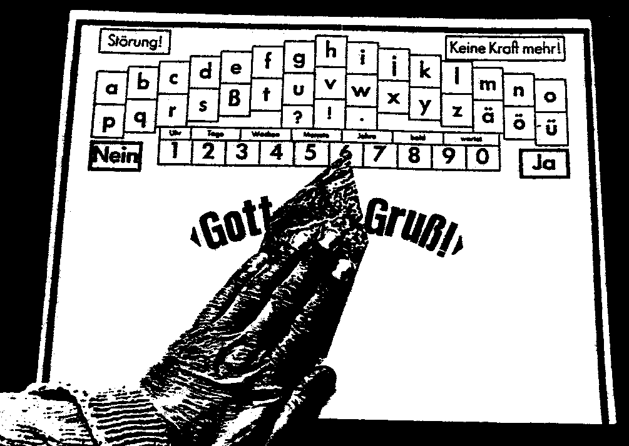

**Image 1:** Ouija Board (derived from French = Oui and German = Ja), often also called Planchette, an instrument designed for exchange of information with otherworldly entities. The design is related to the form of the technical pointer-telegraph form the 19th century.

If this process works properly, meaningful news can be received. The actual perception and reception organs are however from one or a number of psychic test persons. *The corresponding nerve cells are externally agitated consciously and invisibly and they move the fingers of the psychically gifted participants and thereby also the pointer itself.*

This method initially only allows a slow flow of information because something is mechanically moved, read with the eyes and then written down by helpers. But if the working group is working well together, the whole process can take place at a sufficient pace.

An example of this provides the North American medium *Pearl Leonore Curran*, nee Pollard, born on the 15th of February 1883, through which the otherworldly entity “Patience Worth” proclaimed itself (11, P. 216f). From 1913 onwards, this entity transmitted a great literary production over a number of years, mostly in the style of a novel and its extent is estimated at three million words. This treatise represents about 5’300 pages.

The texts were drafted in various English dialects of the 17th century, dialects the American medium and its relatives and friends *were not conversant with*. The chapter in the novel titled “The Sorry Tale”, it describes Christ’s crucifixion and it is a literary work of astonishing power and spiritedness, was dictated in its entirety of 5’000 words in one evening. This represents about nine pages of this treatises. *Patience Worth* never hesitated in the choice of one single word. It was as if a stream of words flowed from the medium. Subsequent changes happened on very rare occasions. She would continue a sentence where she had stopped without hesitation even after lengthy interruptions.

An ancient form of the present Ouija Board is the *oracle breastplate* mentioned on the Bible. Priests and specifically high-priests were the link to the world of the hereafter for the Israelites in the days of the old federation. Just like the medicine men of native tribes, they had to have the special talent that we call a psychic gift. The first prophet of the Israelites, Moses (around 1350 BC) had been strictly instructed about how and from what material the vestments of the priests (Aaron, his brother was the first) had to be made (Exodus 28, 6f). The most important parts were the shoulder garment or the body frock (Hebrew “ephod”), the oracle breastplate (literally: breastplate of justice, Exodus 28, 15) and the golden forehead plate with the inscription “Dedicated to the Lord” Exodus 28, 36).

The oracle breastplate, normally worn over the chest over the shoulder garment, had four rows of gemstones. Each of them was engraved with a character, namely the first letter of the names of the twelve tribes of Israel. This made them represent a kind of alphabet. Two small items also belonged with the oracle plate, divination stones called Urim and Thummim[1]. They were kept on or in the oracle breastplate. God’s instructions to Moses state:

**Exodus 28, 30:** Put the Urim and Thummim in the breast piece so that Aaron will carry them when he comes into my holy presence. At such times he must always wear this breast piece so that he can determine my will for the people of Israel. [2]

Moses’s description of the garment goes:

**Leviticus 8, 8:** He put the breast piece on him and put the Urim and Thummim in it.

When asking God questions, the priest untied the breast plate from the lower part of the garment and positioned it horizontally. He then took the divination stones Urim and Thummim from the breast plate and placed then in the spaces between the gemstones. He then touched the stones ever so slightly with his fingertips. Under the influence of otherworldly entities, under God’s influence  according to the Israelites, the divination stones began to move, psychically pushed by the fingers of the high-priest and they glided across the breast plate and touched one of the engraved gemstones after another. The letters engraved on the gemstones had to be remembered or recorded one after the other as they were touched by the divination stones and assembled into words. This is how shorter or longer pieces of information could be transmitted and received.

Some might object by saying that the twelve gemstones did not represent the complete Hebrew alphabet of 22 letters. But a double occupancy of the gemstones was made possible with the help of the second stone, a method that is still utilised with case shift in teletype technology these days.

The invention of the oracle shield was an important affair 3’200 years ago. Because answers and instruction from God could be received like a regular telegram through the elimination of misunderstandings to a great extent, the required divination stones received the names “truth” and “clarity”.

God would generally be questioned in the so-called sacred tent (Exodus 33, 7) or (Exodus 25, 8 and 26, 1) or in the temple in Jerusalem later. This method was used by the Israelites for around 750 years until they were led away into captivity by King Nebuchadnezzar II (605 – 562) from New Babylon in three waves in 597, 587 and 582 BC respectively. The temple in Jerusalem was looted at that time and the implements designed to question God were lost. There are no reports anywhere that they were actually made anew.

Enquiries with God and his answers and indoctrinations were not restricted to religious matters, but also in regards to judicature, politics and warfare. An example may elucidate this: King Saul, the first Israelite King (around 1010 BC) had fallen into disgrace with God because of his disobedience. Besides, he threatened to kill and therefore pursued the already anointed David who had been chosen by God to be the next king according to the prophet Samuel. Davis sought refuge amongst the Philistines (1 Samuel 27, 8) against whom he had waged Saul’s war as his commander. He maintained a private troop whilst with the Philistines and undertook raids (1 Samuel 27, 8) in order to secure his livelihood through them. The final battle between Saul and the Philistines then ensued. Faced with a difficult military situation, Saul did however no longer receive answers from God through the oracle plate (1 Samuel 28, 6). In his desperation he visited a female necromancer[3] in Endor in disguise. He demanded to speak to the deceased prophet Samuel as he had anointed him king. He wanted advice from him. Samuel did indeed make an appearance, but only the necromancer could see him clairvoyantly. In answer to his pleading questions, Samuel announced that God will cast him into perdition because of his disobedience and that he and his sons would perish in the battle.

As the Philistines went into battle the following morning, David and his private army were rejected as a confederate because of a possible unreliability. He and his troops therefore returned to his place of residence in Ziklad in the land of the Philistines. He discovered that Ziklad had been plundered and devasted by the Amalekites (1 Samuel 30, 1) in the meantime. All the women and the children had been kidnapped. David’s people were terribly upset and threatened to stone their leader. David ordered the priest Abiathar:

**1 Samuel 30, 7:** Bring me the ephod! (ergo the priest’s garment and the oracle breast plate)

Once Abiathar had brought the demanded priest’s garment to David, he directed this question at the Lord:

“Shall I go after those raiders? And will I catch them?”

He received the answer:

“Go after them, you will catch them and rescue the captives.”

David followed this advice and on his march he came across an Egyptian slave the Amalekites had left behind. This slave led him and his people to those they pursued. David attacked them and destroyed them whilst they celebrated their victory and he was able to rescue the women and the children.

**2. The utilisation of the pendulum**

The alphabet is not aligned on a board in a line in this method, but in a closed circle. The indicator here is not a pointer or a glass, but a pendulum on a thin thread. The thread is held by the psychic person between the index finger and the thumb of one hand, whereby the elbow is supported on the table with the circularly arranged alphabet. When at rest, the point of the pendulum should be just above the centre of the alphabet.

The pendulum will initially perform little, irregular oscillations because of the unsteadiness of the arm. But when the method functions correctly, ordered oscillations of great amplitude appear after a certain period of time and they point at a specific letter. This letter must be written down. A certain level of uncertainty is caused by the fact that the indication is ambiguous, as two opposing letters are situated on that swing plane. One has to select one of them.

After the letter has been recognised and written down, the oscillation slowly subsides and the pendulum begins to oscillate on a new swing plane. This then indicates a new letter and one has to write it down or remember it. As with the Ouija board, messages can be received in this fashion also.

*But one has to test where they come from!*

*Is one’s own subconscious expressing its opinion or its hidden desires or do the messages really come from a different plane of existence and therefore from so-called spirit beings? This question is of importance with all received messages. Strict, critical discernment is required here, careful investigation must establish whether the transmissions actually report about things that do not stem from the medium and are also not telepathically drawn off from people standing next to the medium. The possibility of so-called hoaxing spirits making an appearance represents another problem.*

The psychic or mental (as it is often called) use of the pendulum is however not utilised to make contact with the world of the hereafter, it is often used by naturopaths to make a diagnosis or by sensitives to find veins of ore, water (sometimes over a map) or so-called lines of irritation. But where the information actually comes from if the method runs successfully is unclear in most cases. I know people that try to clarify ever important question in their life a priory and they insist that they receive the appropriate answers in the process.

Do they speak with their clairvoyant subconscious when it happens?

The movement of the pendulum happens through little, unconscious movements by the hand holding it. Those that use pendulums often assert that the opposite is true. They will however see that when they firmly rest their hand and the fingers on a stand or place the hand on the edge of a table, that the pendulum immediate stands still and no longer moves. But I would be eager to see anyone whose pendulum continues to oscillate when the hand is absolutely still. I knew a recently deceased, elderly parapsychologist who demonstrated the use of the pendulum to me and he also asserted that the movement of his hand was not the cause, even though it was clear in my eyes that this was so. When I induced him to place his hand on the backrest of a chair, the movement of the pendulum ceased immediately.

The conclusion that the movement of the pendulum is caused through slight and unconscious movements of muscles does in no way devalue or abrogate this phenomenon. It merely says *that the actual receiving station lies in living, psychic human beings*.

**3. The use of the rapping table**

This method, like the preceding methods, furnishes individual letters. It has also become known by the name of “moving table”, even though the table doesn’t actually move.

One or a number of people sit at a not too heavy table and place their hands flat on the table top. When the method succeeds, ergo when the participants possess sufficient psychic abilities to provide the required energy, the table will slightly rise up in the air, either with two legs or (rarer) with all four legs, to then immediately drop again. This produces a rapping sound. If this process is used to transmit information, it must be done numerous times in a row whilst the participants recite the alphabet. The last recited letter must be recorded when the rapping sound stops. The rapping process can then be continued. The recorded letters must later be sorted into words and sentences and they will then form the transmitted message.

When the hands are only placed loosely on the table whilst undertaking the rapping process and if there is possibly an easily slidable tablecloth (not made of plastic) on the table so that the table cannot be tipped through the pushing of the hands, we are dealing with a so-called kinetic apparition and it is then somewhat less likely that the subconscious of the participants produced the message.

Things look different with one individual participant undertaking such experiments. I knew a retired minister 30 years ago who intensively dealt with the method of rapping tables. He thought that he could call upon almost any deceased person at any given time in order to receive messages from them via the rapping table. He sat at a very light table to do this and it would tilt towards him under his hands to then move back again. I rapidly gained the impression that he pulled the table (probably unconsciously) towards him. When I place two pieces of paper under his hands, the rapping stopped. The hand now glided on the table top and pulling the table was no longer possible. I did not have the impression that the messages that I had received through him a priory stemmed from another level of existence. I assume that the minister’s own subconscious revealed itself (At least whilst I was there).

Rapping sounds to facilitate the transmission of information can however not only be produced through the mechanical movement of a table, they can also come about through causes that are paranormally invisible to us, namely through *pieces of furniture* or *heating pipes*. The alphabet must also be recited when dealing with these rapping sounds. It is extremely unlikely that the subconscious of the terrestrial participants produce the messages in this case. Such rapping messages made an appearance with most known mediums that produce physical phenomena.

An example may elucidate what’s presented here:

The schoolmaster *Berthold Romeissen* (1876 – 1962) reports. He writes (11, P. 309):

“During my last year at the seminary in Gotha 1897/98 I lived with my dear friends and classmates Otto W. and Albert T. with the Kapphahn family at 3 Gradlerstrasse. The three of us lived in a really harmonious, brotherly relationship and we enjoyed our golden freedom after our very restricted life at the boarding school. We worked on our respective subjects, our activities at the training school in preparation for the maturity exams without being tied to a specific schedule. That the three of us were free from aerial fancies and that we had a strict mental work ethics is born out be the fact that Otto W. became the rector in a major city in the Ruhr Area (Elberfeld-Barmen) and Albert T. principal in Zella-Mahlis and myself headmaster in Saxony. This was the milieu under which we had the following, extraordinary experience:

After the autumn holidays in 1897, our classmate Adam W. returned from his home in Grossbuschla by Treffurt and he told us that they had held a lot of spiritistic meeting there and that he had attended some of them. Some mischief must indeed have happened here and there, but he had also attended meetings with serious, pious people and that this excluded any deception and some wonderful revelations were received. These meeting would however only succeed if one of the participants was a medium. He had also served as a medium and as the three of us lived so segregated and undisturbed here, we should really try to do this. The three of us balked at the idea and categorically rejected his request for some time, because we knew our Adam W.. He was a regular, helpful and very hard worker, but a dreamer and scatterbrain, one that quickly jumped from one idea to another. But we finally succumbed to his long and repeated urging.

One evening we arranged a three legged washstand to serve as a small table and placed a drawing board on it and we sat around it. Albert T. went down to the Kapphahn;s flat and played the ‘Eriksgang’ from the ‘Prophet’ by Giacomo Meyerbeer on their piano, the music could be clearly heard in our room and it was designed to put us in the right frame of mind. Once Albert returned we formed a chain on the table with our spread out hands and Adam W. asked: ‘Is there a friendly spirit at hand that cold answer a few of our question?’

I don’t quite remember whether the table reacted soon after the first question or only after it was asked a number of times. It initially tilted towards Albert. When we pushed it back, hardly touching it with our fingertips, it repeatedly tilted, but eventually towards me. It was suddenly completely on my knees and a sudden loud, clear rapping came from the gas pipe (It ran through the room for lighting purposes) as if a small hammer had been used. A shiver ran down our spines and as I was touching my neighbours I felt that they were shivering. The rapping sound disappeared after a while and we could breathe easy again. Adam did not receive an answer to his question. When I asked a question, a fierce uninterrupted rapping ensued and I said: ‘If you are as good spirit who can only reveal itself to us through knocking, we must arrange how you can answer our questions with a yes or a no. If you want to answer a question with a yes, knock twice and once for a no. The knocking stopped immediately. This was followed by two sharp knocking sounds and this established the signals for yes and no and they were always correct.

I don’t remember all the questions that we asked to begin with. We were so exited and moved by the first impressions. When we asked questions in regards to the future or when we were not supposed to know something, we didn’t receive an answer no matter how often we repeated the question. But on the other hand, when we wanted to know something that the rapper was willing to tell us, the answer came immediately.

We then made an agreement about the rapping signals for numbers. Questions about birthdays were accurately furnished according to year, month and day and this even if we didn’t know the answer, ergo when it couldn’t be given subconsciously by one of us. When we turned the gaslight back on again after the first meeting, we found that the four of us were as white as the ceiling. The meetings were repeated over the following days. We didn’t tell anyone else about them.

They could however not be concealed from our landlord, because the regular playing of the same tune on the piano in Kapphahn’s flat drew his attention. We therefore informed him about our activity. As an enlightened and intelligent person, he was naturally disbelieving and disquieted that it ‘spooked” in his house. In order to convince himself he participated at one of our meeting and he shivered with excitement. He then said: ‘I will believe you that we are not dealing with a delusion if your so-called spirit gives me the right answer. I will go downstairs and I will write a four or five-digit number on a piece of paper and lock it up in the bureau. Once I have done this I will give you a sign. Let your so-called spirit dictate the number to you, write it down and bring it down to me.’ A four digit number was dictated with very succinct hammer-like blows. I went downstairs and it was correct. Every time we did this experiment it always produced the right answer.

Soon only three of us sat together and it was only Albert T. and myself soon after. The rapping started the moment we sat down and before we even had a chance to ask a question. I could however not make contact with the spirit on my own. I always needed Albert to begin with, but he could leave right after and I remained sitting on the edge of the sofa. The rapping came from above me where the wall and the ceiling meet. It is a shame that I didn’t write some of the amazing answers down in those days!

My questioning became more resourceful. I wrote the letters of the alphabet on a piece of cardboard and I numbered them so that I received the answers in words and sentences. ‘He’ rapped the number and I had the corresponding letter. All I had to do was to assemble the letters into words and I had an actual written answer. I learnt that this was the first time the spirit had contact with a person and that he was still tied to the house, because he had been the previous owner of the house and that his name had been Ramdohr. Mr. Kapphahn ask older people in town to find out if they knew something about the house at 3 Gradlerstrasse. He received the answer: ‘This is indeed the Ramdohr’s villa that belong to the old professor Ramdohr. But he has been dead for a long time.’

The hammer blows were always genuine outbursts of temper, sometime powerful, sometimes careless, sometimes lumbering and sometimes expressing his discontentment. Some of the very important and specific answer have stuck in my memory.

* *The question of whether a God existed was answered with two hammer blows of a never before heard severity.*
* *The question of whether his present condition made a deeper recognition and view of God possible was answered with a ‘yes’.*
* *The question of whether his present existence was a further stage of development for our life was also answered with a ‘yes’.*
* *The question of whether he was able to use other means besides rapping to facilitate terrestrial communication, was answered with a ‘no’.*
* *Whether it was possible with lots of people: ‘No, only very seldom with rapping mediums.’*
* *Whether he was using his sensory organs like eyes and ears, as he was able to hear and see according to our concepts judging by his answers, was answered with a ‘no’.*
* *Whether he had contact with other spirit beings: ‘Yes’.*

Saying goodbye was always a moving and deeply touching affair for me, particularly after we had a lengthy conversation between the two of us, so I said: ‘I thank you dear spirit and good night!’ He then knocked on the ceiling with forceful blows from the corner above me towards the door, two meters apart, and down the corridor until the blows petered out at the end of the corridor.

I asked myself the same question over and over again: Is this a force that slumbers in my subconscious or a force that is outside of me, a real spirit, one that has left his physical body behind and has now entered an advanced state? But the numerous answers and the virtually individual machinations like the just described departure, the joyful rapping when we sat down to converse with one another, made me think that the latter might be the case. This experience did naturally affect me beyond our conversations. But the day of our exams moved closer and our time was too precious for us to spend too much time away from our so imperatively necessary work. Our conversations therefore became rarer all the time.

When I intensively endeavoured to re-establish contact with the help of my bride and my sister in law a few years later, at the house of my future in-laws, we were not successful. I wonder whether I would succeed at the Ramdohr’s house in Gotha after 55 year? And this without Albert T. who had amplified my psychic power so that I received immediate contact?”

**4. The utilisation of the psychograph (or planchette)**

Whilst the received letters were initially grasped by the eyes or the ears and then written down in the previously described methods, they become immediately and directly apparent with the utilisation of a psychograph (Image 2) in a more or less legible fashion.

A psychically gifted person places one hand on a little board, equipped with two wheels and a pencil stuck through it, placed on a piece of paper. If the process runs correctly, the hand of the test subject, like with the Ouija board and the pendulum, moves the little board. The paranormally controlled nerves and muscles produce an instantly readable script in this way. The method is usually used as a precursor to automatic writing or speaking in tongues.



**Image 2:** A psychograph, often also called a planchette (French: planchette = little board) designed to receive paranormal messages. Two of the little legs of the planchette are equipped with wheels whilst the third leg consist of a pencil pushed through it. One hand of the medium placed on the planchette can produce more or less legible writing on a piece of paper placed underneath. The blindfold is there to prevent the medium from reading and thinking about the thus produced writing.

**5. Psychic or automatic writing**

The psychically gifted test person holds the pencil directly in the hand in this method and it waits until the arm is induced to make writing movements. When this process is successful (it might take minutes, days or weeks), it will feel a pulling in its arm and hand and an urge to make writing movement. The hand and the pencil initially move hesitantly and irregularly most of the time to then gradually initiate spiral-shaped writing movements. Hardly legible handwriting gradually ensues, but it does improve over time. The words are often written without transition, ergo without lifting the pencil from the paper, at least in the initial stages, and the pencil is not lifted from the paper at the end of a line either.

Furthermore, the psychic writing is often of a type of writing that the psychically gifted test person is not familiar with. This means in our case that the letters are written in German and not in Italian style. The purpose of this is to take the opportunity to immediately read of what’s being written away from the test person. Because when simultaneous reading takes place, concurrent thoughts and pre-emptive completion of an attempted word often takes place. This can lead to a situation where the thoughts of the receiving person are more powerful than the paranormal control and this can produce false renditions. When the transmitting otherworldly entity (mostly a deceased person) has no command of German writing, if one is for instance dealing with an Englishman who has no second choice apart from Latin, another method is sometimes utilised. Mirror writing is then applied. Such psychically produced writing can only be read with the help of a mirror so that the medium cannot simultaneously read what’s written and therefore cannot think about it at the same time.

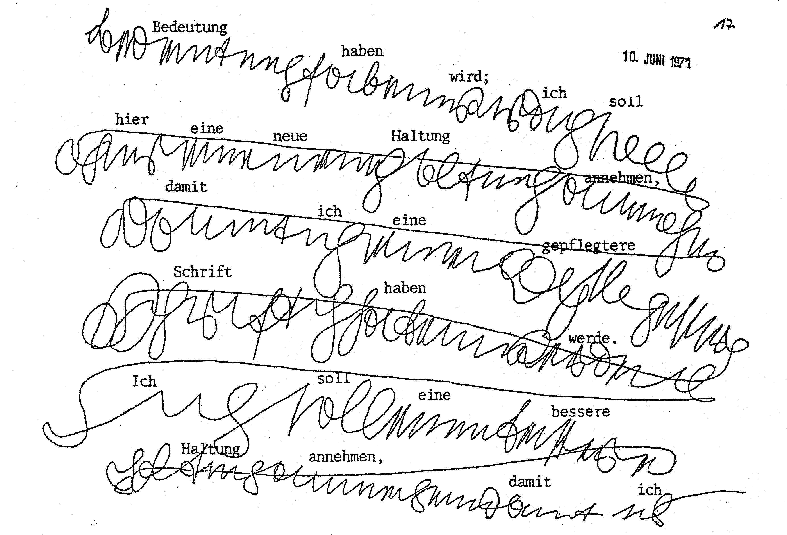

**Image 3:** Psychic writing at the initial stage of psychic development.

Image 3 shows psychically drawn writing in the interconnected German form of style from the initial development of automatic writing by Mrs. K. who was 46 years old at the time. The writing is still hard to read. We are dealing with an excerpt from a lengthy exercise text wherein the deceased father of the medium gives his daughter guidelines about how to go about it.

Image 4 shows a psychic transmission in mirror writing by the Danish medium *Anna Melloni*, nee Rasmussen, born in 1898. The transmission took place in my presence on the 14th of August 1962 in Würzburg and it was directed at me. The medium told me that her psychic abilities appeared for the first time at age 12 and this through the so-called poltergeist phenomenon, ergo in house, involuntary physical phenomena like moving tables, rapping sounds, light apparitions and other spooky events. These phenomena could also be experimentally produced in the presence of Anna and were, amongst others, investigated by the Copenhagen physicist *Professor Christian Winther* and the Danish photographer *Sven Türck* (5). And entity that called itself *Dr. Lazarus made an appearance as* the otherworldly guide of the medium, a name that actually exists in Denmark. But who the personality hiding behind this name or pseudonym was, remained unknown.

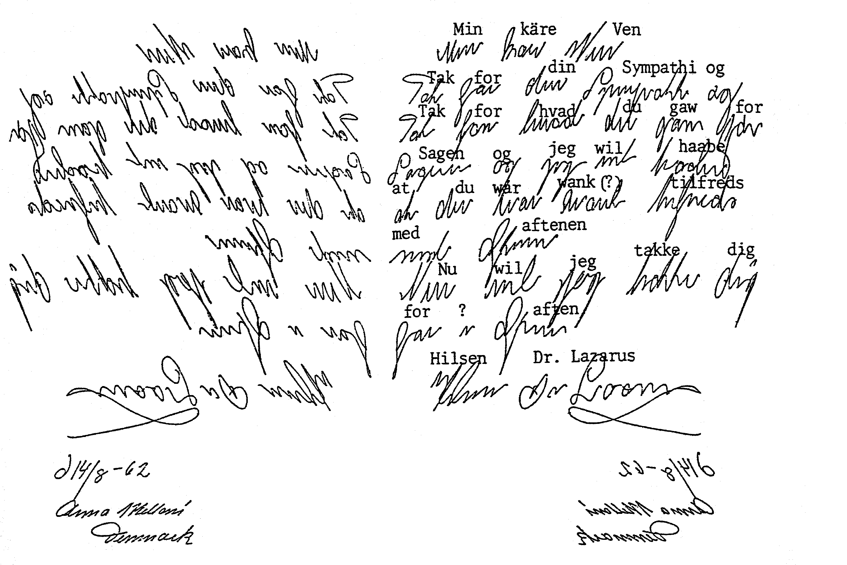

**Image 4:** Automatic writing transmission by the Copenhagen medium Anna Melloni in mirror writing (Left side, underneath is the medium’s handwritten date and name) The right represent the same writing seen through a mirror. The text is in old-fashion Danish and its German translation is: “My dear friend, thank you for your sympathy and everything you did for the cause and I hope that you (one word (wank or want) is not interpretable) were satisfied with the evening. I will now thank you for the evening. Dr. Lazarus.”

The psychically produced writing is in most cases not identical with the normal handwriting of the medium. Messages can also be transmitted in languages and writing styles that are *unknown* to the medium.

*Carlos Mirabelli* was a well-known and important medium of this type. He was born in 1889 in the State of Sao Paulo in Brazil, the son of Italian parents, and he died on the 1th of May 1951. He was run over by a car and died in front of his house. He was not a professional medium, but earned his livelihood as a leading commercial employee. *Mirabelli* gained world-renown through his numerous full-materialisations and other physical phenomena. *Dr. Hans Gerloff* introduced him to the German readership through his book (4). Apparitions like automatic writing and psychic speaking were also a part of Mirabelli’s output and this in *26 different languages and dialects*, amongst them some from Africa and the Far East. This however didn’t happen the way it did with Mrs. K. and Anna Melloni, by beings conscious, but in a full trance and at great speed besides.

In the book by *R. Mikulasch* (8), psychic scripts by Mirabelli are, amongst other things, rendered in Japanese, Arabic and Hebrew, unfortunately not readable or assessable by us. But three scripts therein are in languages we understand, namely in English, French and German and this by an entity that presented itself as *R. Scaciotto*. All three deal with the same theme. Two of these treatises, one in French and one in German, are rendered in image 5 below.

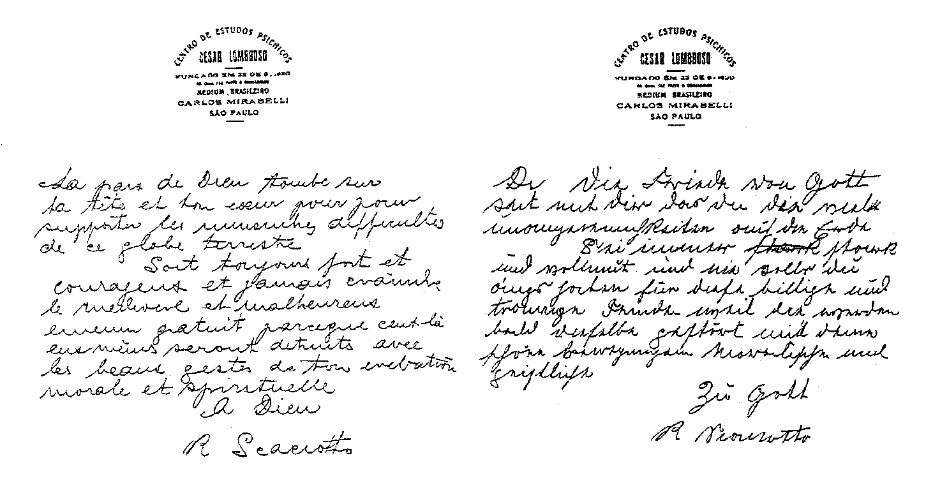

**Image 5:** Scripts by Carlos Mirabelli that he wrote at great speed whilst in a full trance. (Taken from 8 no. 12 and 17).

The following stands out in both texts: The French text is reasonably legible; it seems to have been written with fluency and it contains few mistakes. For instance, “pour” was written twice in the second line (if I read it correctly) and it would have to be “elevation” in the tenth line instead of “evebation” (if I have deciphered it correctly). The English text, it is not rendered here, must be assessed in a similar fashion. The German text on the other hand, even though written in a sufficiently legible way, contains a lot of mistakes. Instead of: "Die Friede von Gott soit mit dir das du die viele unangenemlichkeiten auf die Erde", it should say: "Der Friede Gottes sei mit Dir, damit Du die vielen Unannehmlichkeiten auf der Erde ertragen kannst." He completely omitted the last three words, but they appear in the French text as “pour supportei”.

One more German text is rendered by *Mirabelli* and it is signed by a certain *Richard Wagner*. This text is also written in a twisted kind of German and it also has all kinds of mistakes. The otherworldly entities do apparently not master the German language all that well. The fact that German was written is in itself remarkable, because Mirabelli did not speak German as far as we know.

People can be downrightly bailed up by their ability to write automatically even without an inner preparedness. This happened to *Robert Rollans* from Bohemia (born 1914), now living in Germany, he is a composer and I have extensively dealt with him in my book “Leben nach dem irdischen Tod” (13). At age 33, *Rollans* and his three brothers participated at three spiritistic meetings conducted by a psychically gifted mathematics professor.

He reports the following (13, P. 20):

“About one year later I attempted to write a letter late at night. I sat in front of a piece of paper with a pencil in my hand and I was about to start to write. I suddenly felt a strange power taking control of my hand and it began to write. I put the following words to paper: ‘Don’t be afraid, it is me, your brother Robi.’ He had been a young doctor and had died 8 years prior. I was deeply impressed by the message my hand produced, but I was also filled with extreme fear because I hadn’t been aware to this point that I can do automatic writing. The psychically gifted mathematics professor had only used the ‘moving glass’ method. Because of my fears I never dared to attempt to write automatically. My otherworldly brother however calmed me down and he wrote: *‘Think of nothing and allow you hand free reign.’* He then took command of my hand and he continued to write: ‘I am your deceased brother and I will tell you a lot of things about us and the world of the hereafter. You must be prepared to write with me often so that I can tell you lots of things from above.’

This was the beginning of my psychic activity, it had started with a great shock and great fears, because I am a timid kind of person. My anxieties did however disappear completely later because three deceased doctors, a very eminent historian and linguist called Hasdeu and his daughter, who had lived in Paris and had died at a young age, made contact with me. After my father had passed away, he was also a doctor, he also joint me. I have received a lot of significant psychic messages in the meantime.”

In the cases described so far we are dealing with a situation where a psychically gifted person records written messages without his own conscious will, controlled by outside influences. This can however also take place differently, namely in a way where the medium *“hears” the messages inside of itself paranormally* to then put them to paper normally with his own hand or where they are fed paranormally directly into the brain without any acoustic effect. One call this *“inspiration”*. The received information is in this case also quite normally written down after or eventually only verbally expressed.

The late Catholic priest *Johannes Greber* (1876 – 1944) made contact with such a medium in the late autumn of 1923. He was a priest in the small rural community of Kell near Andernach. A man from his community came to see him one day and asked for his opinion about Spiritism. He challenged him at the same time to form his opinion after making his own observation first. *Greber* therefore participated at meetings in the form of a spiritistic divine service of a small group in Kell. During the course of a few weeks, a young pair of brothers by the name of *Gosber* were apprenticed to become mediums in front of his very eyes. *Heinrich Gosper* into a full trance and speaking medium and *Carl Gosber* into an inspiration and automatic writing medium.

*Greber* was instructed by an entity from the hereafter at the beginning of the meetings via a third, already trained medium (5, P 33):

“You have presently two types of mediums here and they are in the process of being trained by the world of spirit. One of them is a so-called ‘inspiration medium’. A spirit sends him specific thoughts of such an intensity that his own thoughts are ousted and he stands under complete control of the spirit. This medium doesn’t just receive these thoughts from the spirit, he is impelled to either speak them aloud or to write them down. The medium retains his full consciousness whilst this is happening. – Your inspiration medium still requires more tuition so that his receptiveness for inspirations from the world of spirit can be perfected. A lot of things that represent a hindrance must be expelled from him. You presently do not understand what this could be. This will become clear to you later.”

*Greber* reports about the further development in his own words (6, P. 6):

“This young man has neither the inclination to write nor the required schooling nor an inherent gift for this. He felt quite unexpectedly that he had to get up early in the morning in order to write. He didn’t know a priory what he had written. The words and sentences were suddenly given to him and he felt pushed to write them down. What he wrote was not part of his knowledge He also never read or heard what he had written anywhere before. It was an impartation – inspiration.”

Amongst other things, 17 treatises in prose or verse were produced in the meantime about themes like “*God’s shepherd and his flock*” or “*The spiritualisation of the soul*” or “*What did the saviour do for you?*”. Everything was produced in clear-cut German handwriting, the like German students still mastered and utilised in those days. It was published in 1975 in (6).

**6. Speaking in tongues**

This can take place whilst the medium is in a *full trance* state. The medium’s own spirit is eliminated, ergo virtually expelled from its own body. An otherworldly spirit entity takes possession of the body of the psychically gifted human being instead and it controls its nervous system. The medium is usually incapable of remembering what has happened within its body during the full trance state. The spirit entity on the other hand is able to largely use this body as if it was its own and also speak through its vocal cords. This can also happen in languages that the medium is not familiar with and in a way of expressing itself that others are usually not accustomed to. A lot of messages from the world of the hereafter have come to us here on Earth in this way. The already mentioned *Priest Johannes Greber* received most of his transmission in this fashion.

But there is a second type of speaking in tongues whereby the medium retains its own body consciousness, the way it is the case with the utilisation of the planchette and with automatic writing. One calls this a *state of semi-trance*. One’s own consciousness is indeed retracted a little, but the psychic speaker can remember the gist of the content of what was said after. The nerve cells of the medium’s speech and word construction centre are however paranormally controlled by an otherworldly entity. Such a medium usually speaks in its own way of expressing itself and in its own dialect. Difficult, technical texts with lots of foreign words, words unfamiliar to the medium, are hardly possible to transmit like this.

In 1986, I questioned the *speaking medium Mrs. A*. (born 1948) whom I have been working with for many years, in regards to this theme. She told ne (13, P. 85):

“When dealing with themes that are foreign or abstract in my eyes and I am not familiar with, I get the feeling that the spirit entity cannot use my vocabulary and must initially search to see what it can utilise from it. It must somehow construct something from it. Whole thought connections are often used and sentences are not always put together word for word.

Problems arise when dealing with things that are utterly alien to me. I have often noticed this because I do not have the words in such a case. This makes me utterly unhappy. I actually feel that the spoken word does not hit the mark. I have often felt that there must be more to this. I kind of sense it, but I cannot express it. This naturally conceals the danger of an unintended misrepresentation, particularly with names and dates.

But I have the feeling that the words flow relatively freely from me if the theme is familiar to me, because the thoughts and the vocabulary are expedient for the spirit entity.”

Some mediums prefer a state of *semi-trance* to a full trance, because they are then not completely sidelined and are able to experience some of this, ergo they are not just instruments that are devoid of will. The disadvantage of this is that the danger of false transmissions is considerably higher than in a full trance.

**7. The visionary show**

The transmission of information from the world of the hereafter can also take place through a visionary show. Psychically gifted people receive paranormal, *quasi-optical sensations*. They have the impression of seeing and eventually also hearing something, as if it was flowing into them through their own sensory organs. The medium *Pearl Leonore Curran*, mentioned in the first chapter, who channelled a great prosaic production in an old English dialect with the help of a Ouija board, experienced the appearance of such visions. She reports about it (11, P. 222):

“As the writing developed further, the writing began to be accompanied by graphic, pictorial visions. When the stories flow, the scenes become alive and clear, the figures move, play their roles and also converse with one another. The image isn’t just concentrated on the story being told; it also includes everything around the vision. If for instance two people appear that talk to one another at a street corner, I not only see them, but I also see the whole environment of the street with its houses, stones, dogs, people and everything else, exactly the way it would be in a real scene. When the people talk in a foreign language, like in the story ‘Sorry tale’, I hear the conversation, but the voice of Patience (the otherworldly entity) overlays everything to either translate or to indicate the passage to me that she likes to use in her narration. –

For instance, if I wanted to know the exact fruit a woman at the market sold or if I wanted to smell the scent of a flower or feel the quality of a unknown fabric, my own inconspicuous self would audaciously participate in the show and I might have nonchalantly approached the stand of the woman, picked up a fruit and tasted it or smelled the flowers in a garden or felt the fabric. This experience immediately became my own, as if I had actually experienced it, because it was as real to me as any other, normal personal experience.”

The visions of the tailor’s daughter *Therese Neumann* (1898 – 1962) from Konnersreuth in Upper Palatinate became very well known. She suffered temporary blindness in 1919 after an accident dousing a fire in 1918 and after a number of years in a sickbed, paranormal, inner voices made an appearance from 1925 onwards that cheered her up and gradually brought about her recovery. *As from Christmas 1926, Therese refused to ingest all nourishment and she lived for 35 years without eating or drinking anything.*

During the night between the 4th and 5th of March 1926, the wounds of Christ, with their associated bleeding, ergo something that one calls stigmata, appeared for the first time. This impressive process repeated itself every Friday after that until her passing, with the exception of the festive seasons, but was particularly pronounced on Good Friday.

After the commencement of her fasting in 1926, Therese experienced ever increasing visions of Christ’s suffering and other events from the gospel. Therese was insensitive to external impressions and also unapproachable in this ecstatic-visionary state. She experienced these visions with all of her senses. She didn’t just “see” during these visions, but also “heard” and she was able recount what she had heard in the spoken language, for instance Aramaic or Greek, as far as she could remember the sounds.

Therese had up to one hundred of such visions every year. Her narrations and the external signs of her stigmata impressed a lot of the visitors that came to Konnersreuth by the hundreds, as well as theologians, believers and the curious. A lot of them had their Christian faith strengthened or found their way back to it. One can only see this strange happening as a sign from the world of the hereafter, designed to stir up some of the people on Earth and to point out the existence of the divine world.

**8. The direct voice**

Messages from the world of the hereafter via the spoken word cannot only happen through the mouth of the medium, but can also be *triggered through a terrestrial organism.* One calls this phenomenon “direct voice”.

We are dealing with a more or less loud and variably well understood “human” voice of paranormal origin that develops within free space. Otherworldly entities create materialised ectoplasm in order to generate it (a paranormally created substance that is manly generated by the attending medium), it represents *a kind of larynx* separate from the medium. Otherworldly entities that want to make contact with people on Earth head for them.

A very well-known proponent of this phenomenon was the English medium *Leslie Flint* (born 1911). At age 17, he attended a spiritistic meeting and his attention was drawn to his psychic abilities at this instance. After initial reluctance, he allowed it to unfold itself. Different types of phenomena made an appearance to begin with, materialisations amongst them. But the “direct voice” phenomenon developed after a number of years and it supplanted all other paranormal processes.

He was accurately examined in May 1948 with the help of technical means by the research officer of the *Society for Psychic Research* in London, a *Dr. J. West* and three of his colleagues. Flint’s mouth was taped shut and both his arm were tied to the armrests of a chair. Furthermore, a larynx microphone connected to an amplifier was attached to his neck. One wanted to ascertain whether the expected voices only came from his own body. As the experiment was carried out in darkness, Flint was observed with an infrared night-vision apparatus. The results of this examination showed that *Flint* did not produce the voices himself, but that they sprang from a position next to his body. They were loud and clear and they started with the welcoming words “good evening” followed by a lengthy conversation between the voices and the examiners.

Another examiner in the field of direct voices was *Arthur J. Findlay* (1883 – 1964). He was active with doing social work, he was an English Justice of Peace, founder of the Glasgow *Society of Psychic Research* and the author of a number of parapsychological books. From 1919 onwards, he worked with the English medium *John C. Sloane* (1870 – 1951) in Glasgow. This medium specialised in “direct voices”, but he was also clairvoyant and clairaudient and spoke in a trance.

*Findlay* writes about his examinations (1, P. 40):

“There is no more powerful and convincing evidence for the survival of human beings after their demise than through direct or independent voices. Both of these descriptions are common for this phenomenon and they refer to the appearance of voices and parlance from entities that are completely independent from all flesh and blood people.

Direct voice represents the highest psychic phenomenon that has been discovered so far and also the most convincing, completely apart from the fact that it deserves our highest amazement. All other human discoveries sink into meaninglessness in comparison to this great discovery, the discovery of the direct method of connection between us and the departed, not with the help of all kinds of rapping sounds, but through the most intimate of all forms of making contact, the human voice.

All other forms of psychic phenomena can be falsified by a fraudulent medium, but the direct voice in its correct form cannot be falsified. Myself and others have often heard two and sometimes three voices of various timbres and various personal structures, different from those present, speak simultaneously and about various themes that were only known to the person they were directed at, whilst the medium either talked to the person next to it or about another matter or whilst I had my ear close to its mouth, without a sound escaping its lips.”

Findlay had this to say about the prerequisites for producing a “direct voice” (1, P. 13):

“In regards to the ‘direct voice’ that I am referring to now you’ll find that the best results are received in darkness, because vibrations of light make a sufficiently solid creation of the ectoplasm more difficult, something that is required to make the air oscillate. Even though I have heard voices in daylight, they are certainly stronger and better developed in darkness or by red light, because the later doesn’t have the same destructive effect as white light.

Quiet and harmonious prerequisites are also essential, and the condition of the atmosphere also has an effect on the results at times. The results are weak when the air is for instance heavily charged with electricity; whereas the best messages take place by clear, sharp moonlight, when the atmosphere is not too heavily burdened with too much humidity.

Anyhow, the prerequisites that make talking possible are very delicate and the best results can only be achieved based on experience. When these are present, the proclamations are really wonderful. Voices from all educational levels and ways of speaking address the participants at these meetings and their personal way of expressing themselves can in turn reveal them as being individuals that once lived on Earth.”

**9. The direct script**

Written messages from the world of the hereafter do not just eventuate through the physical hand of the writing medium, they sometimes also eventuate “directly” *through the circumvention of a terrestrial hand*. This can happen in a way whereby the participants of the experiment cannot see at all how the script eventuated. It is suddenly there.

Here is an example of this:

A research group that calls itself “SORRAT” (10), (SORRAT = *Society for Research on Rapport and Telekinesis)* observed this. It was founded by a *Dr. John G. Neihardt* (1881 – 1973). He was a literary critic, poet and professor at the University of Missouri (USA).

When he married his wife *Mona, nee Martensen* in 1908, she was psychically very gifted, an interest in paranormal events awakened in him. He got into contact with a series of mediums during the ensuing decades, the already mentioned *Pearl Eleonore Curran* amongst them, and he studied their abilities.

After he retired professionally, *Niehardt* lived on the Skyrim Farm, 11km North of Columbia (Missouri). With a *Dr. John T. Richards,* they gathered a circle of a dozen young ladies and gentlemen around themselves, people that were interested in parapsychological research (10, P. 11). The participants sat around a heavy wooden table that weighted 25kg during their attempts and they touched it lightly with their hands.

Paranormal happenings gradually began to manifest themselves like rapping sounds in the floor and in the walls and the movement of objects that included the free hovering of a small table. Apart from this, sensible messages from otherworldly beings were received and this through rapping sounds or through a planchette. They sometimes also produced “direct writing” on a piece of aluminium foil. The foil was about the size of an A5 piece of paper and it was placed each time in a flat box made of diaphanous plexiglass. After the box was closed, its edges were sealed. Nobody on Earth could produce graphic characters on this piece of foil without opening the box, thereby breaking the seals.

Two of these boxes, each equipped with a piece of aluminium foil, were placed in a glass showcase from 8:30 pm onwards during a meeting on the 8th of April 1978 (ergo after *Dr. Neihardt* had died) and one of the participants (a lady) sat in front of it to keep an eye on it. Apart from *Dr. Richards,* nine other people participated in the experiment. The letters “P” and “IP” were spelled out to begin with, followed by “China closed” (Glass showcase) The guardian of the glass showcase called out enthusiastically soon after. She had discovered that the following poem had been scratched on the piece of aluminium foil (10, P. 152):

*"Love is not Love*

*That hath not Charity*

*Nor is the trove*

*Of world's goods, Sanctity.*

*Now at this Eastertide*

*Remember Him*

*Who died for thee,*

*Yea, on the Tree,*

*With Song, glad Hymn,*

*And Holy minstrelry.*

Patience Worth.”

The mysterious “*Patience Worth*” appears here once again, she had announced her presence for the first time on the 8th of July 1913 through the American *Pearl Leonore Curran* and did so for many years after. The appearance of *Patience Worth* to the SORRAT group can be explained through the fact that it’s now deceased founder *Dr. Neihardt* had intensively examined the case Curran-Patience Worth in the years after 1926 as literary critic. Like the publicist *Caspar Yost*, he had arrived at the conclusion that *Pearl Curran* could not have produced the works of “Patience Worth” according to her own human personality and her own knowledge.

One more poem in old English from this unknown entity eventuated on the Skyrim Farm and this in a way that can certainly not be ascribed to the subconscious of a living human being. With the second type of direct writing, the writing implement is indeed physically-materially made available, but one cannot directly see how the writing is produced, because the process takes place concealed.

Scientific examinations of paranormal appearances through eminent natural scientists began in Europe and America about 130 years ago. One of them was the German physicist *Professor Friedrich Zöller* (1834 – 1882), Professor Ordinarius at the *University of Leipzig*, and he accounted for the field of astrophysics. He wrote important works about the nature of comets and about photometric and spectroscopic research.

Induced by his astrophysical concept of space and animated by his visit to *Professor Crooks* in 1875 in London, *Zöllner* carried out extraordinarily important experiments during 1877 and 1878 in Leipzig with the American medium *Henry Slade* (1836 – 1882, a dentist). Co-researchers and witnesses were Professors *Gustav Theodor Fechner* (1801 – 1887, Physicist), *Wilhelm Weber* (1804 – 1891, Physicist), *Wilhelm Schreiber* (1826 – 1908, Mathematician) and a number of non-academic friends were also present.

Only one of impressive experiment from the plethora of undertaken trials and achieved results is going to be mentioned here. The following has to be said in advance in order to understand it: *Slade* held the opinion that he was not the actually causer of the phenomena that developed when he was present, ergo that his subconscious did not produce all these events, but that otherworldly entities, that is to say, for us invisible inhabitants of another plane of existence, produced these happenings. *Professor Zöllner* agreed with his opinion after the conclusion of their examinations. The assumption of otherworldly entities was based on the fact that one could exchange information with them, that they answered questions and provided guidelines and besides, that they possessed extraordinary abilities and opportunities.

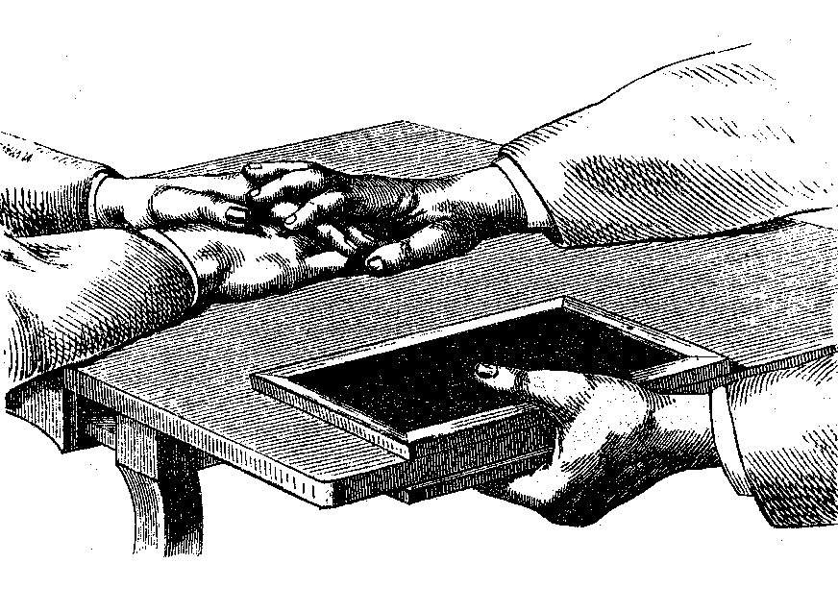

**Image 6:** The development of slate writing with the medium Henry Slade (1836 – 1905). (From 17, Volume 3, P. 260)

The form of the messages in regards to questions and wishes expressed by those present was the usual language spoken. The answers from the otherworldly entities – *Slade* called them “spirits” – were given in writing on a slate tablet, like the ones we used 30 years ago at elementary schools. The writing, in *Slade’s* case, was however not produced with a piece of chalk guided by him, it happen whilst he held one or two slate tablets above, respectively above and below the table top (Image 6) and that he placed a small piece of chalk in the space between the slate tablet and the table or by placing two slate tablets on top of one another with a small piece of chalk in between. These were then used by otherworldly entities in order to produce the respective writing. Those present didn’t actually see what was being written, but they could hear the scratching sound produced by the piece of chalk.

All of *Slade’s* apparitions took place in broad daylight or under artificial light. *Zöllner* actually brought his own slate tablets for the experiments with him, so that *Slade* could not have used pre-prepared tablets.

Zöllner describes one of these experiments, one that took place on the 7th of May 1878 at 8:30pm at the flat of his friend O. von Hoffmann. The former had brought a large number of slate tablets with him and he had cleaned them a priory himself. After *Slade* had uttered an impressive prayer to start with, *Zöller* reports (17, Volume 3, P. 263):

“Slade now asked me to take two of the new tablets and to place a small splinter of chalk between them and then solidly seal these two tablets together. I did this after I had reassured myself that the tablets were perfectly clean. The sealing process was carried out on four places along the longer sides of the tablet and I then placed the tablets with the small pieces of chalk between them, on that corner of the table (they sat at) that was furthest away from our hands. We placed our hands together on the table top so that Slade’s hands were covered by my hands and thereby hindered from moving at the same time. This had hardly been executed when the untouched tablets stood up on their sides a number of times, something that was clearly perceived by us in the bright light of the candle in the middle of the table. Both tablets then settled back in a somewhat different position and the sound of a stylus guided by a strong hand, writing between the tablets, became immediately audible. After the end of the writing was announced through the three ticks we were familiar with, we separated our solidly intertwined hands, concluded the meeting and picking up the double tablets, moved to the next room where *von Hoffmann* and his wife expected us. The recently sealed tablets were separated in the presence of these people. Both sides were completely covered with English writing.

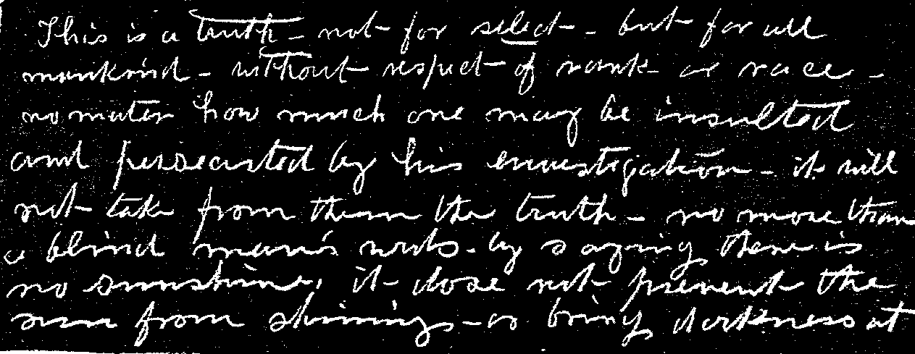

**Image 7:** Writing on a slate tablet that eventuated through the channelling of the medium Henry Slade on the 7th of May 1878. (From 17, Volume 3, panel VI)

Image 7 represents a photographic reproduction of one of the tablets on a smaller scale. When the two tablets are placed together again, the two superimposed sides of the tablets represent the situation wherein the surfaces were in fact written on. The following is the original English text:

First tablet: “This is a truth – not for select – but for all mankind – without respect of rank or rate – no matter how much one may be insulted and persecuted by his investigation – it will not take them from the truth – no more that a blind man’s words by saying, there is no sunshine, it does not prevent the sun from shining or bringing darkness at…”

Second tablet: “…noon; the blind man can say that sunlight doesn’t exist, because he cannot see the light of the sun; the person that states that this is not true says so because he has no evidence of the truth about these things. Do not scold the people that cannot see this, but help them by showing them the path to this divine truth, we are not able to tell you more at this stage because the space is full (on the tablets), continue with your investigation and you will receive your rewards.” (The second tablet was translated back from German to English)

*Zöllner* harboured the assumption and the hope that the “spirits” could transport physical objects from completely locked rooms or containers without causing visible damage to walls or without opening containers. In December 1877, he placed a number of coins into two cardboard boxes (boxes for medication) to but this question to the test and he sealed the lids by gluing strips of paper over them.

When Slade was present at the experiments in May 1878 in Leipzig for the second time, *Zöllner* produced the two boxes (one cylindrical, the other square in shape). He had however forgotten in the meantime what sort of coins were in the boxes. Only by shaking could he ascertain that the cylindrical box contained a larger coin (3 or 5 Marks) and that the square box must contain two smaller coins (1 Penny up to 50 Pence).

On the 5th of May 1878 at 4:25pm, *Professor Zöllner*, his friend *Oscar von Hoffmann* and the medium *Henry Slade* sat at a small gaming table in a living room filled with bright sunlight. All three of them checked to see whether the cardboard boxes were still sealed with sticky tape and by shaking them ascertained that they contained something that had not been determined at this stage. *Zöllner* told *Slade* that it was his wish that the invisible, intelligent entities should remove the content of these two boxes without opening them in the process.

*Zöllner* reports the following event (17, Volume 3, P. 236):

“Ready to oblige me as always, *Slade* picked up one of the slate tablets lying there at the ready, placed a piece of chalk on it that was by chance considerably larger than usual and held the tablet half way under the table with his right hand. We heard the writing and when the tablet was pulled from under the table, we found a request written on it, namely to place a second piece of chalk on the tablet, something that immediately happened. Thereupon, Slade, who sat to my left (*von Hoffmann* had changed his position to my right) held the tablet once again under the table and he and us also, waited with anticipation for the things that were about to happen.

Both of the sealed boxes had remained untouched and were roughly at the centre of the table. A few minutes might have passed without anything happening, when Slade stared at a specific point in the corner of the room and surprised us by slowly saying individual words, one after another and some were also repeated: “I see - see funf and eighteen hundred seventy six”. Neither Slade nor us knew what this was supposed to mean and almost simultaneously with *von Hoffmann* I made the comment that “funf” would certainly mean five and that the solution of the example would be 5 + 1876 = 1881.

Whilst I half-jokingly made this comment, we suddenly heard a solid object fall onto the tablet that Slade was still holding under the table with his right hand all this time (whilst the left hand was laying in front of us on the table). The tablet was immediately pulled from under the table and the 5 Mark coin dated 1876 that is reproduced in image 8 was on it. I naturally immediately reached for the cardboard box in front of me that nobody had touched during the whole process, in order to ascertain through shaking the box that the coin placed in it half a year ago, was still there – and lo and behold, it was empty and quiet, the box had been robbed of its content, namely the 5 Mark coin.

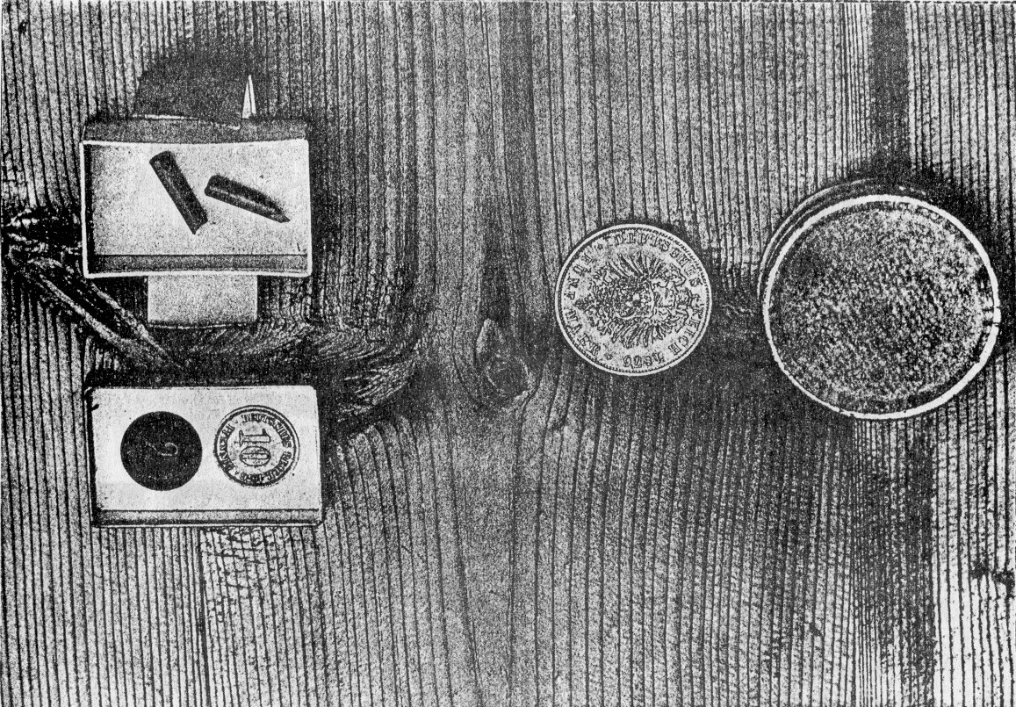

**Image 8:** The transport of coins from a sealed box during an experiment by *Professor Friedrich Zöllner* with the medium Henry Slade on the 5th of May 1878. (Taken from 17, Volume 3, panel 3).

Our joy over having achieved such an unexpectedly successful experiment was naturally great, the more so because the existence of the direct perception of objects was simultaneously confirmed, something that was not affected by our sensory perception the usual way. This could also not be due to reading the thoughts of the medium, that is to say, the perception of imaginations that are already present in the heads of human beings. Neither I, and to an even lesser degree, *Slade* and *von Hoffmann* knew what kind of coin was in the box nor the date on it. I was so pleased with this so successful experiment under such pressing condition that I was about to bring the meeting to a close in order to postpone further experiments to a later meeting. Slade had made a comment in the meantime, namely that the only 10 minute long session had not affected him at all. Slade’s comment induced us to maintain our positions at the table and to engage Slade in liberal conversation.

I guided the conversation towards his meeting with the *Grand Duke Constantine of Russia* and beseeched him to give us some detailed information about the phenomena that took place there, because the press had only released some aphoristic (tightly formulated, witty thought) news about it. *Slade* mentioned at this opportunity that he had succeeded with a very strange experiment with one of his tablets in the presence of *Grand Duke Constantine*. Two pieces of chalk had been accidentally left on one of the tablets, one could hear the two pieces write simultaneously when he held it under the table and when he pulled the tablet from under the table, he discovered that one of them had written from right to left whilst the other had written simultaneously from left to the right. I immediately suggested that we should see whether we would also succeed with this experiment; this suggestion came to me quite casually from the association of ideas the two pieces of chalk had produced, produced by the above mentioned experiment, without us having recognised the purpose of this written request.

*Slade* was immediately prepared to fulfil my request; he held the slate tablet with the two pieces of chalk under the table top and we very clearly heard the two pieces write on the tablet soon after. When the tablet was pulled from under the table, we found a message written in English on it; its lettering is photographically reproduced in image 9. It stated:

10 Pfennig 1876

2 Pfennig 1875

*Let this be prove to you of clairvoyance after the 9th day you must rest or it will harm you and the medium, believe in me, your friend.*

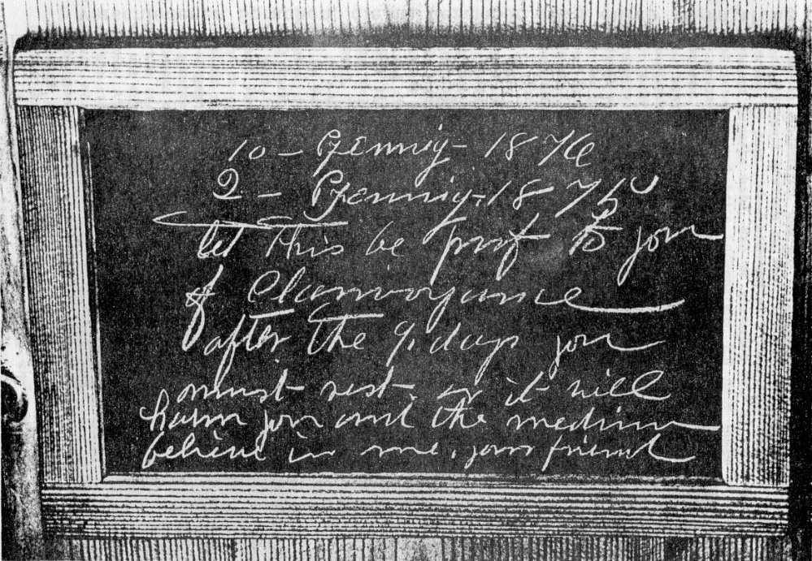

**Image 9:** Slate tablet with paranormally produced direct writing, received during an experiment by Professor Friedrich Zöllner via the medium Henry Slade on the 5th of May 1878.

(Taken from 17, Volume 3, plate 3).

We immediately related the content of the first part of the message to the square, still unopened box that contained both coins. After having shaken it to ascertain the presence of two smaller coins through hearing them rattle inside and without knowing their value or year of production, I was just about to open them. I suddenly changed my mind and I returned the still intact box to the middle of the table whilst *von Hoffmann* and *Slade* also mentioned the possibility that both coins could also fall from the unopened box onto a tablet held under the table, like the 5 Mark coin had done a short time ago.

Having received this comment, *Slade* immediately held another empty tablet under the centre of the table top. This had hardly happened when we distinctly heard two coins fall onto the tablet’s surface and after closer inspection did indeed find the comments on the other tablet confirmed.

Extremely pleased, I now reached for the still sealed box with the certain expectation that, like the round box, it would be empty and that shaking it would no longer produce a rattling sound inside of it. Our astonishment was great when a rattling sound could be heard and this also from two items, but judging by the changed character of the sound, could not be coins.

I immediately entertained the intention to open the box, something that could not be accomplished without tearing it apart, when *Slade* attempted to have our question answered in the usual fashion in such cases, namely by “his” spirits via a tablet. He only just managed to put the tablet with a piece of chalk on it halfway under the table, when we heard the distinct sound of writing. The surface of the tablet had something in English written on it:

“Both pieces of chalk are in the box.”

Both large pieces of chalk were indeed nowhere to be found and when I opened the box by tearing the paper strips is was glued shut with, we found, to our great joy, that both pieces were in it. These are also photographically reproduced in image 8 lying in the open box.”

The paranormally received writing on a slate tablet via so-called direct writing played a major role in the described experiments. *Professor Zöllner* received a lot of such tablet scripts when *Slade* was around. Invisible entities provided answers, instructions to act and general teachings through them. The scripts were predominantly in English. But writing in *German, French, Dutch* and *ancient Greek* also appeared, languages *Slade* himself had no mastery of.

* *The development of scripts always took place under circumstances that excluded a normal physical origin, ergo in a way as if invisible entities guided the small pieces of chalk through thick materials.*

A tablet script was once transmitted in *Slade’s* presence where *five different languages* had been used on the one single tablet. This writing came into being in December 1878 at the private residence of *Mr. I. Kleeberg* in Berlin. He had purchased two slate tablets and a small piece of chalk. Mr. *Kleeberg* and an elder acquaintance of his each held a tablet with one hand (17, Volume 3, P. 284) over a living room table by bright daylight.

*Slade* placed the piece of chalk on one of the tablets. The second tablet was then placed on top and the two gentlemen tightly held them together with one hand each. *Slade* in the meantime placed both his hands clearly visibly on the table. Those present heard writing noises coming from between the tablets shortly after. They observed turning movements of *Slade’s* heads whilst this was going on. After the writing noise had ceased and after the tablets had been exposed, the writing shown in image 10 appeared. The content in *English, German, French, Greek and Dutch* stated the following:

2) Look about over the great mass of human intelligences and see for what these endowments are given to man. Is it not to unfold the great truth God has embodied in him? Is it not mind that frames your mighty fabrics! The soul that is endowed with powers. Shall he not go an unfolding these powers as God has sent his angels to do? Must man pass his judgement upon God's laws that he does not understand? We say no!

2) Es ist mir schmeichelhaft, Sie bedienen zu können.

I am flattered that I am allowed to serve you.

3) Que la grâce soit avec vous tous qui êtes en Jésus-Christ. Amen.

May God’s grace be with all of you that are in Jesus Christ. Amen.

4) π .

Evil people only look after their own advantage.

5) Die het zaadije wisdom geeft, ein verzadigt al wat leeft.

He who gives the seed its growth nourishes everything that lives.

Characters of an *unknown style of writing* can be seen under the Dutch text. *Zöllner* had already received a similar text on the 7th of May 1878 through *Slade,* it was in German and English on a sheet of paper. It was on the inside of two tablets sealed at 6 points before the process (17, Volume 3, P. 256 and plate IV). This text has not been deciphered to this point. But the other foreign language texts that were produced in *Slade’s* presence show that he could never have been the originator of them. He had no command of these languages.

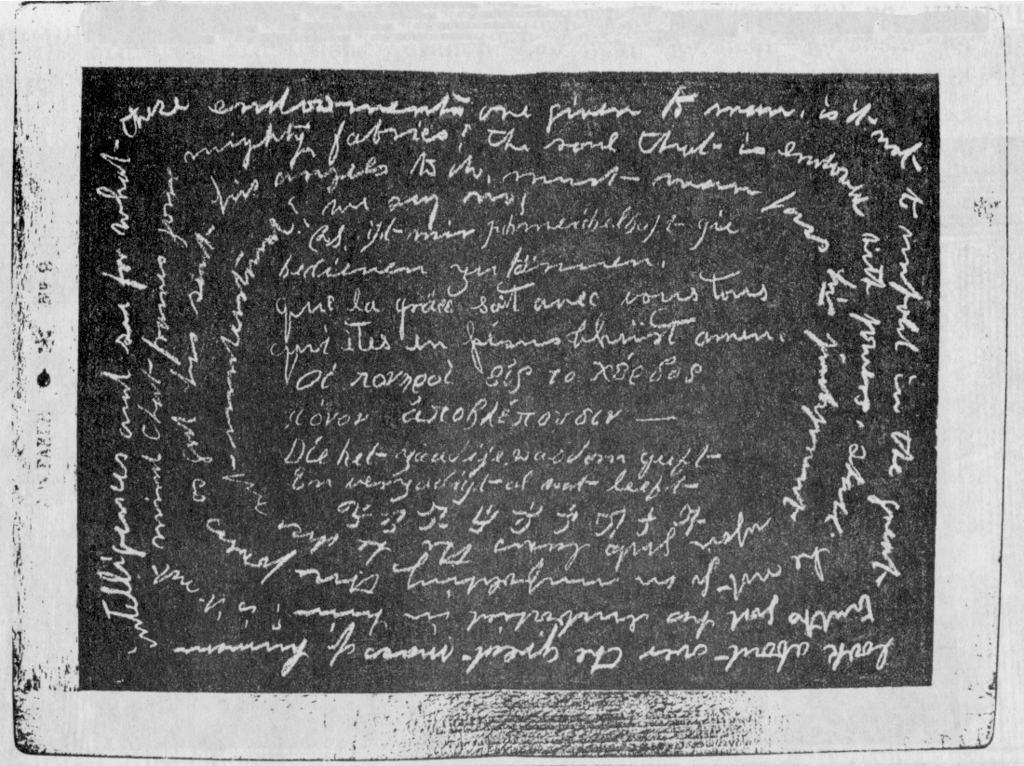

**Image 10:** Slate tablet with paranormally produced writing in five different languages, received in December 1878 through the medium *Henry Slade* at the residence of *Mr. I Kleeberg* in Berlin. (Taken from 17, Volume 3, plate VIII).

* *These and other experiments that were carried out since the middle of the 19th century in a lot of countries in Europe, the Americas and Asia, sometimes by eminent scientists, furnish evidence gained through experience that another, for us invisible sphere of existence exists next to our material sphere of existence, one that we will enter after our terrestrial demise. It is however not completely occlusive from us, because people with the appropriate psychic gifts possess the opportunity to exchange information. Parapsychological experiments and psychic messages furnished and still being furnish provide the evidence for our personal survival after our terrestrial demise (Source: 18; 4).*

Messages from the world of the hereafter usually do not come to us through direct writing on slate tablets or paper as with *Henry Slade* but usually through the automatic writing or psychic speaking of a suitably gifted medium. People close to death sometimes also give accounts of strange experiences from the borderline between life and death after having been physically unconscious. – Experiences that one can already regard as a fist insight into the world of the hereafter. The Swiss-American physician *Dr. Elisabeth Kübler-Ross*, like the American physician *Dr. R. Moody*, collected such near-death experiences from their patients and she tells about them in the preface of *Dr. Moody’s* book (19, P. 10):

“All of these patients experienced the sensation of being carried from their material physical shell and of having had a deep feeling of peace and wholeness. Most of them perceived another person, one that helped them during their transition to another level of existence. Most of them were welcomed by relatives that had gone before them, relatives they were close to or a religious personality that played an important role in their life, one that naturally conformed to their religious convictions.”

*Dr. Elisabeth Kübler-Ross* writes about the process of one’s final departure from this Earth in her own book “On Life after Death” (20, P. 76):

“After we have been welcomed by our otherworldly relatives and friends, and also our spirit guides and guardian angels, we undergo a symbolic transformation that is often described as going through a kind of tunnel. This transformation is represented through a river with some and as a gate with others, all according to each’s individual relationship to the value of symbols.”

A *third method* of direct writing is one where observers can *actually follow* how the writing comes into being. The writing implement (a pencil or a ball-point pen) is usual of a size that it cannot work obscured. The observers do however not see a hand guiding the writing implement. The pencil is enveloped by a cloudy structure of ectoplasm instead.

We can see one such case in image 11. It shows the direct writing with the Danish medium *Einer Nielsen* (1894 – 1965) on the 14th of February 1953 in Copenhagen.

The medium is in a full trance, sitting on a chair in what is called a cabinet, not visible here. The spectators sat themselves around a small table and they placed their hands loosely on top of one another. A pencil started to write on the table, it is surrounded by a veil of ectoplasm.

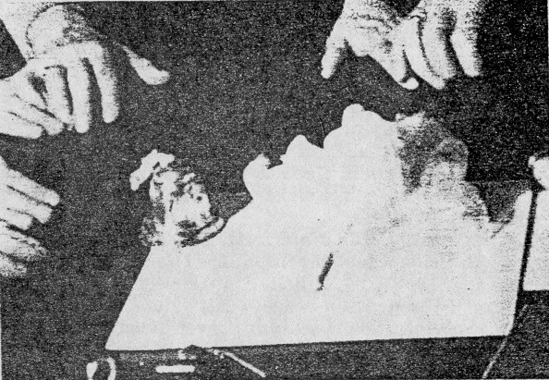

**Image 11:** The development of direct writing with Einer Nielsen on the 14th of February 1853. (3, P. 73).

The already mentioned SORRAT group in the USA, now situated in Rolla, Missouri, also photographed the development of direct writing and they were even able to film it a number of times.

One can see on the pictures how a ball-point pen stands erect over a piece of paper and carries out writing movements. It is however *not* enveloped in a veil of ectoplasm. Meaningful and easily legible texts of a similar content that those with *Henry Slade* eventuated.

Image 12 shows a part of the writing that eventuated in November 1988 in Rolla. It was taken from (16, P. 12).

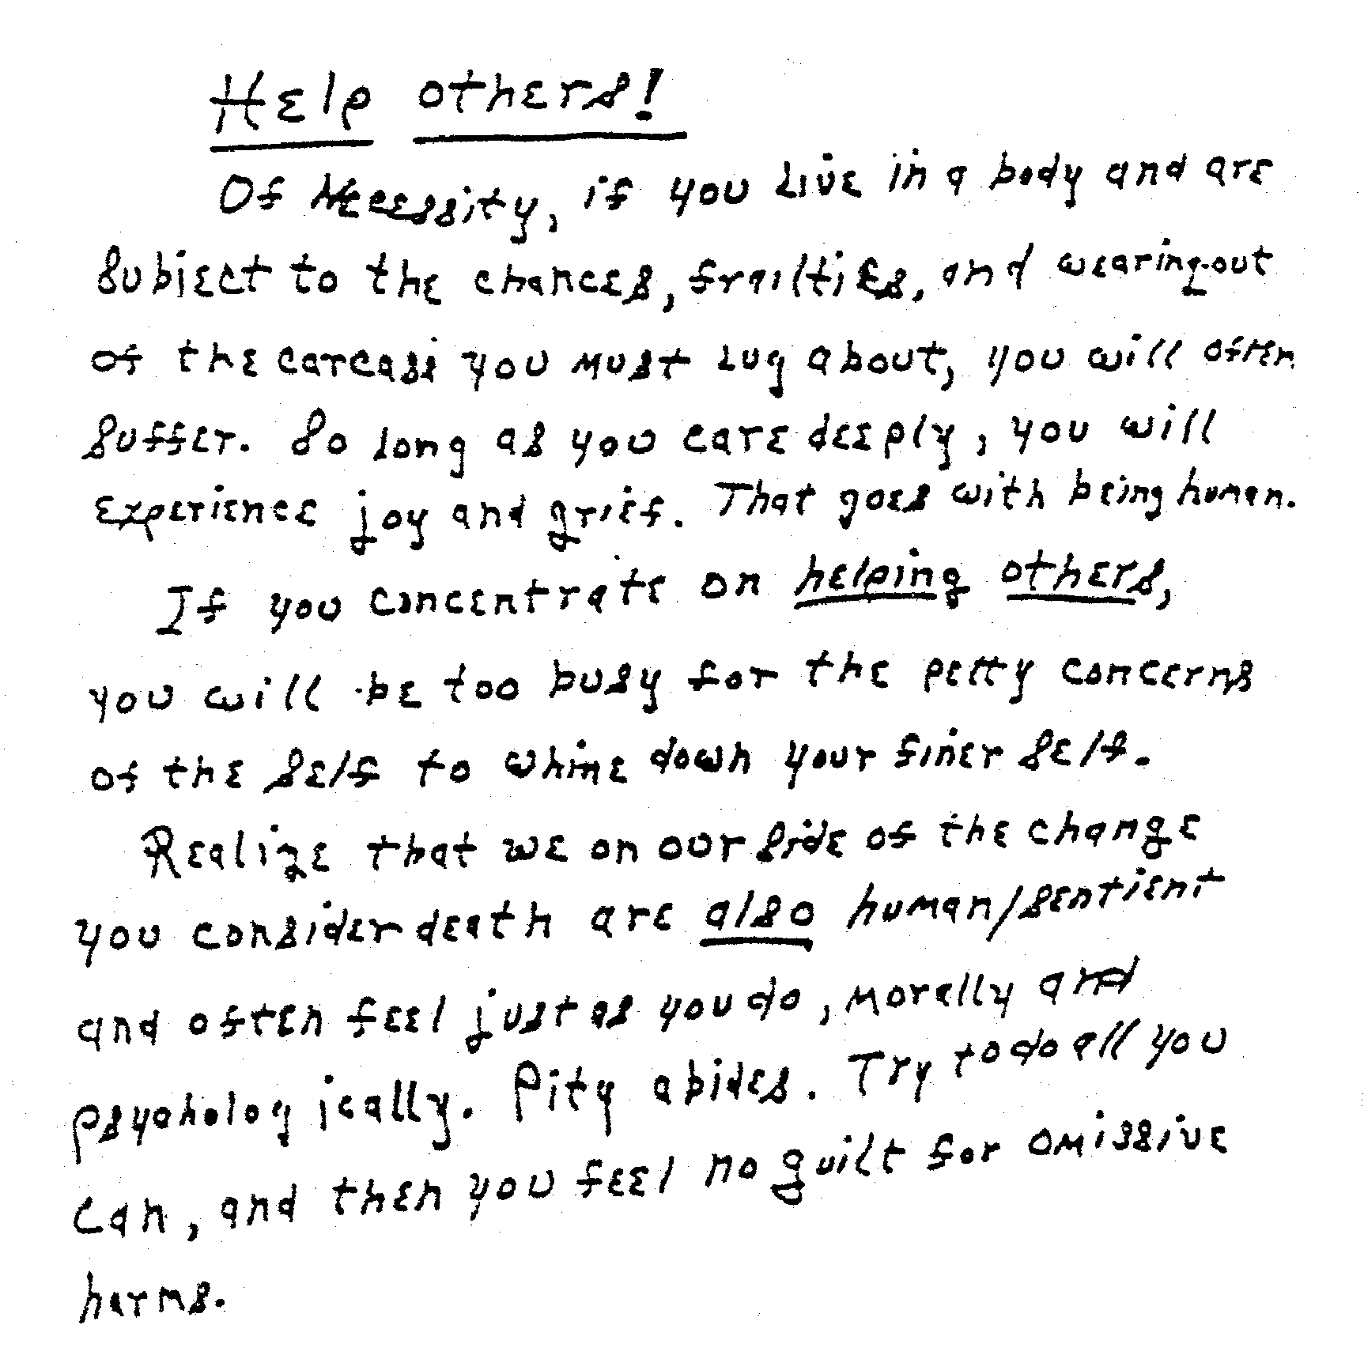

**Image 12:** Direct writing, received in November 1988 in Rolla.

**10. The effects of so-called “materialisations”**

When making contact with the world of the hereafter, when the method functions, there are always some effects here on Earth, for instance through parlance or writing. This can however also take place through the temporarily reconstructed physical body of otherworldly beings (deceased people most of the time) that is then capable of performing various actions, for instance talking, writing or moving objects. This is then called “materialisation”. One talks about a *“full materialisation”* or a *“full-phantom”* when a “human” body is reconstructed completely or almost completely. But one talks about a *“partial materialisation”* or a *“partial phantom* if only a part of a human body is reconstructed.

Phantoms are constructed from terrestrial organic matter that sometimes flow visibly from the medium as so-called *“ectoplasm”*, it sometimes flows invisibly from the medium that is usually in a trance, but it can sometimes *also be gathered from the spectators that are present*. The ectoplasm is sometimes capable of separating itself from the medium and to preform itself into a phantom. A complete, human-like shape can eventually develop from it.

* *Their heartbeat, pulse and breathing have been tested, we are therefore dealing with entities with a temporary body, sometimes for the duration of a minute to a maximum of one hour. The phantoms dissolve again after, whereby the physical matter the phantom has been constructed of returns back to the medium.*

The following were well-known and eminent materialisation mediums:

* *Carlos Mirabelli (1889 – 1951)*
* *Margery Crandon (born around 1895 – 1941)*
* *Einer Nielsen (1894 – 1965)*
* *Elisabeth d’Esperance (1855 – 1919)*
* *Franek Kluski (1874 - ?)*

With the latter we are dealing with a former senior bank employee and writer from Warsaw. Next to other apparitions, the appearance of isolated and animated “human” hands and sometimes even feet, could be abundantly observed in his presence. At the turn of the year 1817/18 he discovered his own psychic abilities when visiting meetings of the Polish materialisation medium *Jan Guzyk*.

This ability developed to an astonishing degree over the next years and he wasn’t just tested in Warsaw, but also at the laboratories of the *Institut Metapsychique International* in Paris. The examiners in Paris were the director of this institute *Dr. Gustave Geley* (1868 – 1924), French Psychologist *Professor Charles Richet* (1842 – 1925), French astronomer *Professor Flammarion* (1842 – 1925) and various intermittent observers. The following processes could also be observed over the years with *Kloski n*ext to the ones described in detail below:

* *Paranormal movements and levitations* of tables, other objects and of people (Medium and participants at his meetings).
* *Paranormal light and luminous phenomena* of various types.
* *Paranormal rapping sounds* and *automatic writing* by the medium in a semi-trance or full trance under the influence of otherworldly entities.
* *Paranormal magnetic processes* and the materialisation of complete “living creatures” (human beings and animals).

We are dealing with the paranormal materialisations of separated human limbs to begin with. The experiments took place at the *Institut Metapsychique International* in Paris towards the end of 1920. A room the size of 5m by 9m without windows, but with two doors that were locked during the experiments, served as a laboratory. Apart from *Kluski*, *­*who sat on a simple chair, only the examiners were present. Two of them, one on each side, held his hands during the duration of the experiment. The rest of the participants also held one another’s hands, thereby creating a closed “chain”. Due to the light sensitivity of the ectoplasmic object the lighting consisted of a dark-red light of a 50 Watt filament lamp.

*Kluski* remained almost completely quiet during the duration of the meeting. The only movement that he sometimes made whilst in the trance state consisted of placing his head onto the table in front of him or onto the shoulder of one of the controllers. His hands never moved.

After the start of the meeting, *Kluski* very quickly fell into a *semi-trance* state, he therefore remained conscious and he could also observe all happenings. Every act of will or every attempt of any other active participation by *Kluski* immediately stopped the processes. Complete passivity of the medium was absolutely required. *Kluski* sometimes fell into a full trance in order to achieve this to a sufficient degree. The processes eventuated relatively soon once the meeting had started. Pulse and breathing accelerated somewhat during the process.

*Dr. Geley* reports about the 14th of November 1920 (12, P. 74):

“*Professor Richet* controlled the left hand of the medium. I suddenly saw a white mass emerge from the left side of the medium that almost immediately took on the form of a hand, it agilely advanced forward until it touched the arm of the professor. The latter called out at that very moment: ‘I have been touched” as he had not yet seen the hand. This same fact probably happened numerous times, but this had remained unnoticed.”

Geley reports about the meeting on the 20th of November 1920 (12, P. 75):

“I held the left hand and *Count Julius Potocki* the right hand of the medium. The control was complete. Amongst other important phenomena, I suddenly saw a long and delicate hand at the end of an arm, it formed in front of my eyes, move diagonally across the circle towards *Madame Geley* who sat opposite me. The whole hand, the forearm and the upper arm were visible. It was the beautifully formed hand of a man. The wrist was delicately developed, forearm and upper arm were dressed in a fabric made from white linen with regular longitudinal folds. (The medium wore black paletot). This shape disappeared after it had touched *Madame Geley*.”

These hands often touched the observers that were present. They felt *warm*, as warm as “living” hands at normal temperature. They grazed or stroked the hands, arms or heads of the experimenters in particular. The touch was always soft and gentle, never fierce or rough. They often moved object that were there and they were sometimes *self-luminous*. In order to be able to verify these limbs not only subjectively, but also objectively, paraffin forms were made that were later filled with plaster. Professor for anatomy at the University of Michigan (USA) *F. W. Pawlowski,* born in Poland, participated at one of *Kluski’s* examinations in Warsaw in 1924. Human full-phantoms appeared on this occasion and Pawlowski reported about it (9, P. 19):

“In Kluski’s case, the phantoms usually appeared *unexpectedly* behind or next to the medium. I then saw something akin to *illuminated smoke or fog* that was hovering over the head of the medium like a small cloud. The cloud moved sideways and within a few seconds turned into a human head; or it spread vertically and turned into a complete human apparition that immediately began to walk around etc. The phantoms often appeared far from the medium, behind the backs of the participants furthest away or the furthest part of the room where the meetings took place.

The phantoms appeared behind my back on several occasions. The sound of their breathing made me aware of them, something I could hear them clearly, even before those that sat opposite me could see them. When I turned around I saw their faces one foot away from me, they smiled and they looked at me attentively. Some of them breathed very heavily as if they had come from a strenuous run, when this was so, I felt their breath on my face. I once listened to the heartbeat of one of the phantoms.

These apparitions moved around the table and around the participants. They performed strange movements and jumps that if they had actually been connected to the medium with an ectoplasmic cord or a similar band, the participants would have been wrapped around with it. None of the participants of this circle ever mentioned such an ectoplasmic entwinement.

Judging by the noise of their footsteps on the floor, the weight of the phantoms must have been normal. When one was touched, one had the impression of being touched by something dense. But a lot of these apparitions flew through the air, over the table and the participants if one asked them to do so. At one such opportunity I observed two phantoms flying above our heads under the high ceiling and perform strange summersaults, whilst one illuminated the other with panels of light. It was really something beautiful to behold, a kind of aerial ballet.

The phantoms quite often placed the panels of light in front od me after they finished their turn around the table and before they vanished. It tried a couple of times to stop the nearest apparition to me from grasping the panels of light by picking them up with my hand. But they were taken from me every time with a firm and strong grip.

The most surprising and interesting thing about these apparitions, virtually the most important thing for me, was the perfectly human way they behaved. They behaved like participants within a society. During their rounds around the table they greeting the more familiar participants with a precognitive smile, whilst they attentively looked at new circle participants. The inquisitive look in their eyes is difficult to describe and is akin to that of children at an age when their intelligence awakens. One spontaneously thinks about whom amongst the two, human being or phantom, is more interested to see the other.

Some of the phantoms are more mellow whilst others show a more cheerful disposition. I could gather from their endeavours to understand our glances, our questions and our answers and from their actions, that they were very interested in convincing us that they are actual entities and not an illusion or a hallucination.

As these apparitions are perfectly human and realistic at the same time, a critical sceptic will say: ‘Well, this is easy, they are actual human beings.’ But this wouldn’t explain the partial materialisations of hands, arms and heads. These apparitions are also not always of a normal size. Towards the end of a meeting, when the medium is somewhat exhausted, or if it didn’t feel too well before the meeting, the phantoms are not their full size, but only a third or half their size. When I first saw such a phantom I thought that it was a child, but closer inspection showed a wrinkled face that told me that it was an old woman or an old man of abnormal size. The circle’s leader used to say in such cases: ’We want to help the medium (a technical expression within the circle). He began to knock a rhythm to which all participants breathed deep and rhythmically. The effect of this process was wonderful: The diminutive phantom figure grew and achieved its full size within a few seconds.

The phantoms that showed up with Kluski belong to various nations and they usually speak their native tongue. But they understand the language of the words directed at them very well in spite if this (Polish is usually used within the circle).

They seemed to have the gift of being able to ‘read’ the souls of other souls, because it isn’t really necessary to express a wish or a certain question out loud. The thought alone suffices to have it acted upon. One only has to think about what one would like the phantom to do and the request is either carried out or refused. Some do indeed refuse at times to do certain things or they declare that they are not capable of doing it or at least not at this hour, or they promise to do it or attempt to do it at another opportunity.

Not all apparitions can talk. A lot of them prefer to communicate through rapping, something that is extremely boring and time-consuming, because one always has to recite the alphabet from the beginning. The voices on the other hand are perfectly clear and of normal volume. They sound like a loud whisper.

The expression of their faces whilst they talk is very convincing. At one opportunity I could clearly perceive an expectant expression on the face of the apparition of a Turk (often also seen by the other participants) who bowed in front of me saying: ‘Chokyash Lehistan’. When he realised that I did not understand he repeated the same words with a smile on his face. Not knowing what he wanted, but with the feeling of sympathy derived from the Polish nation’s chivalric notions, I said to him: ‘Vive la Turquie’. One could clearly see how pleased he was about this. He smiled, his eyes beamed, he crossed his arms, bowed and he disappeared. I wrote his words in polish-phonetic style in my notebook. Next day, I asked someone who knew the language to translate these words to me and found out that it meant: ‘Vive la Pologne’.

I could narrate many more interesting experiences, but I must stay within the boundaries of my report. Some of my observations were not included in this report. I am in the process of dealing with the phenomena that I have not mentioned here and I will soon send them to Warsaw.

In any case, I am convinced that we are on the threshold of a new science and maybe also reached a new era.

People will find it impossible to negate or dismiss these phenomena and it is impossible to explain them as some slight of hand.

I admit that all of this is beyond our comprehension. The miracles of modern science have corrupted us. We can no longer believe in the natural that comes to us with such great beauty, we can no longer believe in mysteries. To accept this would change our whole position in regards to life and death from the ground up and also that of philosophies and the sciences.”

A lot of full phantom phenomena appeared with Einer Nielsen in Copenhagen and they were also photographed numerous times.

* *One estimates that 1,700 materialisation meeting took place between 1914 – 1961 with Nielsen and that around 17,000 full-materialised phantoms appeared.*

Many figures appeared more than a hundred times, but depending who was amongst those present and amongst the spectators, new one also came all the time. The phantoms that intermittently turned up professed to be deceased relatives or friends of those present and they were indeed recognised and acknowledged as such.

Image 13 shows a photo of a full-phantom or almost full-phantom male, that showed himself to Einer Nielsen in 1950. It is not yet or no longer fully materialised because the left side of its body is *diaphanous*.

* *The right arm of the medium standing behind in a full-trance can be seen through the phantom.*

In order to show that the phantom is not the dressed medium, the controlling spirit made the medium step out from behind the curtain of the separated cabinet. The medium’s closed eyes indicate a full trance.

* *The phantom doesn’t actually stand, it hovers between the first and the second row of the spectators, ladies in this case and they can be recognised by their white collars.*

The severe mummification of the phantom is due to the fact that the *visible flashlight* used in Copenhagen at that time was *very unpleasant* for the phantoms and their ectoplasmic body. The powerful flash of light immediately dissolved them. The white garment was supposed to reflect as much light as possible.

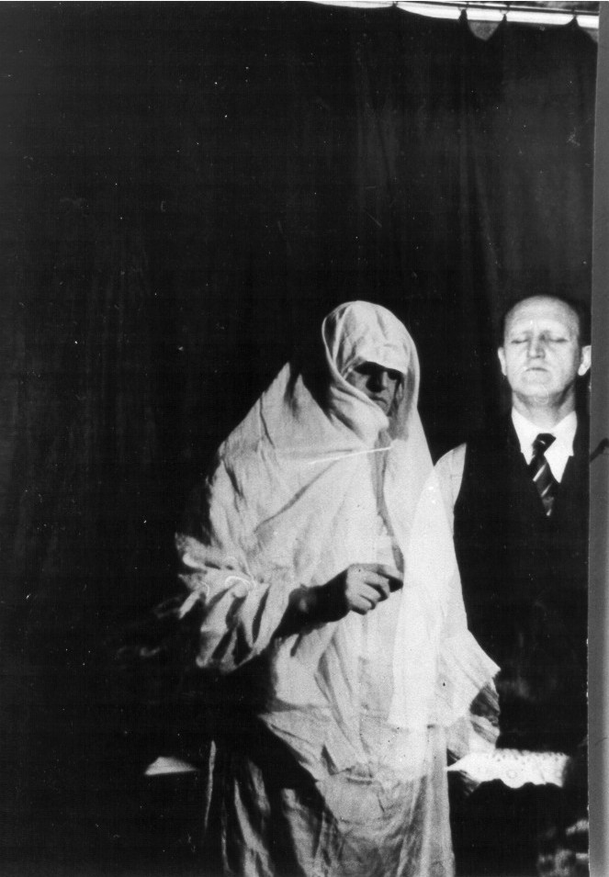

**Image 13:** The male phantom, hovering in from of the medium Einer Nielsen, still partially diaphanous. Photo taken in Copenhagen in 1950. (Taken from 3, P. 70).

**11. Final observations**

The readers of this treatise might, depending on the inner attitude, feel a desire to also make contact with the world of the hereafter.

* *It has to be said that such a step is not without danger!*

To not take any precautions is akin to opening the front door at night and calling out: “All of you, just come in!” Those that come can turn out to be very disagreeable and in certain circumstances, might not want to leave again voluntarily. Many have been robbed or murdered because they indiscriminately allowed unknown people to enter their home. The same can happen when one makes reckless contact with the world of the hereafter.

I depicted the kind of terrible things that can happen in the treatises (12, Chapter 6; 14). I give you an example here. It was reported by the American parapsychological researcher *Professor Hans Holzer* (born 1920). After describing two previous cases he writes (7, P. 154):

“I heard about a considerably more serious case soon after wherein no positive result ensued. It deals with the wife of a well-known publishing director. She wrote, painted, was a beauty, very witty and well liked within society. She was not physically ill when these events took place. She drank a glass or two now an again, but she was no alcoholic and she didn’t suffer from depression. She had no problems and also no interest in the occult, something she regarded a superstition.

This *Mrs. K.* was at the cottage of a relative whose hobby was ‘moving tables’. She was in good spirit and she allowed herself to be talked into participating, not out of curiosity, but to oblige her host. A friend of the host was also present and she carried out the function of convenor.

*Mrs. K.* had hardly placed her hands on the table when she found the whole thing too boring and she got up. One then produced a Ouija board and *Mrs. K.* joint the group again. The board seemed to completely concentrate on *Mrs. K.* and to such a degree that she became frightened and wanted to stop, but the host talked her into taking a piece of paper and a pen and to write if the spirit wanted her to do so. *Mrs. K.* thought that this was unlikely and she was very surprised when the pen stated to doodle something on the paper that seemed to be a distorted face, maybe the face of an insane young man. The writing was arranged around the drawing and it stated:

‘I have killed the ones that I love.’

The word ‘killed’ was written with such force that the paper underneath was torn. *Mrs. K.* jumped to her feet, screamed wildly, something that filled the others with fear, and went into such a deep trance that she didn’t seem to be back to normal for a long time. Afterwards, she was deeply distressed about her first experience of being thus controlled. She was now no longer as sceptical as before and she swore to never ever challenge the eerie ever again.

But the door that she had opened did not want to close again. She became the instrument of a whole series of disembodied personalities that used her as a medium in order to make themselves known after years of disappointed oblivion. They were soldiers, the architect of the house, a gentleman from the 18th century and the violent murderer who had open the psychic door. He had been a painter and he began to control *Mrs. K.* to such a degree that her own pleasant style was supplanted by the violent, forceful style of this young man. She couldn’t pick up a brush without being under his influence.

This was followed by a brutal old hag (an untidy, neglected old woman) and she cause *Mrs. K.* a lot of harm.

Her frightened husband had her examined in every respect, but one certified her as being spiritually and mentally extremely healthy. An explanation for what was happening to her could not be found. A series of psychiatrist, friendly towards parapsychology, tried to help her – but without success.

After I was introduced to her I tried to encourage the personality that had entered her to leave her mind. But one cannot talk to an insane person and the battle ended up being a very tough one. To have her gain some kind of control took months and required intensive and deep hypnosis.

She had a few personal disappointments, she wrote and painted very well, but nothing had been published or sold.

These disappointments were soul destroying and they drove her toward alcohol. It now became even *more difficult* to keep alien personalities from entering her mind. The new opportunities gradually began to fascinate her and she spend a lot of time with developing her psychic talents. Instead of closing her mental door, she opened it wide for all the personalities that wished to write with her hand.

She started to ail and her state of health did not improve in spite of all the cures she took. Her body was already damaged. A lot of people tried to help her by expelling the alien spirits that controlled her.

*Mrs. K.* is an invalid person now, someone who cannot hope for a noticeable improvement of her state of health. A had success with her for a while, but once she no longer expressed the desire to fight, all endeavours were in vain.

As a medium, *Mrs. K.* attracted all these alien personalities. She was a natural, but she didn’t know and she never learned how she could control these invasions so that they couldn’t harm her.

* *There are registered cases of seemingly healthy people that suddenly run amok or kill close relatives. They usually cannot give a reason for their actions. A lot of them no longer remember anything from a specific point onwards, they have what is called a ‘mental block’.*

Did another personality take control of their body to commit the terrible crimes? – Did an evil disembodied entity discharge its malice and animosity through a man who came home after a day’s hard work?

No court of law will accept such an explanation – but it could be the truth just the same!

* *Such cases often happen under the influence of alcohol.*

The band between the conscious and unconscious mind loosens when in an alcoholic state and this makes it easy for another spirit personality to take possession of someone’s spirit. This also applies to a weakened consciousness after using drugs, this includes medicinal and psychedelic drugs (in a euphoric, trance-like state of mind caused by drugs) like opiates and barbiturates.

However – without the ESP ability (ergo psychic gift) of the ‘victims’, such terrible things would not have eventuated. ESP is in such cases rather more of a curse than a blessing, because the so affected do not know how they have to behave.

*The best defence against this is still the knowledge of human capabilities and a better understanding of the duality of our world – spirit and matter.”*

Thus far the explanations of Professor Holzer.

I would like to add that *knowledge based on religious* and a *connection to GOD* are required to better defend oneself. *Holzer* doesn’t mention prayers asking for divine protection at all, he does however talk about hypnosis and kind words. But this did apparently *not suffice*.

* *The communication with the world of the hereafter may never degenerate into something to amuse society, to satisfy one’s curiosity or into child’s play.*

“Moving tables” was for instance used by many people to amuse themselves during the turn of the century (19th to 20th century) and writing with a planchette is carried in many classrooms *by students* these days. Youth magazines provide the necessary explanations and they explain how one can make contact with the world of the hereafter through “pendulums”, table rapping and psychic writing. This may remain harmless and without damaging consequences in many cases, because it doesn’t function due to a lack of psychic ability or because one soon gets bored with it and ceases to attempt it.

* *It can however have terrible consequences through the onset of hearing voices that cannot be silenced in the form of obsession or possession. Those so affected can end up at a psychiatrist faster than they care to.*

Here an example: Towards the end of October 1987, I was visited by four ladies and a gentleman who had read exact instructions for making contact with the hereafter in an old issue (September 1986) of the *youth magazine “Bravo”*. They said to themselves: We can surely also do this if children can accomplish it. They did indeed manage to get a small table to levitate under the hands they placed upon it. Three of the four ladies displayed psychic abilities, particularly a *Mrs. D.* She heard voices and soon after began to write automatically. She was impelled to transmit the most diverse messages, particularly from a spirit entity that professed to be the deceased mother of one of the other ladies. The entity indicated that it had been poisoned and that the tankard used to give her the poison was still in the coffin. One should open the grave and remove the tankard with the poison and read a requiem. Her mother had however died of natural causes!

The conditions and the conspicuous behaviourism of *Mrs. D,* became so dire over time, that her husband and her mother instigated her committal into a *psychiatric institution*. Mrs. D. was treated with psychotropic drugs there, but they were very unpleasantbecause of their side effects. In order to be released from the institution, she asserted that she no longer heard voices. She did in fact continue to hear voices and she remained in contact with the otherworldly entities after her release from the psychiatric institution. In order to be able “to converse” with them, she was instructed to talk normally or to whisper when giving answers. Under instructions from the spirit entities she had to learn to speak without moving her lips so that her relatives didn’t notice anything.

When *Mrs. D.* visited me, she declared that she talked to her spirit entities for about two hours every day. She thought that she no longer dealt with hoaxing spirits, but with spirits that wanted to help other spirits. But she had received instruction *to no longer read the Bible*. The spirits were going to tell her later about the things that were right in the Bible and that were wrong. *Mrs. D.* wasn’t perturbed by this request and she behaved in a very trusting manner towards her spirits. The first *nonsensical requests* didn’t make her suspicious at all. She didn’t follow my advice to entirely *cease* her contact with her spirit entities and to balk at any further messages and requests. She abided by the forbiddance by her spirit entities to visit me again. I am afraid that *Mrs. D.* will in the long run encounter an unfavourable development of her situation.

* *But those that dare to make contact due to a thirst for knowledge or search for religious truth in spite of the possible dangers, should only do so if they have no material aims, if they have a solid religious foundation and constantly ask God for his protection through prayers.*

The already mentioned *Pastor Johannes Greber* received the following indoctrination from the world of the hereafter in regards to this (5, P. 35):

“The training of mediums is an important and sacred affair. You should therefore often pray for the mediums during your meetings and ask God for energy and assistance so that everything will run according to God’s will and so that the mediums become useful instruments in the hands of goodness and so that they remain true to God.”

* *Besides, everyone that participates in psychic communications should be very careful and not allow themselves to become indiscriminate servants of otherworldly entities, entities that might possibly profess to be God, Christ or some other famous personality. Such entities are to be subjected to stringent examinations and they must be rejected if the slightest suspicion arises.*
* *Besides, one should treat all predictions about an imminent end of the world with a sceptical mind.*

*Only then* can seekers hope to draw a rich, spiritual benefit from the communications with the hereafter and gain an even *more solid* relationship and *greater* trust in God and in Christ. Their lives will then run along quieter tracks and not every calamity will bowl them over and make them despair. They will find it possible instead to help other people in their distress and hardship and to console them and give them hope. Such seekers will already endeavour to arrange their lives here on Earth in such a way that it will not disadvantage them after their demise.

* * * * * * *

**Bibliography**

(1) A. Findlay: "Gespräche mit Toten", Verlag Hermann Bauer, Freiburg 1960

(2) L. Flint: "Voices in the Dark", Verlag Macmillan, London 1971

(3) H. Gerloff: "Die Phantome von Kopenhagen, ein Bilderbuch", Verlag Welt und Wissen, Büdingen-Gettenbach 1958

(4) H. Gerloff: "Das Medium Carlos Mirabelli", Verlag Walter Pustet, Tittmonning/Obb. 1960

(5) J. Greber: "Der Verkehr mit der Geisterwelt Gottes, seine Gesetze und sein Zweck". Johannes Greber Memorial Foundation, 139 Hillside Avenue, Teaneck, N.J. 07666, U.S.A., 10. Aufl. 1987

(6) J. Greber: "Von Gottes Boten inspiriert. Die Schriften eines Bauernjungen", Johannes Greber Memorial Foundation, 139 Hillside Avenue, Teaneck, N.J. 07666, U.S.A.

(7) H. Holzer: "Das Übersinnliche ist greifbar", Prisma Verlag, Gütersloh 1978

(8) R. Mikulasch (Herausg.): "O Medium Mirabelli", Santos (Brasilien) 1926

(9) F. W. Pawlowski: "Die Mediumschaft des Franek Kluski", Z. f. Parapsychologie 1926, S. 5-22

(10) J. T. Richards: "SORRAT, A History of the Neihardt Psychokinesis Experiments 1961-1981", The Scarecrow Press, Metuchen, N.J. & London 1982

(11) W. Schiebeler: "Der Tod, die Brücke zu neuem Leben", Verlag die Silberschnur, Melsbach/Neuwied 1988

(12) W. Schiebeler: "Zeugnis für die jenseitige Welt, eine Darstellung der Erfahrungsbeweise", Verlag "Die Silberschnur", Melsbach/Neuwied 1989

(13) W. Schiebeler: "Leben nach dem irdischen Tod", Verlag "Die Silberschnur", Melsbach / Neuwied 1989

(14) W. Schiebeler: "Die Zuverlässigkeit medialer Durchgaben und die Prüfung der Geister", Parapsychika 1980, S. 64-102

(15) S. Türck: "Jeg war dus med Aanderne", Steen Hesselbachs Forlag, Kopenhagen 1940

(16) W. Uphoff: "New Paranormal Scripts from Rolla, Missouri", New Frontiers, No. 30 & 31 / 1989, S. 12

(17) F. Zöllner: "Wissenschaftliche Abhandlungen", 4 Bände, Verlag L. Staakmann, Leipzig 1878-81

(18) E. Mattiesen: "Das persönliche Überleben des Todes", 3 Bände, Verlag Walter de Gruyter, Berlin 1936-39 und Nachdruck 1962

(19) R. Moody: "Leben nach dem Tod", Rowohlt Verlag, Reinbeck 1977

(20) E. Kübler-Ross: "Über den Tod und das Leben danach", Verlag die Silberschnur, Melsbach, 4. Aufl. 1985

**Index**

Introduction 2

1. The Ouija Board 3

2. The utilisation of the pendulum 5

3. The use of the rapping table 6

4. The utilisation of the psychograph (or planchette) 9

5. Psychic or automatic writing 10

6. Speaking in tongues 15

7. The visionary show 15

8. The direct voice 16

9. The direct script 18

10. The effects of so-called “materialisations” 28

11. Final observations 33

Bibliography 37

1. **Urim and Thummim =** Truth and Clarity or as Luther translated it = Light and Justice.
2. All Bible citations according to the translation by Dr. Hermann Menge.
3. One would call her a medium these days, one through which deceased people and other otherworldly entities could announce themselves. Necromancers mainly made contact with spirit beings antagonistic towards God in those days, contact with entities from heathen religions, the so-called “spiritually dead”. This is why God asked Saul (Leviticus 20, 271) to evict these necromancers (1 Samuel 28, 3) in order to stop the constant seduction of the Israelites through their otherworldly clients. The necromancer in Endor had slipped through the net during these measures and was therefore still alive.