PSYCHO-SCIENTIFIC FRONTIERS

Selected publications from a variety of subjects of psycho-scientific research. Editor: Rolf Linnemann (Certificated Engineer) * Steinweg 3b * 32108 Bad Salzuflen * Tel. (05222) 6558

Internet: https://www.psygrenz.com E-Mail: RoLi@psygrenz.de
Translator’s email : evak30@optusnet.com.au

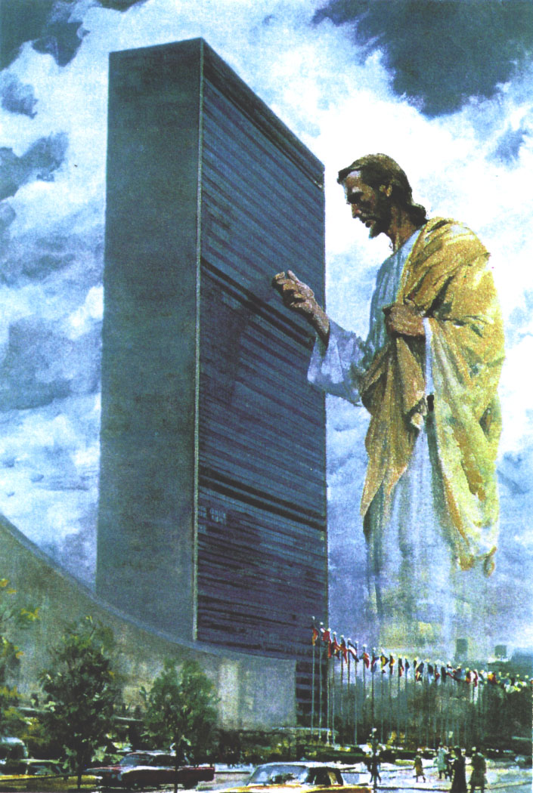

Strangers

visit the United Nations

The following report stems from the journal “Spiritual Life”, F. Schmidt, Cleveland, Ohio, and it is a few years old, but its content is extraordinary.
A reader of the above mentioned journal wrote to the editor to tell him about a radio message and he asked him to publish it in order to find out whether other readers of his journal had by chance also heard the message or whether they could verify it in some other way so that one could ascertain what one was actually dealing with here, - whether some commentator had invented the story or whether it was an actual event, whereby it had not been ascertained whether some dreamer had a hand in this by gaining unauthorised access to the place where this event is supposed to have taken place.

Bad Salzuflen, August 2003

1. Report by the editor F. Schmidt

The letter from the reader from Central-California reached us in 1950 and the gist of it is:

“Dear Mr. Schmidt, my wife and me are still extremely bewildered about a radio broadcast by the Radio Station KHJ that we heard by chance at 8pm on Christmas Eve. We had left the radio on in the hope to hear more Christmas carols. But a voice suddenly appeared instead, it reported about a very specific session of the United Nations at Lake Success, N. Y.. This report didn’t seem to be a direct news report but rather an entertainment segment that had been slotted into the current radio program.

The radio announcer reported: At a specific session of the United Nations, a man was suddenly noticed in the assembly hall wearing a dark suit, his hands looked like the hands of a labourer, tradesman or farmer. Nobody had observed the man entering the assembly hall. He was suddenly there, something that astonished everyone, because the entrances to the hall were usually closely guarded by the police. The delegates however seemed to have simply resigned to the fact that this man was present. A certain content and peaceful mood seemed to permeate the scene to a degree that the unknown man could even approach the Russian delegate Wischinsky. The following words were heard:

‘The axe has already been placed at the roots of the tree for the guilty party.’

The delegate Wischinsky entered the conversation with the stranger in good humour by asking:

‘Do you mean Russia?’

Whereby the strange man nodded. The radio announcer further reported that the strange man also talked to other delegates, but that one didn’t hear from the position the man was who reported the incident to the guy who announced this incident over the radio. This much could still be heard, namely that the strange interloper into the assembly hall called out to the delegates:

‘Why do you turn your plows into swords once again?’

The one that had heard all of this wanted to quickly approach the unknown stranger, but before he could reach him the unknown guest had disappeared without a trace. No trace of him was found outside the building either. He was and remained elusive. Some of the readers of the ‘Spiritual Life’ here in California might have accidentally also listened to this radio report and they could give me their interpretation of it.’

This strange radio report on Christmas Eve about an incident at the United Nations, the ‘Spiritual Life’ reported about in their belated February issue, late because of strikes, was also heard by other readers. Here is a communication from Arcadia, California:

‘Dear Mr. Schmidt, in your February issue you ask for information in regards to a radio broadcast by the radio station KHJ. I didn’t hear the broadcast myself, but I went to an evening lecture in Los Angeles where a speaker mentioned the event the way you reported it in ‘Spiritual Life’. Something must certainly be right about this incident. But why do the papers keep completely quiet about this incident?’

Another letter from Los Angeles:

‘Dear spiritual siblings, we heard the exact same on the radio on Christmas Eve as you describe it in your February issue. We wanted to hear more Christmas carols and this is why we switched on the radio. The news and the voice sounded as if dear God spoke himself and if he wanted to give one last warning.’

The following report came from New Jersey:

‘Dear Mr. Schmidt, I heard the strange radio broadcast about a mysterious visitor to the United Nations and this here in New Jersey. It was the evening of Christmas Eve. My husband and me sat in the living room and we listened to Christmas carols. For no particular reason I asked my husband: ‘What station are we actually listening to?’ ‘I do believe that it is WOR’ my husband answered.

Suddenly, at 7:37, we heard a deep melodious voice talk in a way that asked the listeners to choose between believing what was subsequently said or not. The voice had a resonance that fascinated me. I did unfortunately not have a pencil at hand. The voice proceed to report about a session of the United Nations – about an ‘important conference’.

Once the delegates had assembled around the large table, a STRANGER was suddenly seen in the assembly hall. Everyone was astonished that a STRANGER had managed to enter through one of the very tightly guarded doors. But one eventually got used to the presence of the STRANGER. The mood amongst the delegates was a peaceful one. A discussion about the situation the world was in took place. The STRANGER listened to what the delegates had to say. After all the delegates had their say, the STRANGER entered the conversation and strange as it may seem, everybody calmly listened to him. The visitor talked to every delegate. He said to the Russian delegate Wischinsky:

‘The axe has already been placed at the roots of the tree.’

Smiling benevolently, Wischinsky replied to this comment by asking half mockingly:

‘Do you mean the roots of the Soviet Union?’

The STRANGER affirmed this by nodding his head. He then proceeded by looking at every delegate individually and then declared:

‘I cannot find one single righteous person amongst all of you.’

The visitor wore a costume that was common in antiquity in the orient. He also wore sandals. Somebody wanted to get closer to this figure, but it suddenly disappeared without leaving a trace. The guards at the doors were asked whether they had seen anyone walking through the doors. All of them said no.’

A reader in Milwaukee investigated the whole affair more thoroughly. She had sent a copy of the February issue of the ‘Spiritual Life’ to a specific mission that entertained contact with the United Nations. She received the following answer:

“Dear Mrs. …, we thank you for your letter from the 5th of February and for the issue of the German journal ‘Geistiges Leben’. As the gentleman who usually deals with such things is presently in India, I decided to answer you myself. After I had read the article in the journal, I immediately called the United Nations to asked them to do some research in regards to this event. The answer was that the guards at the doors of the assembly hall believed that this man had simply crept into the assembly hall. They said that this happens quite often when somebody wants to personally talk to one of the delegates. The man in question had simply been expelled from the hall and then let go.! There was nothing mysterious about this case according to the guards.

Sincerely F. J. R. technical adviser.’”

Taken from the “UFO-Nachrichten”, Issue 10, July 1957.

2. A STRANGER once again visits the United Nation

The following article is taken from the “Parade-Magazine” from the 25th of December 1960, one of the Sunday supplements that is published with numerous other newspapers in the USA.

“During the recent convention at the “United Nations” of the highest political leaders in Earth, it was reported that an impressive looking STRANGER, who one assumed to be the speaker of some peace movement, slipped into the foyer for the delegates and preached peace to all those that would listen. The Washington correspondent for the “Parade-Magazine”, Jack Anderson, incorporated this event into a Christmas story whose message was as old as the Christmas festivities we celebrate every year, and as new as today’s newspaper headlines.

The foyer for the delegates within the rooms of the UN felt electrified with anxious concerns. The debate over disarmament this morning had been a stormy affair. The behaviour of the Russians (Khrushchev) had frightened and shocked the statesmen that were assembled there. Even Hitler and Mussolini had not rattled their sabres as much as this man with his rockets. He displayed a new nadir of brutal diplomacy with his waving hands and his screaming voice. The world once again heard the well-known cry: ‘Power before Justice!’ Up in the pressroom, rattling typewriters and telex machines sent his massage of violence and fear to all the nations on Earth. In the high, spacious foyer of the delegates that faces the East River, the diplomats huddled in groups to discuss the ominousness of his behaviour. An obvious warning had sprung from his pomposity and his aggressiveness, namely: “Those that are not with us, are against us!” This is how the nations on Earth make their decisions, some out of fears, others because they are annoyed and still others out of ignorance.

This was the moment when the STRANGER entered. With the exception of an attentive security guard, whose attention was captured by something that could have been a reflected light from one the large wall widows that gleamed in the winter sun, he remained unobserved for a few minutes. The STRANGER seemed to have a glow around him, but the security guard had the strange feeling this was of a different origin than the sparkling sunlight. The STRANGER was tall, held himself very erect and dignified without appearing stiff or arrogant. He was dressed plainly. He wore a not too expensive, but immaculate suit. But it was his head that caught most of the attention. He had thick, chestnut coloured hair, parted in the middle and it fell in waves down to his shoulders. A short, forked beard completed the picture. His skin was suntanned. His blue eyes had a penetrating, authoritative, but strangely mild look about them.

The head of security was used to seeing people of all kind of description, as they were assembled here from all the different countries on Earth. He thought that the STRANGER was the representative of some peace organisation, maybe a little on the odd side, but harmless. He discretely approached him in order to check his credentials.

The STRANGER had move across to a group of Asians and engaged them in conversation. His voice was deep, almost melodic but somehow penetrating. To his great astonishment, the head of security was able to understand every word that was said. It was exactly like the instant translation that took place during UN debates, but without a headphone.

The STRANGER said: ‘Good-will must exist between people before peace can reign on Earth. The LOVE that burns within individual hearts emits a glow. The glow from many hearts could produce such a bright LIGHT, that all DARKNESS would be banned from this world.’

The STRANGER moved from one group to another to spread his message. Attracted by his ‘magnetic personality’ and his talent for languages, the security guard followed him in awe. Others also seemed to notice that the STANGER’S words could be understood by people that spoke a different language. But they rejected this idea as if they didn’t trust their own ears. Whilst he thus pleaded with them, he encountered some cynicism, but he never lost his temper. His face was earnest, well even a little sad most of the time. But when he smiled it was an infinitely mellifluous smile.

The Russian then stormed into the hall with his entourage, agile like a bear. He immediately became the main attraction. Even those that hated and feared him move closer in order to hear what he might say. He traversed the hall, made jokes, slapped people’s backs and shook hands. He held court. The diplomats gathered around him and hung on his every word. Suddenly, as if on command, the people parted and the Russian stood face to face with the STRANGER.

‘Goodwill’ shouted the Russian, ‘that is phrase that will but you to sleep. But we do not sleep. The cannibals want to disarm us so they can stick us into their cauldrons. Our military might prevents them from destroying and devouring us. We cannot defend the achievement of communism with good-will.’

The STRANGER admitted, ‘You have established a great military might. Other nations have done the same and they now lie in the dust of history. A great spiritual power last a lot longer. A military nation is like a wild animal without a conscience and without it, it cannot control its cravings.’ The STRANGER smiled and he asked, ‘who profits from a fight between wolves? Which one of the mauled wolves is better off with his wounds? For as long as nations meet force with force, fear of death and not LOVE will reign the world. Hatred begets hatred, force demands force, one war sows the seeds for the next war. Who should break this terrible cycle?

The Russian said, ‘You talk of peace. We want peace. We are against waging wars. We live on the same planet as the capitalistic countries. All we ask for is co-existence. People do not always marry because they love each other, but they still live in rational harmony with one another.’

‘Those that exclude LOVE from their human relationship amongst one another will not find peace’, the STRANGER warned softly. ‘They expanded their dominion over the dominated without their consent. Brutality and fear might make people obey them, but it will not make them love them. The power of LOVE can however disarm the world in spite of it.’

The Russian snorted like a wild boar. ‘Capitalists do not love their fellow men’ he said. ‘They created paradise for the rich and hell for the poor. Millionaires talk about their belief in God, but they continue to rob the population. This is the power of the Dollar.’

‘Human beings are not perfect’ the STRANGER admitted. ‘Many who pray with their lips do not pray with their heart. LOVE is a delicate plant. It has grown over the centuries, it has blossomed and then wilted again. It has lots of roots – sincerity, compassion, humility and gentleness – and all of them flourish best in freedom. Why are you so alarmed about the word LOVE? Human beings do not love their neighbours less, because they loves their country. They do not love their country less because they love all of mankind. But true LOVE cannot survive without freedom.’

The Russian had a sinister look in his eyes when he growled: ‘Enough of this fairy-tale about freedom. The capitalists boast about their free world. Free from what? The unemployed are free from work. The poor are free from money. – We establish true freedom in our communist countries – freedom from unemployment, from hunger and from exploitation. The capitalists say: Trust in God, love thy neighbour and you will enter paradise when you die. We communists trust in our labour. We want to create a paradise in this life and not in a future life.’

The STRANGER sighed. ‘This word has no meaning without the freedom of the spirit. All human beings would like to have the good things in life. But there is more joy in a full soul than in a full belly. You have a strange paradise where you live, one that causes many people to flee from.’

‘People like to wear their old shoes’ the Russian strafed the Russian, ‘they behave towards communism they way they behave towards new shoes. They are afraid that, like new shoes, the new system could be uncomfortable. Those that fight against it will get hurt. They will end up on history’s rubbish tip.’

‘I know your fondness od Russian proverbs’ the STRANGER replied. ‘One of them states that garbage can best be recognised by its stench.’

‘History is on our side’ the Russian called out. ‘Might is on our side!’

‘Might has always been on the march and justice has always been treaded upon’, said the STRANGER. ‘But the future continues to rise from the dust. Justice lives on in the hearts and the minds of people well after might has been buried in the graves it created for itself.’

He then looked at the Russian with piercing eyes until the stocky fellow began to sweat and to feel restless.

‘Whatever is wrong for one human being to do to another is equally wrong for one nation to do to another’, the STRANGER explained. ‘The deeds of a nation now lie squarely on your shoulders. You can no longer unload your conscience on Lenin or Stalin. You have taken the responsibility into your own hands. Let me tell you something: It is better to suffer an injustice than to cause one, it is better to feel pain than to cause pain to others.’
The STRANGER smiled his lovable smile. The Russian looked at his watch with a sinister look on his face and lurched away followed by his lackies. The STRANGER looked at his departure without saying a word. He then slowly walked from the foyer to the meditation room, where everybody, of every denomination, could pray. His face seemed to be even sadder and his shoulders were slumped. His hand had a well-used Bible in its grasp. The guard waited outside the meditation room. A few minutes passed and the STRANGER had still not emerged. The guard open the door slightly to look inside. The room was empty! The only evidence that the STRANGER had been there was his Bible. It was on a chair and it was open, it showed John, Chapter 10. The guards felt drawn towards it and his gaze locked on to Verses 14 – 16:

‘I am the good shepherd… I know my sheep and they know me and I am willing to die for them. There are other sheep which belong to me but they are not in this sheep pen. I must bring them too; they will listen to my voice …’

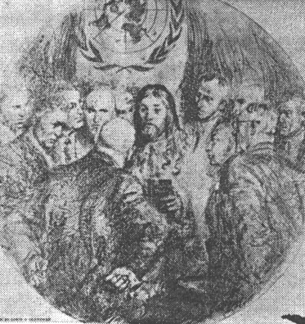

Illustrative depiction of the STRANGER with Khrushchev. .

From: "UN" Nr. 58, June 1961

