PSYCHO-SCIENTIFIC FRONTIERS

Selected publications from a variety of subjects of psycho-scientific research. Editor: Rolf Linnemann (Certificated Engineer) * Steinweg 3b * 32108 Bad Salzuflen * Tel. (05222) 6558

Internet: https://www.psygrenz.com E-Mail: RoLi@psygrenz.de
Translator’s email : evak30@optusnet.com.au

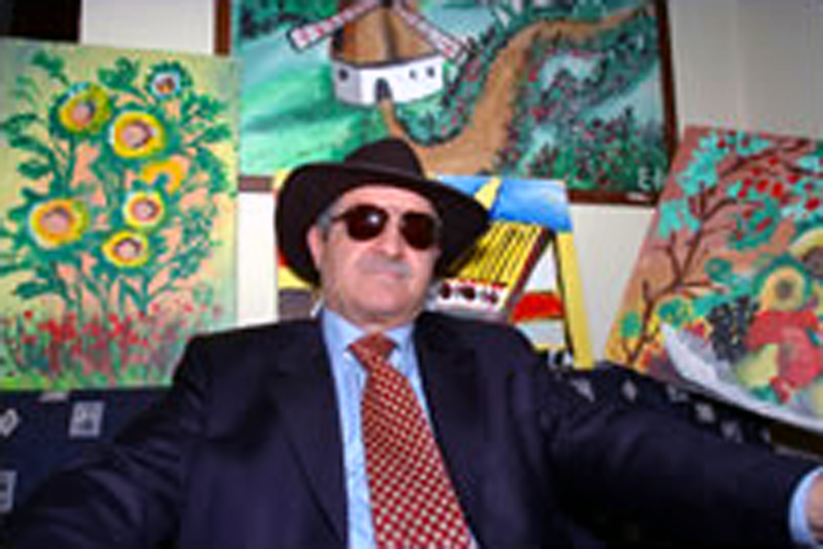

Esref Armagan,

A blind painter from Istanbul,

astonishes the sciences.

Blind from birth, Esref Armagan amazes the sciences. This painter paints with his Third Eye, he claims. Actually, one of the numerous extrasensory phenomena that are at the disposal of every human being. Through Armagan’s paintings, TALENTS and FORCES that slumber in all human beings become recognisable. These latent abilities are unfortunately not trained by the majority of people and they are actually suppressed from birth by the daily distractions our world confronts us with. This blind painter shows us the possibilities.

Esref Armagan was born in one the poorer quarters of Istanbul 51 years ago and has been blind from birth, something that is hard to believe when one looks at his paintings. One of his eyes has not developed beyond a rudimentary bud whilst the other only displays scars. Only a few children from his neighbourhood were educated and Esref Armagan spent his early years on the street just like them. – Isolated by his blindness, he turned to drawing things. He scratched drawing in sand to begin with. At age 6, he used pen and paper. Aged 18, he began to paint with his fingers, first on paper and then with oil paint on canvas and later, from age 42 onwards, with water colours.

Armagan painted houses and mountains, butterflies and flowers, still life, birds and people. Things and creatures that he could never see with his physical eyes. He describes colours, shadows and perspectives, but he never sees any of them. This is why he activated – he says so – his Third Eye that can see everything a human being with healthy eyes can see and he uses it to paint his paintings. Esref Armagan had become famous beyond his nation’s borders when he was 30 years old and he was invited to visit countries like China, Czech Republic, Italy and The Netherlands.

John Kennedy, psychologist at the University of Toronto said: “His paintings are disarmingly realistic and his abilities are enormous. I have tested blind people for decades, but I have never come across an achievement like this.” Esref Armagan was invited to Boston. Scientists there wanted to find out by taking a quick look at his brain, how a man who has never able to see can paint such pictures, pictures that others people can recognise and even admire. One ascertained that he displayed the same brain activities as people with normal vision. – An enigma to the sciences.

Armagan also applies his remarkable gift in his daily life. He walks around without a white cane and finds his way everywhere. He possesses an intensive sense for his environment, because once he has been somewhere, he will always find his way back there, even after a number of years have passed.

Two examples of Esref Armagan’s works:

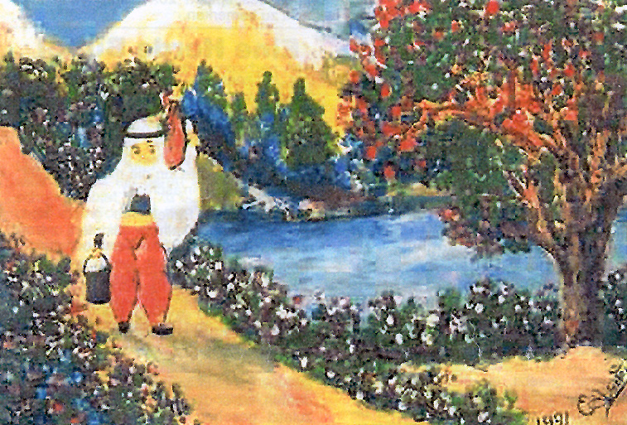

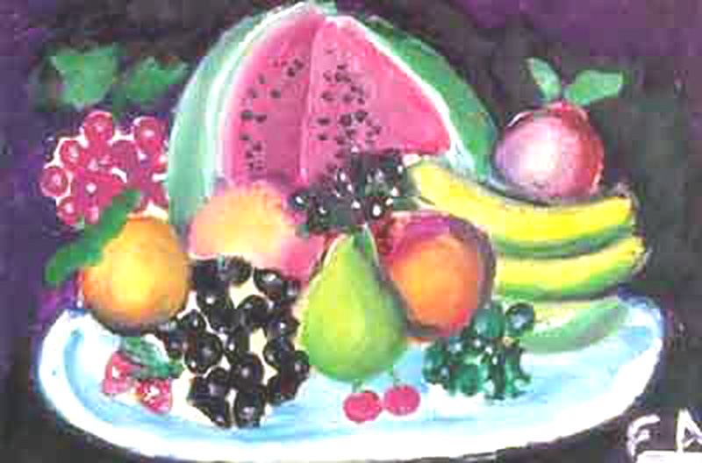

Esref Armagan also painted a portrait of a former First Lady of Turkey and also of the present president and prime minister. Armagan is married and they have two children. His work has been displayed in over 20 exhibitions in Turkey and also abroad. Armagan has been a guest of Turkish television a number of times, also of the Turkish press and he has been on programs of the BBC and ZDF.

Sources:
https://www.newscientist.com/ (also search > Esref Armagan)
https://www.armagan.com

