PSYCHO-SCIENTIFIC FRONTIERS

Selected publications from a variety of subjects of psycho-scientific research. Editor: Rolf Linnemann (Certificated Engineer) * Steinweg 3b * 32108 Bad Salzuflen * Tel. (05222) 6558

Internet: https://www.psygrenz.de/ E-mail: RoLi@psygrenz.de

Author : Professor Dr. Revold I. Polonnikov - Dr. Alexander A. Rasin

Title : Evidence of telepathy through experiments

Professor Dr. Revold I. Polonnikov was born in Tashkent in 1926. We worked at the “Russian Institute for Navigation and Time” and this is where he wrote his dissertations. A professor since 1985 and since 1992, chief scientific director at the Institute for Precision Mechanics and Optics in St. Peterburg and responsible manager for paranormal processes. He dealt with this theme since 1964. A monograph under the name “Einige Fragen des Navigationsproblems in der Bionik” was published in 1968. He published 23 articles on this subject alone. He is the author of six monographs, over 80 articles and made 51 inventions.

Dr. Alexander A. Rasin was born in St. Petersburg in 1953. He has written more than 35 articles, inventions and dissertations at the Institute for Technology at the University at St. Petersburg in physical chemistry. Due to health problems of his wife, A. Rasin came into contact with questions of healing, something that changed his whole life. He discovered the method that allows one to expose energy transfers and he asked himself whether such opportunities would also present themselves to him. Aged 40, he ended his career in the military as a colonel. He had already carried out around 850 healing séances up to that point. Reports about him were published in 150 newspaper articles and 30 television programs reported about him. During the past years he worked with great success as a spiritual healer in Germany, Switzerland and in Spain. He was a speaker in Basel at an ESP convention.

We are faced with considerable difficulties when we try to register the receiver channel of phenomena like Psychokinesis or Telepathy in experiments. These difficulties already arise during the establishment and the introduction of a correct experiment. Further difficulties arise during the primary and the repeated processing of the results of these experiments. Only information from experiments are usable that exclude the traditional transmission channels (the visual, acoustic, kinaesthetic, olfactory and vestibular channels) from the telepathic channel.

It is also very important that the penetration of the sent signal from the agent to the percipient is not possible via bioanalysed channels. Even when the nature of the telepathic channels is unknown, it is still important that no penetration of signals from the agent to the percipient via traditional channels is possible. One other groups of difficulties one encounters is that one has to expect the following when working with signals that carry useful information:

- A very limited extent of a priori information; the nature of useful signals and interferences are not known.
- The strength of the useful signals (if one can actually talk about them in a factual manner) is very minimal.
- Practical work with these phenomena shows that the transfer of information take place via forms and not numbers and symbols as expected.

An attempt was made during these tests, namely to reduce the difficulties on the basis of using codes, because they are stable in regards to interferences.

Organising the experiment

This type of experiment was carried out on the 26th of June 1993 in St. Petersburg (Russia) at the Institute for Precision Mechanics and Precision Optics.

The chair holder was Professor G. Dulnew.
Observers of these experiments were:
Professor Dipl. Ing. Alex Schneider (CH).
Dr. E. U. Hasler (CH) was present as percipient.
Professor R. Polonnicov and Dr. A. Rasin conducted this experiment.
Dr. Rasin functioned as agent.

Two similar experiments were carried out (The second experiment after a urine-therapy treatment by Dr. Hasler). The experiment was conducted with a device complex called “Eniotron”. The measuring probes used, they registered the condition of the percipient and the agent, were a heat flow meter and thermo-elements.

Heat flow and the local temperature were measured near the test subjects. The two test subjects were separated at a distance of circa 2 metres by a wall that resisted all kinds of waves (known waves). No sound, heat, light, chemical and kinetic signals were sent to the test subjects.

A miniature traffic light sat on the table of the agent and it showed red or green at Professor Polonnicov’s discretion. Only the agent saw the light signals. They could not be perceived by the percipient.

The task of the member of the experiment were as follows:

The director, Professor Polonnicov, was in charge of the miniature traffic light. The sequence red/green was planned and controlled to the second with a timer. Only the director knew this program. The control panel was out of sight of the test subjects. The agent had to bring his psycho-physical powers in accordance with the switched on colours. The red light for instance, gave the signal to start concentrating his psycho-physical powers on one of two, previously selected images, the green light on the other. These powers should always be aligned evenly, when one or the other light shone. The percipient was asked in the meantime to concentrate on receiving these completely unknown images or signals.

Disturbance stable codes

Before the start of the experiment, the agent had to be able to concentrate on two different images. The opportunity to conduct the experiment only eventuate after the agent had concentrated on an image.

The selected, image-symbolic connection was tested with this experiment. The agent could only operate with images. We talk about a symbolic connection when we are able to establish a certain sequence with the opportunities presented with these two images. This might give us the opportunity to establish a mathematical code.

As previous research indicated, the telepathic connection functioned retarded (the agent could only concentrate on a new image after circa one minute had lapsed). The Codes of Barker were selected as the first series of codes for the first experiments (Image 1).

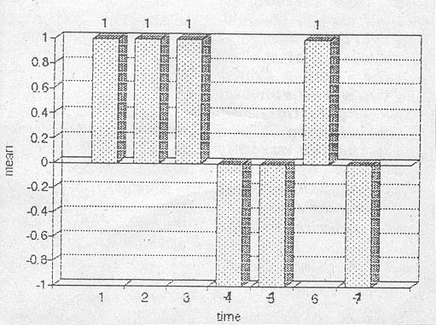
Image 1:
Code of R. Barker

If we apply this hypothesis, namely that different amounts of psychic energies are required to produce two different images, they should become apparent with the change of characteristic attributes, namely the local heat flow on the forehead when the agent changes from one image to the other, and when the telepathic channels functions, also mirror with the percipient.

In this way, when we register the average value of the heat flow or the statistical central value, these processes will have the “image” of the Code of Barker. This “image” might be interfered with a little, but only a simple task in the transmission theory arises, namely the uncovering of the signals with known forms with an additive mixture of signals and interferences. This task has a better solution as extremum of the function of the correlation between the used local heat flow and the main series (Barker-Code).

The results of the experiments

Seven symbols (Barker-Code with m = 7) within a timespan for every symbol of 120 seconds were realised in the experiment. The repeated processing was calculated from the results of the classical statistics and the methods of the apparametric statistics and the non-linear values of the heat flows. We can see a number of examples of the utilisation of the methods of classical statistics in images 2 and 3.

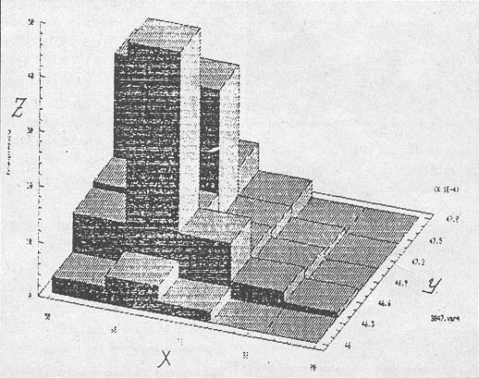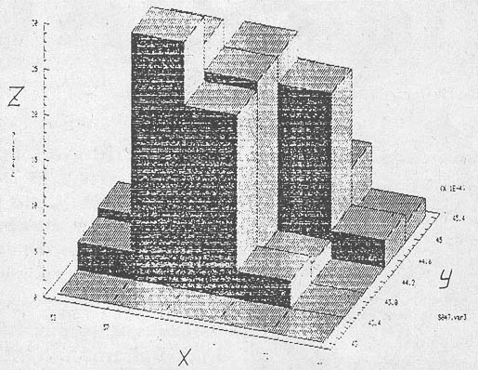
Image 2 Image 3

The histograms are depicted here in three coordinates and they characterise the work done on the objects. Image 2 is a recording by Dr. Hasler. Image 3 by Dr. Rasin.

Coordinates:
X is the heat flow
Y is the local temperature
Z is the frequency

The information signals from the agent and the percipient after the non-linear filtration can be seen in image 4 (first attempt) and in 5 (second attempt). The result of the addition of the Barker-Code plus the filtered signal from Dr. Hasler before the urine-therapy Rn = 18, after the urine-therapy Rn = 26. The addition of the Barker-Code to the filtered signal from Dr. Rasin is 104 in the first attempt and 51 in the second.

The results of the addition with the agent and with the percipient are considerable higher than the interferences after the exit from the filter, besides, such a characteristics certifies for us that the relationship signal/interference (S/R) was predominantly more than one.

- The confirmation that a telepathic connection channels exists has thereby been furnished.

Just how good the improvement with the correlation process (the addition of the main code) is, shows the relationship U = S/R at the exit from the filter / S/R at the entrance to the filter. The comparison of these characteristics from the first and the second attempt can be seen in image 4 and 5, for the agent and the percipient respectively.

These images clearly show that the registration para-metrics of the telepathic perception with Dr. Hasler marginally improved after the urine-therapy. The corresponding registration para-metrics with Dr, Rasin is basically somewhat lower in the second attempt, because he intentionally reduced the concentration. The height of the first attempt was not seen as desirable.

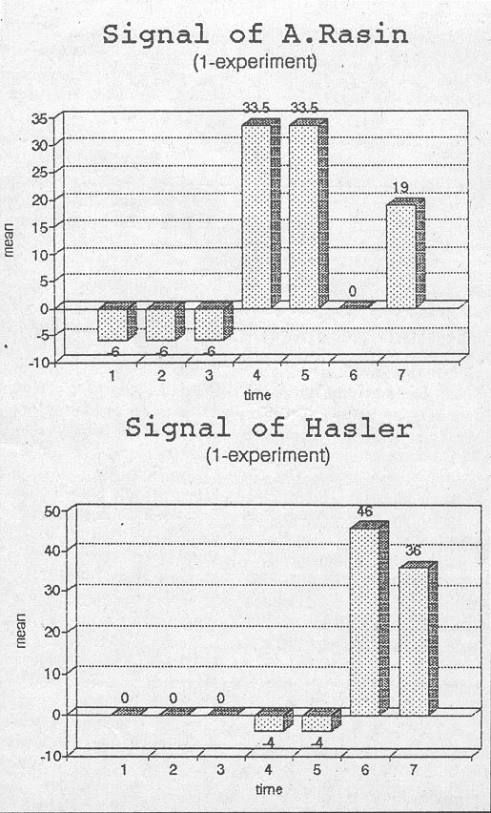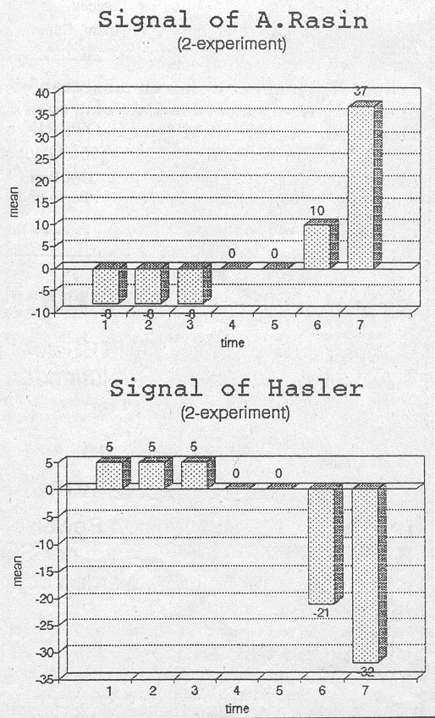

A short summary

The proposed method and the conducted experiments show that this method not only shows the existence of the telepathic channel (or its absence), but also the quantitative change of the sensitivity of this channel under the influence of this and other external factors, for instance characterised by urine-therapy or the strength of concentration.

* * * * * * *

